ADOPTED – AUGUST 27, 2019
AGENDA ITEM NO. 29

Introduced by the County Services and Finance Committees of the:

INGHAM COUNTY BOARD OF COMMISSIONERS

RESOLUTION AMENDING AND RESTATING THE INGHAM COUNTY
DEFERRED COMPENSATION PLAN

RESOLUTION # 19 – 339

WHEREAS, Resolution #80-357 adopted the original Ingham County Deferred Compensation Plan; and

WHEREAS, Resolution #08-079 amended and restated the Ingham County Deferred Compensation Plan; and

WHEREAS, amendments and changes to the tax laws have occurred since the plan was originally adopted; and

WHEREAS, an updated plan document has been drafted to include all amendments and tax law changes; and

WHEREAS, the County Deferred Compensation Committee has reviewed the updated plan document.

THEREFORE BE IT RESOLVED, that the Ingham County Board of Commissioners hereby approves the attached amended and restated Ingham County Deferred Compensation Plan (“Plan”).

BE IT FURTHER RESOLVED, that a contract is authorized with Nationwide Retirement Solutions, Inc. for plan administrative services, effective immediately.

BE IT FURTHER RESOLVED, that the Board Chairperson is authorized to sign any necessary contracts after review and approval as to form by the County Attorney.

COUNTY SERVICES: Yeas: Celentino, Stivers, Grebner, Sebolt, Maiville, Naeyaert
Nays: None Absent: Koenig Approved 08/20/2019

FINANCE: Yeas: Grebner, Morgan, Tennis, Crenshaw, Polsdofer, Schafer, Maiville
Nays: None Absent: None Approved 08/21/2019

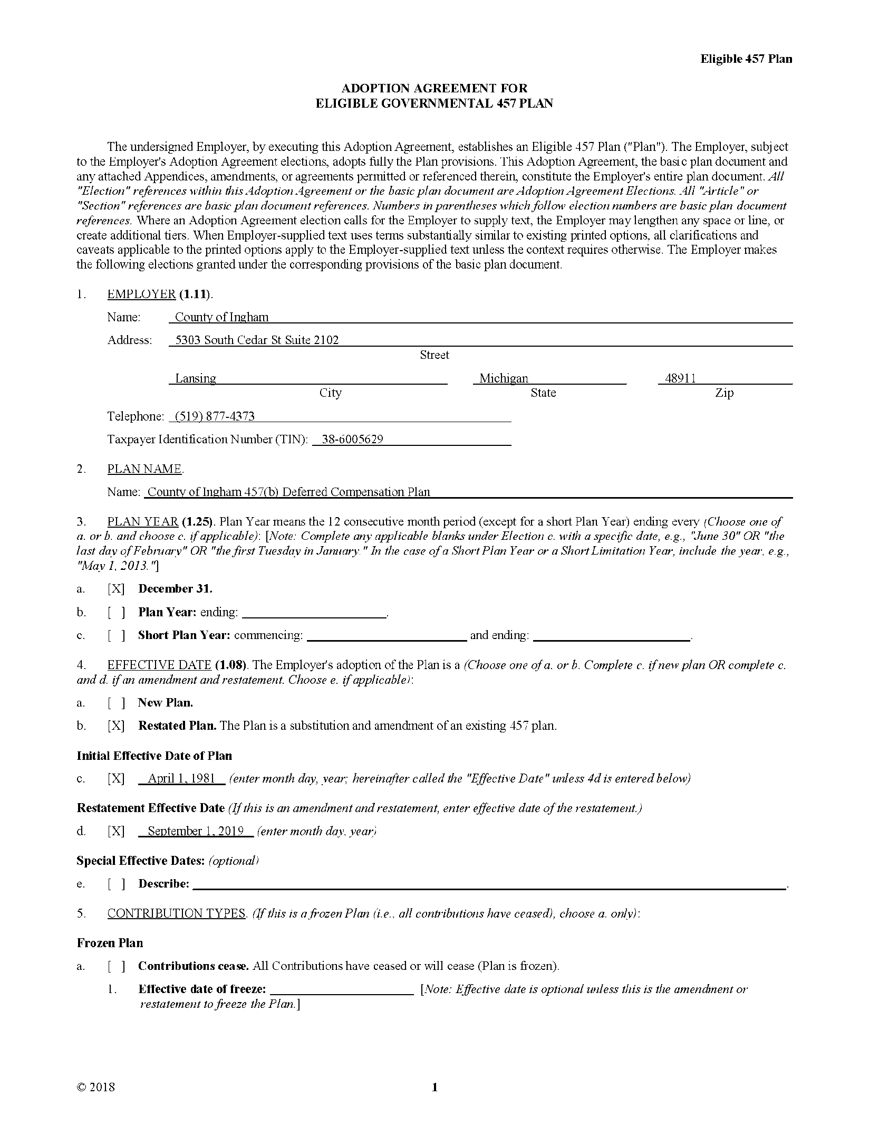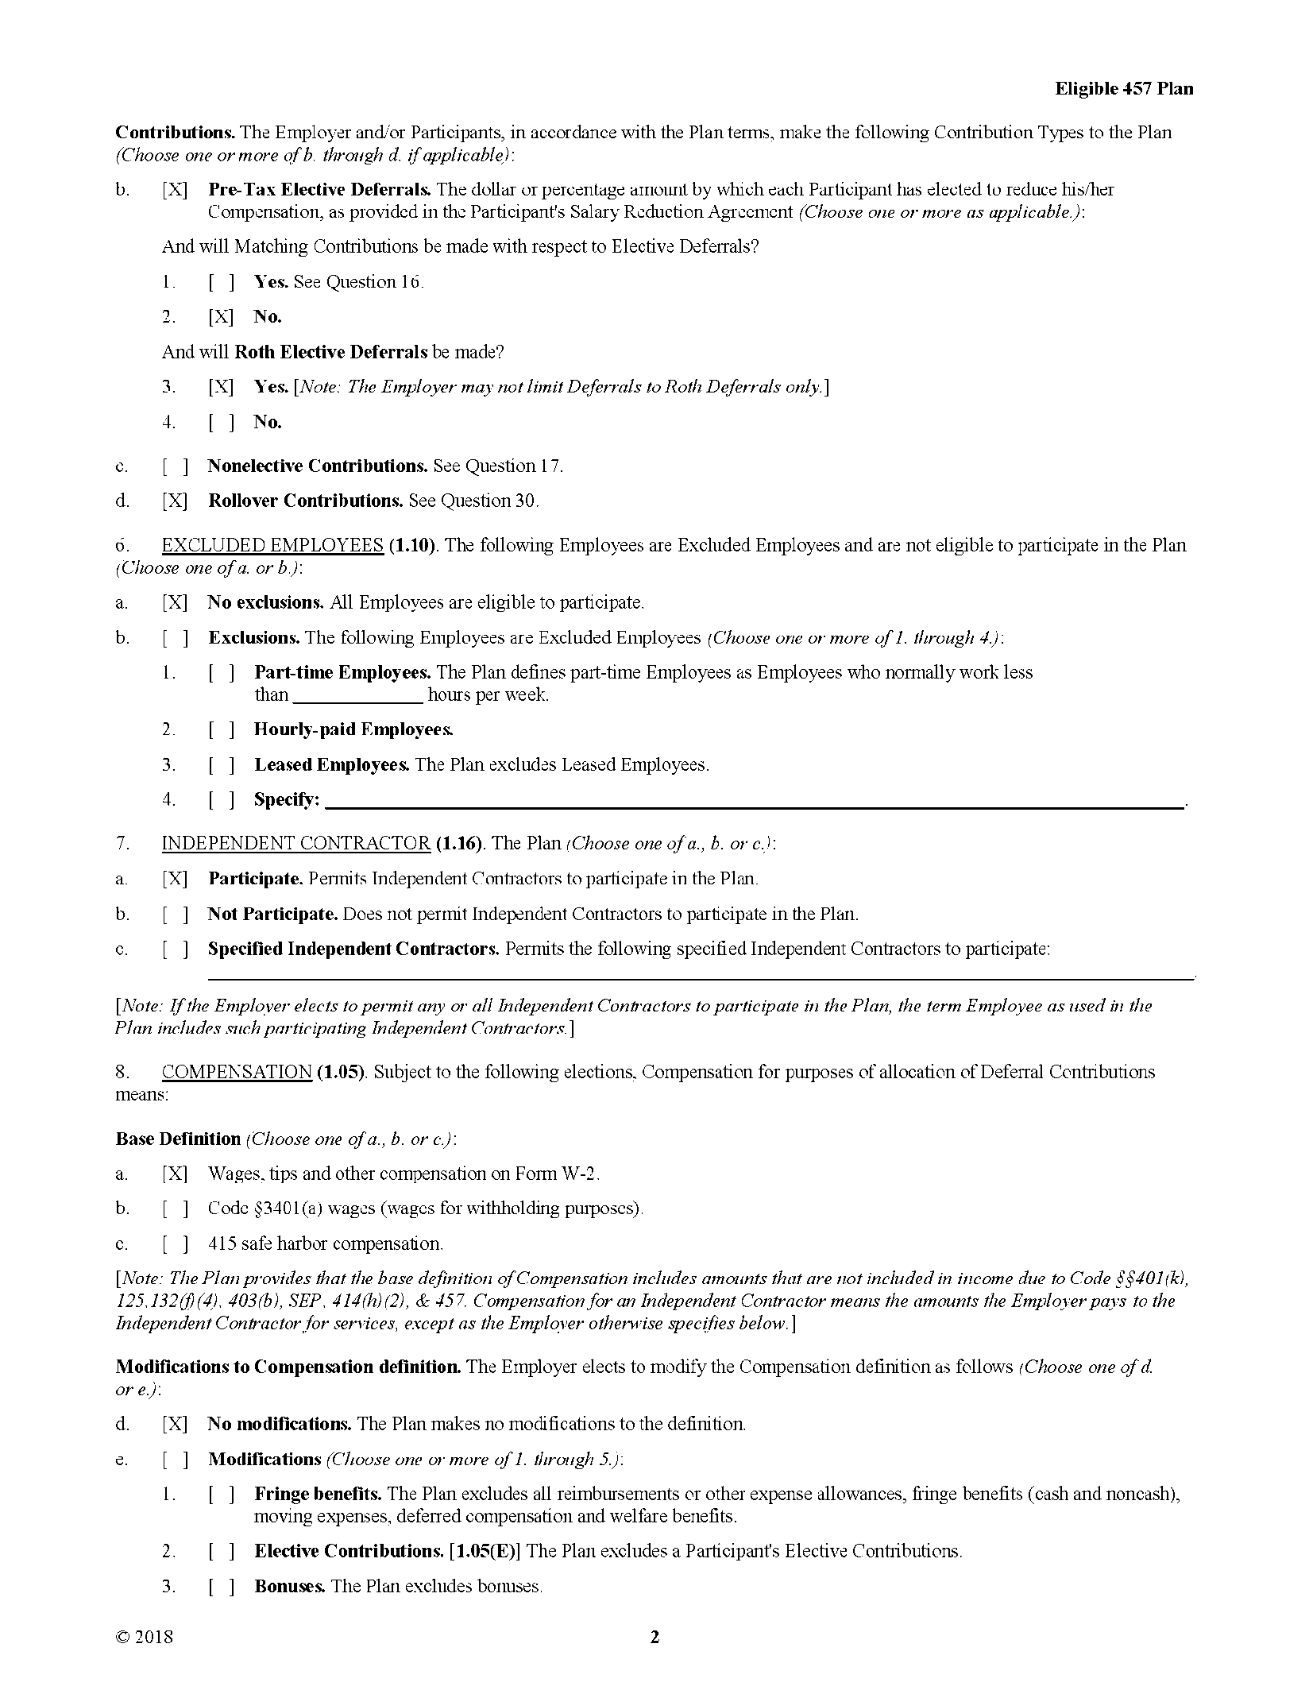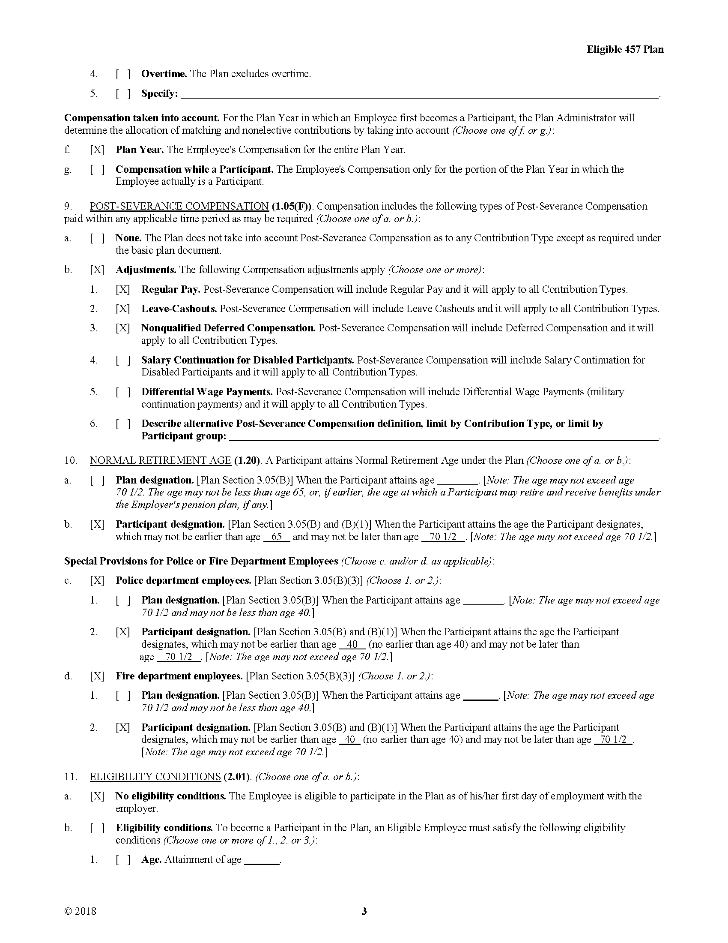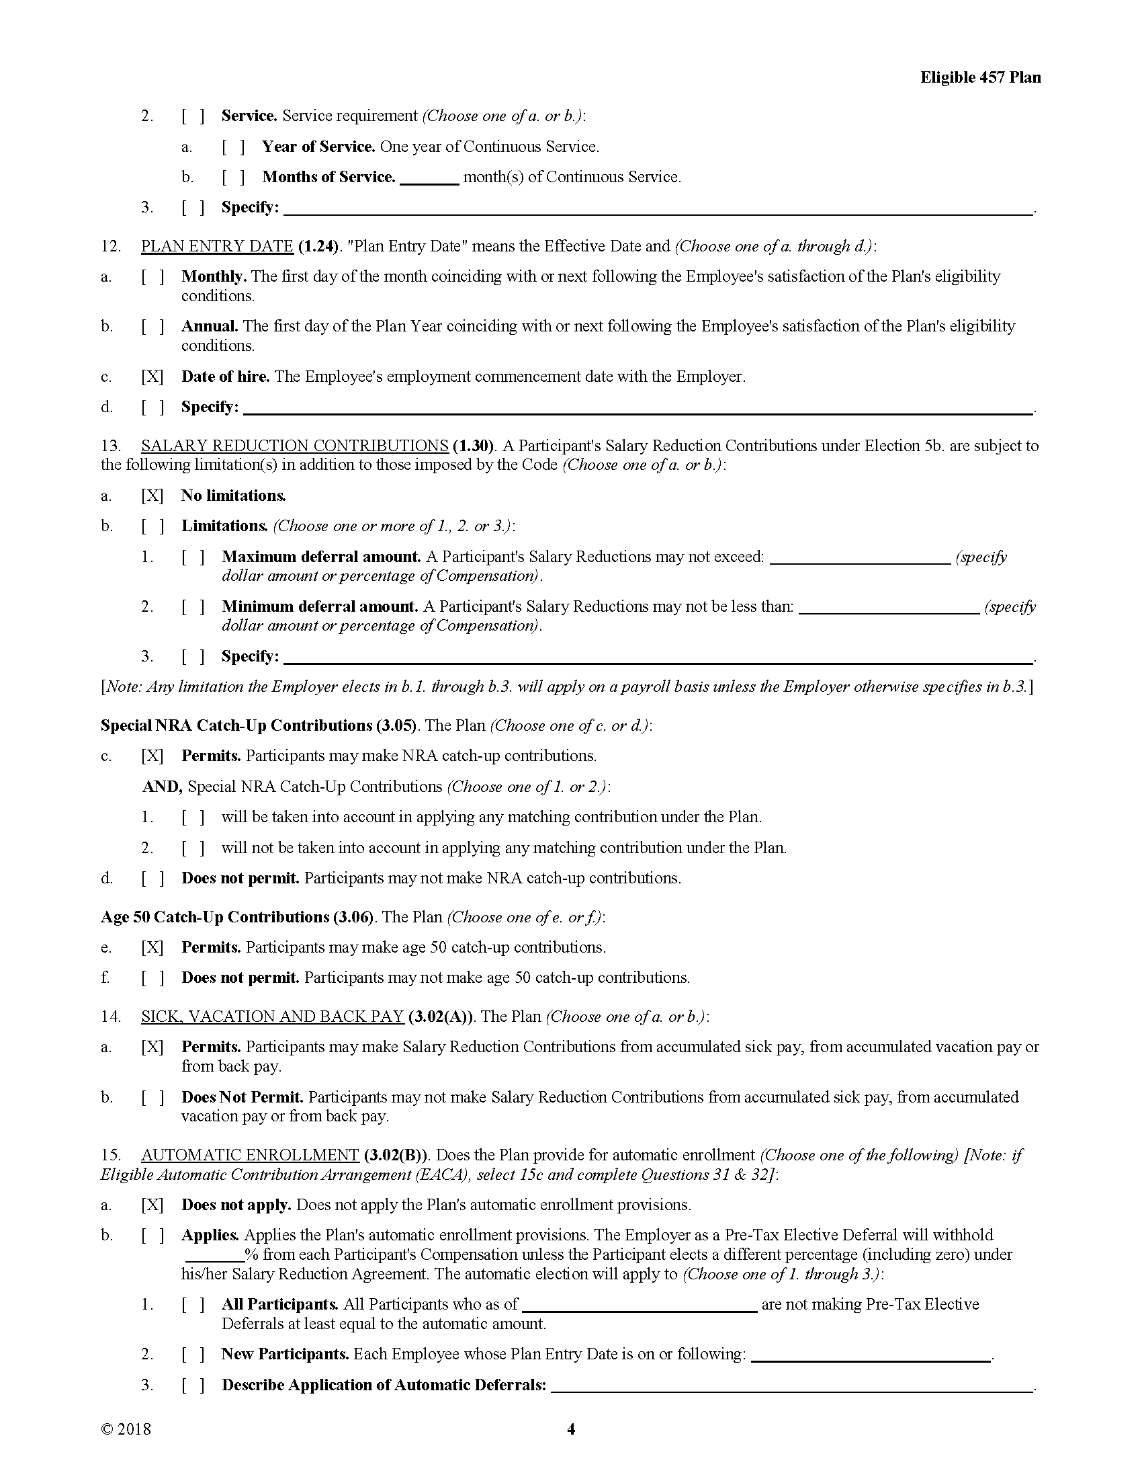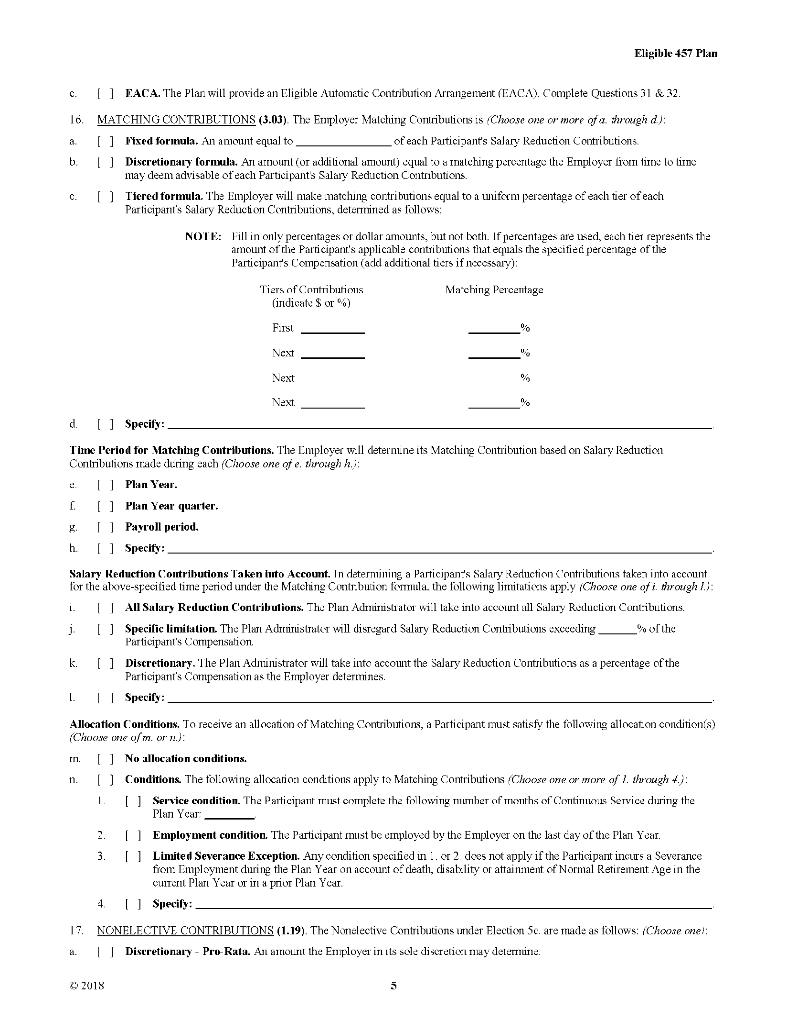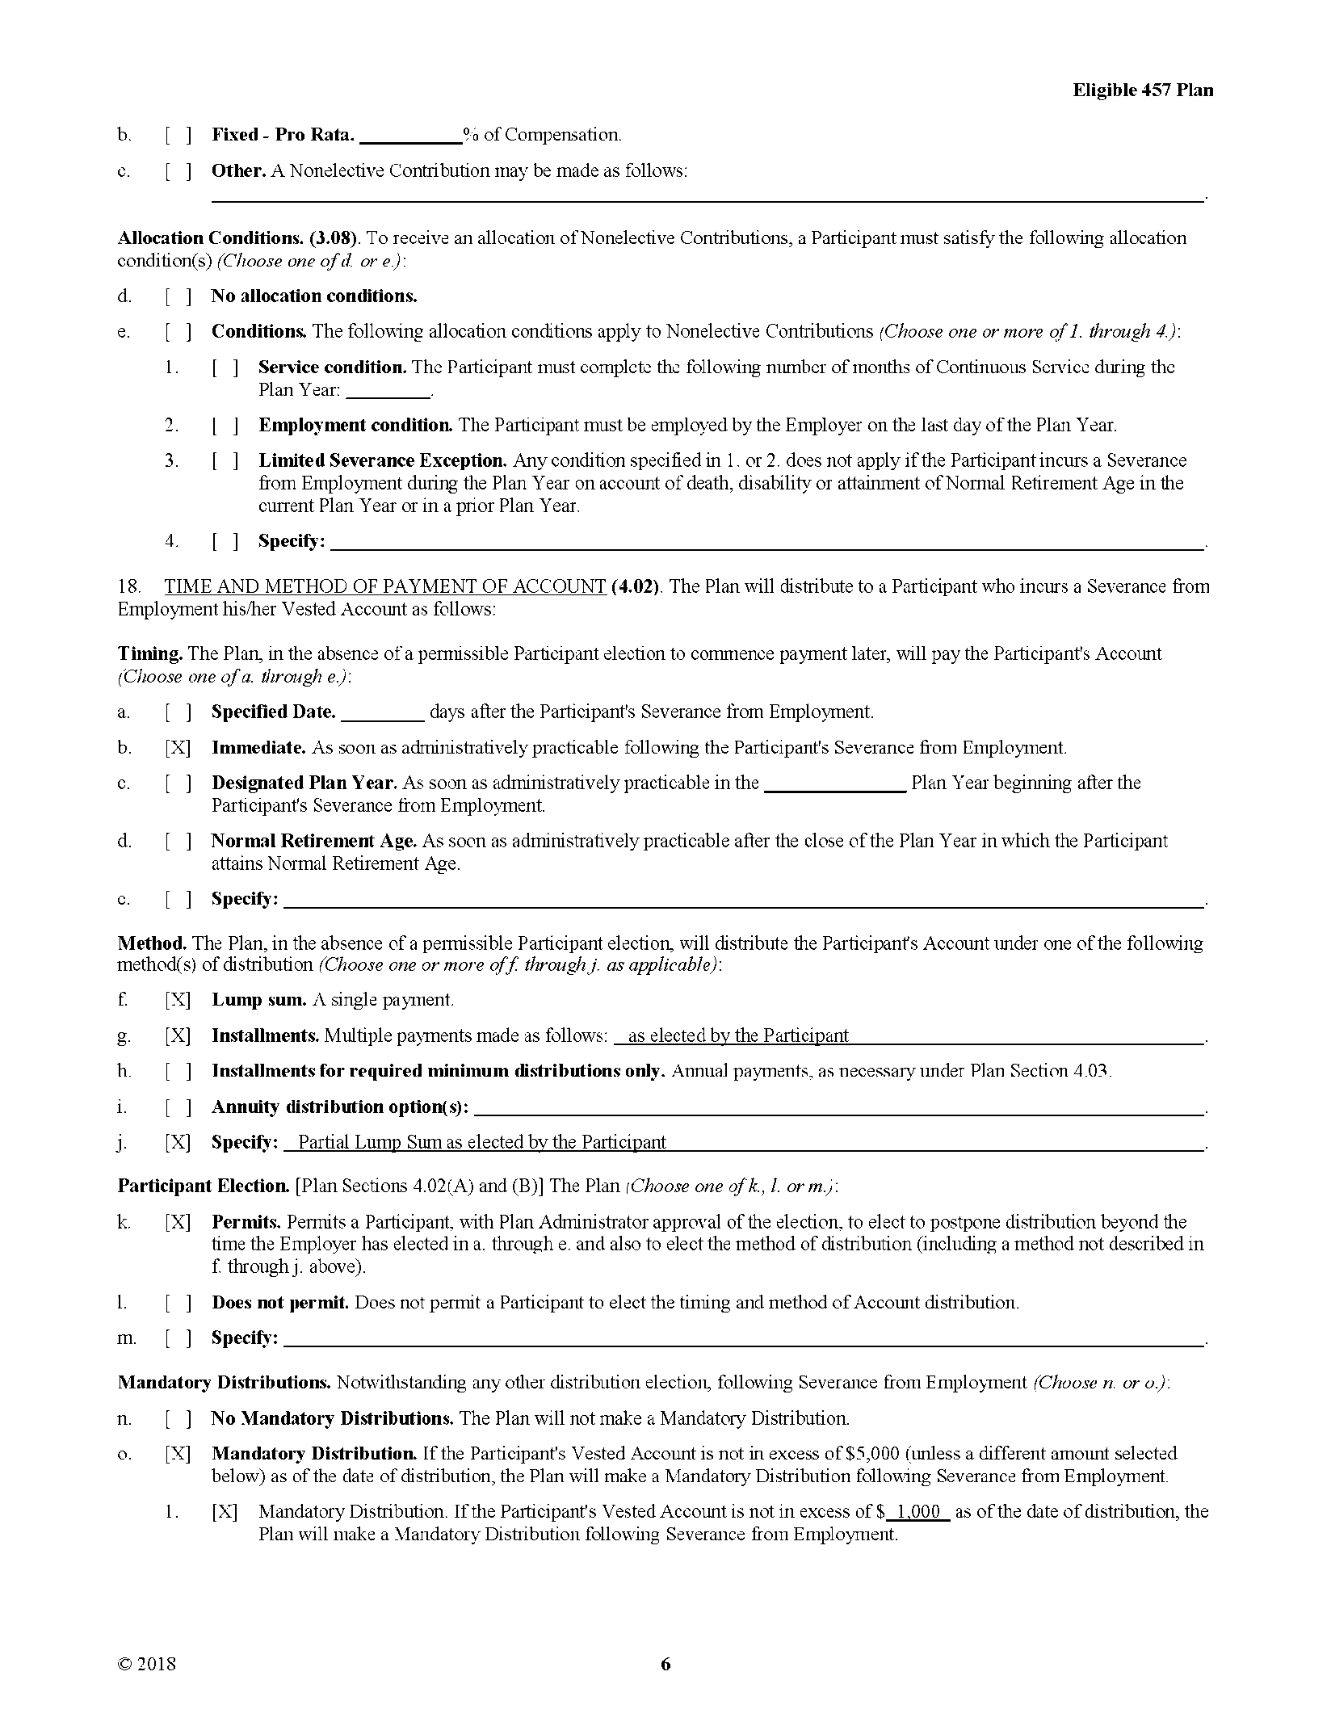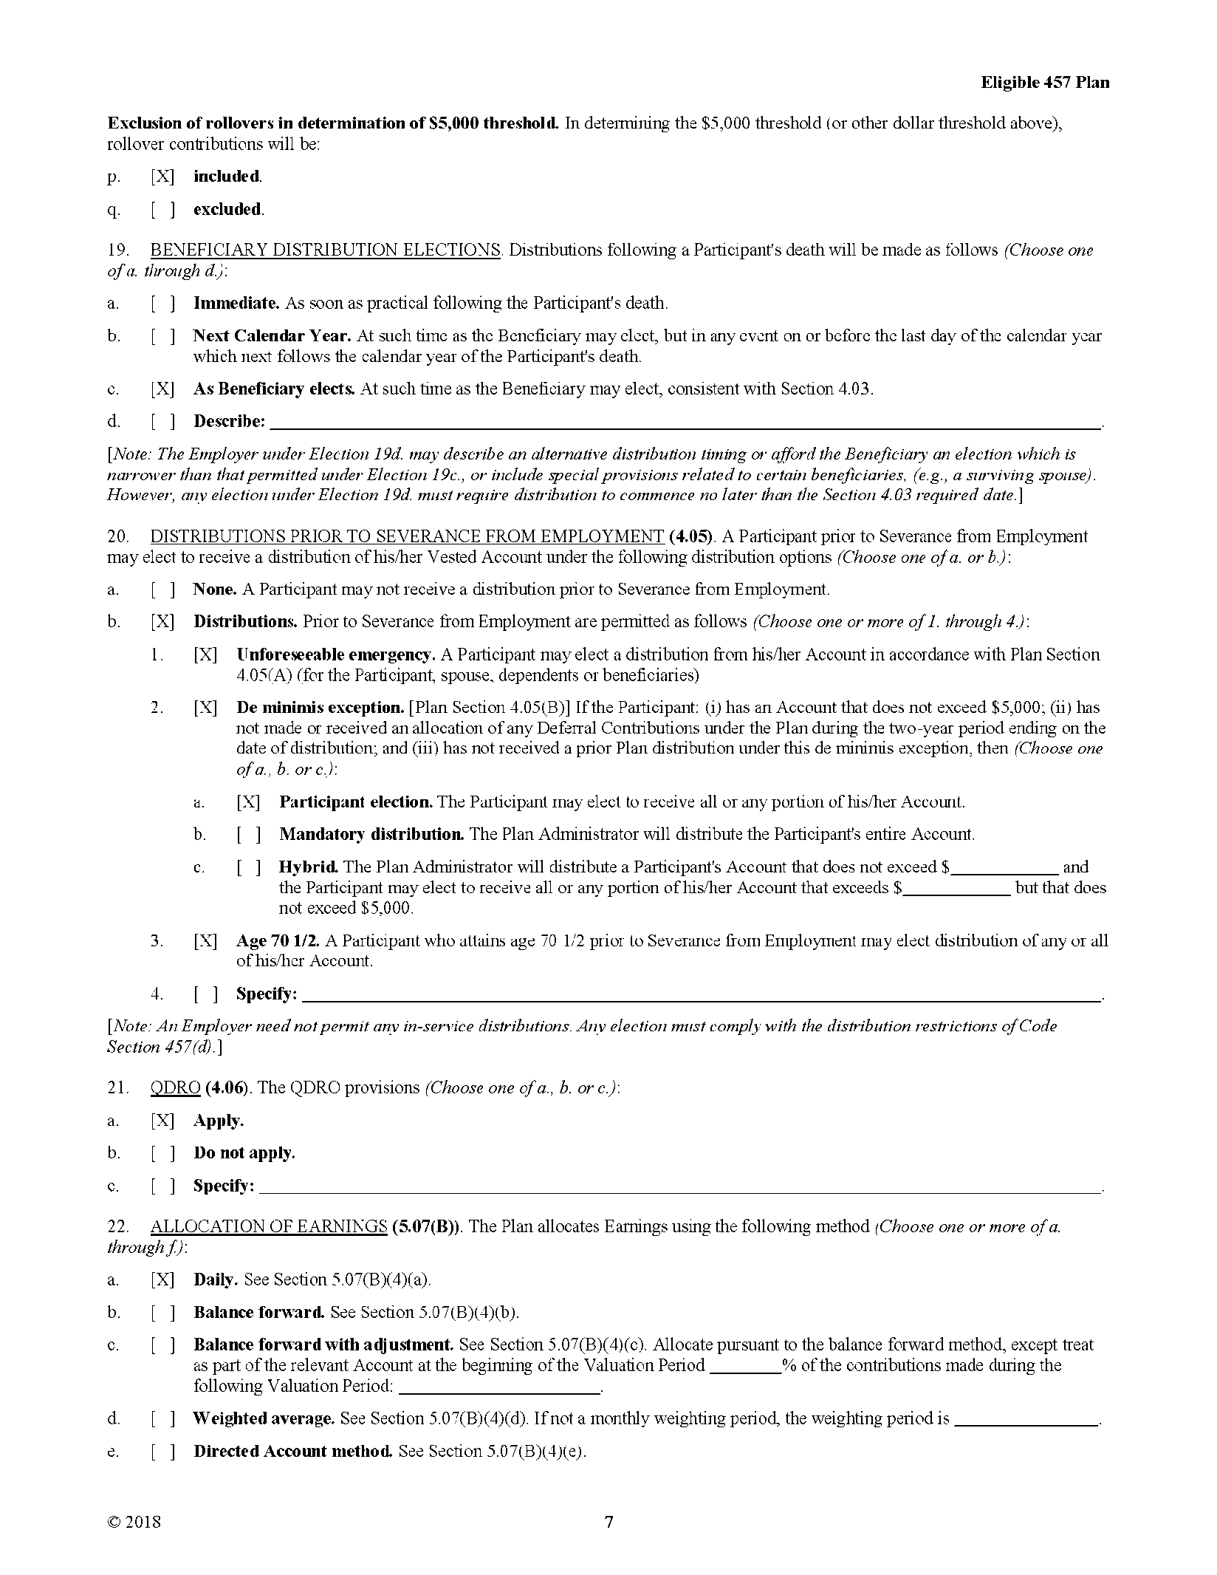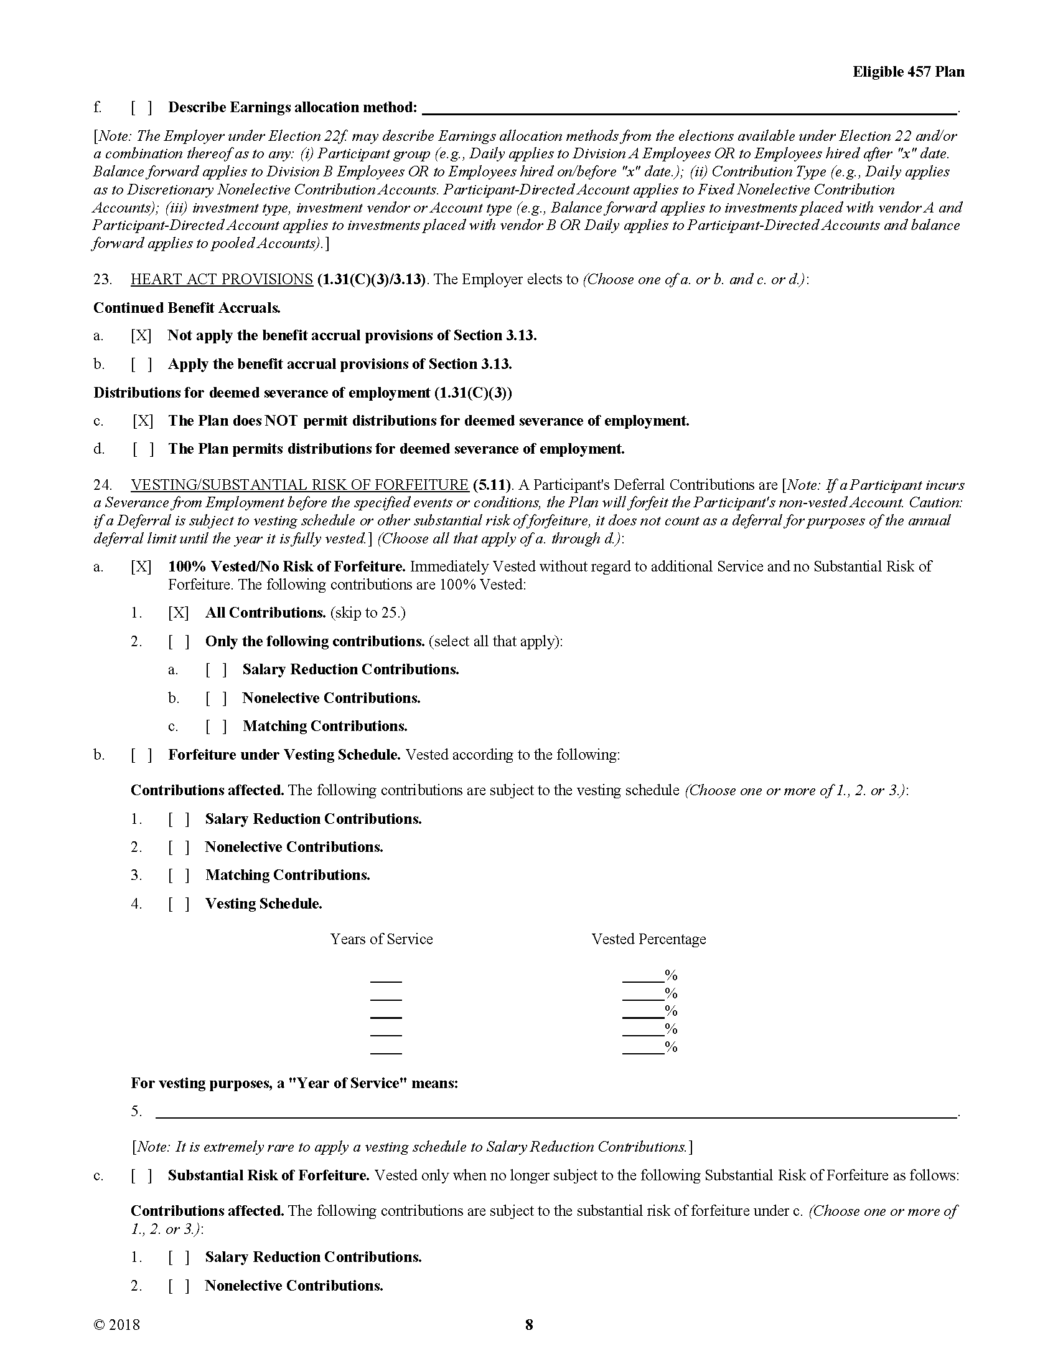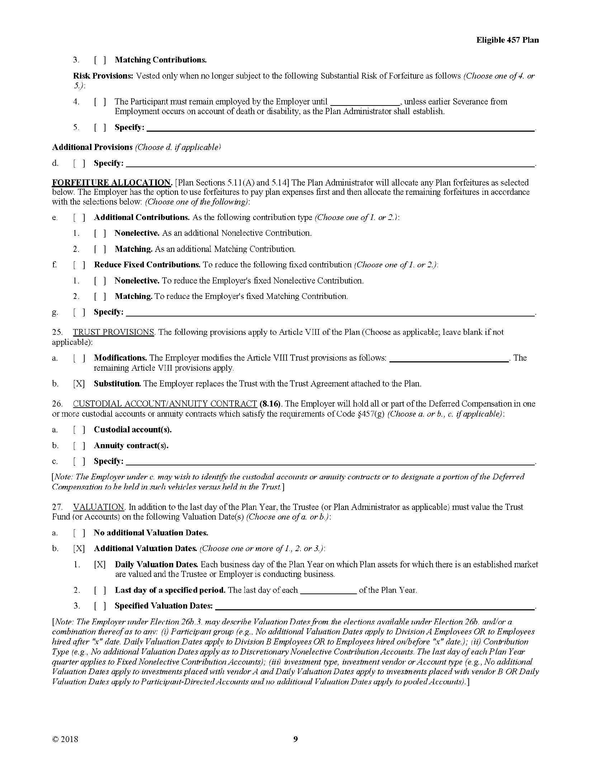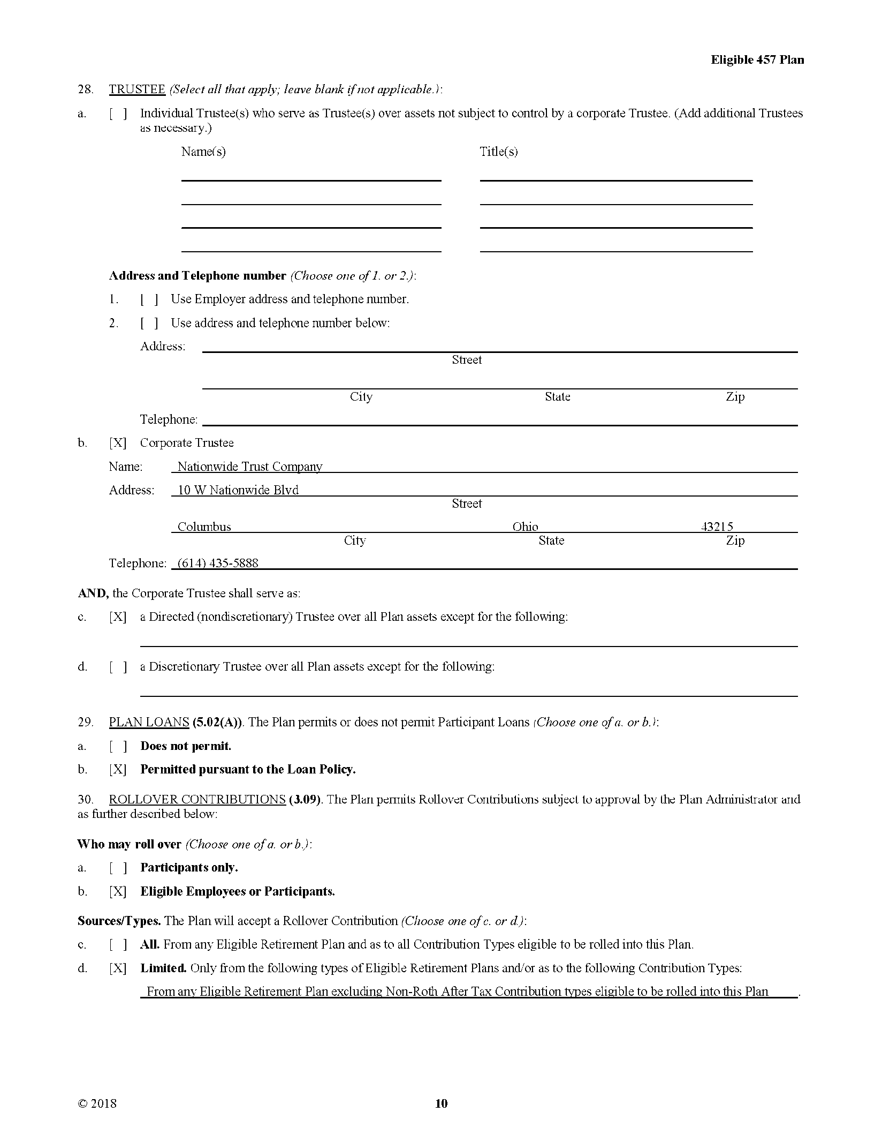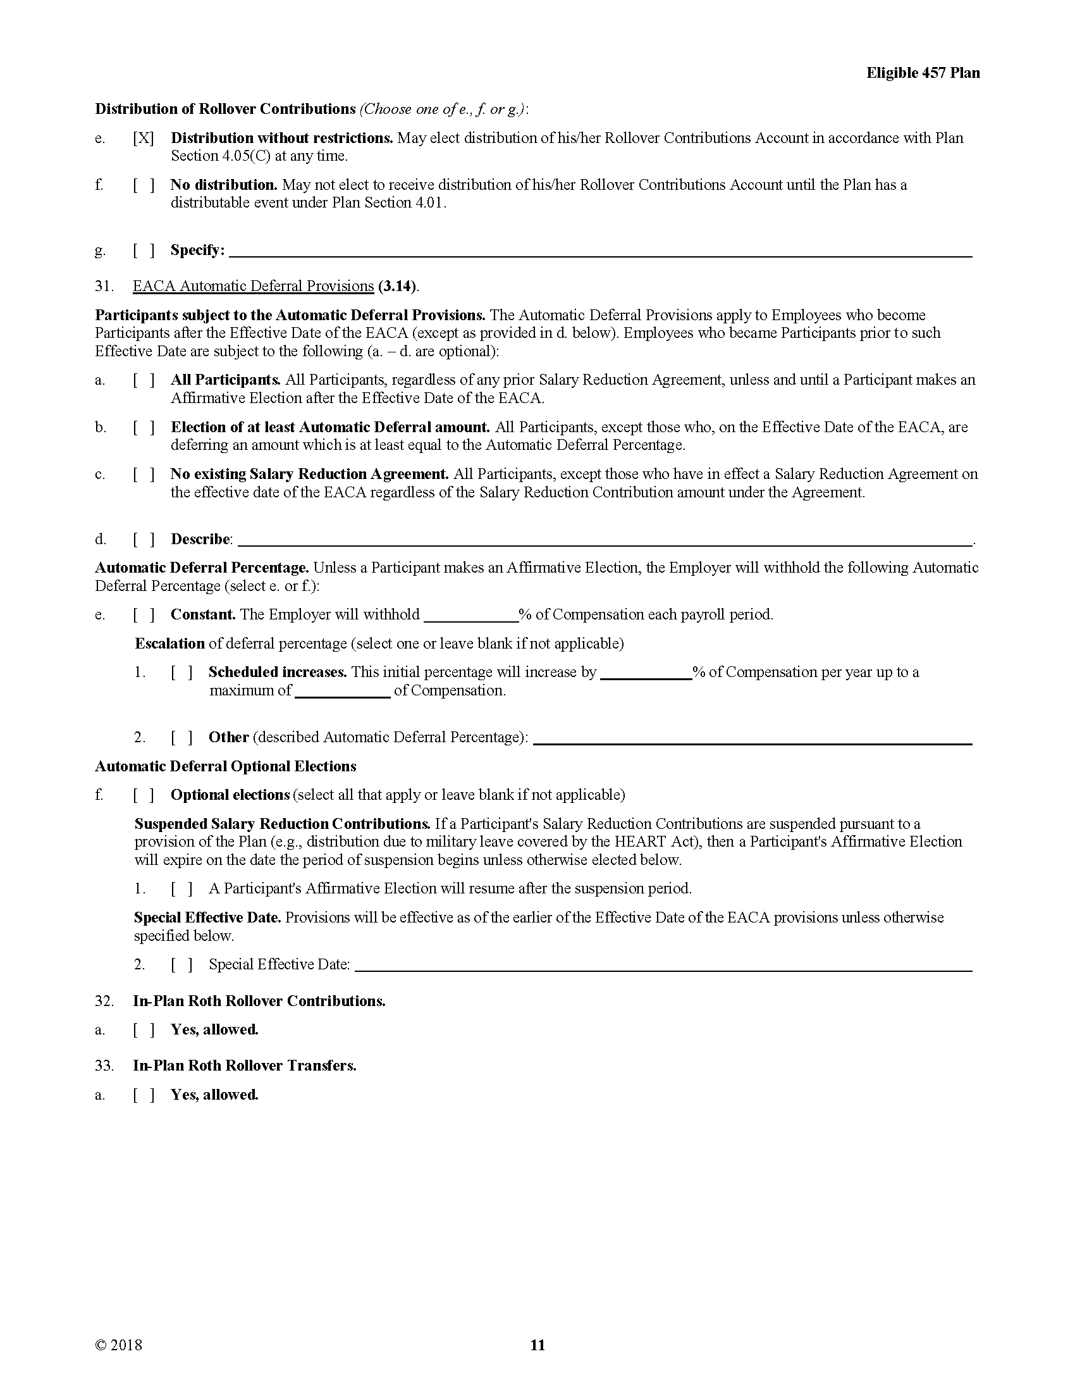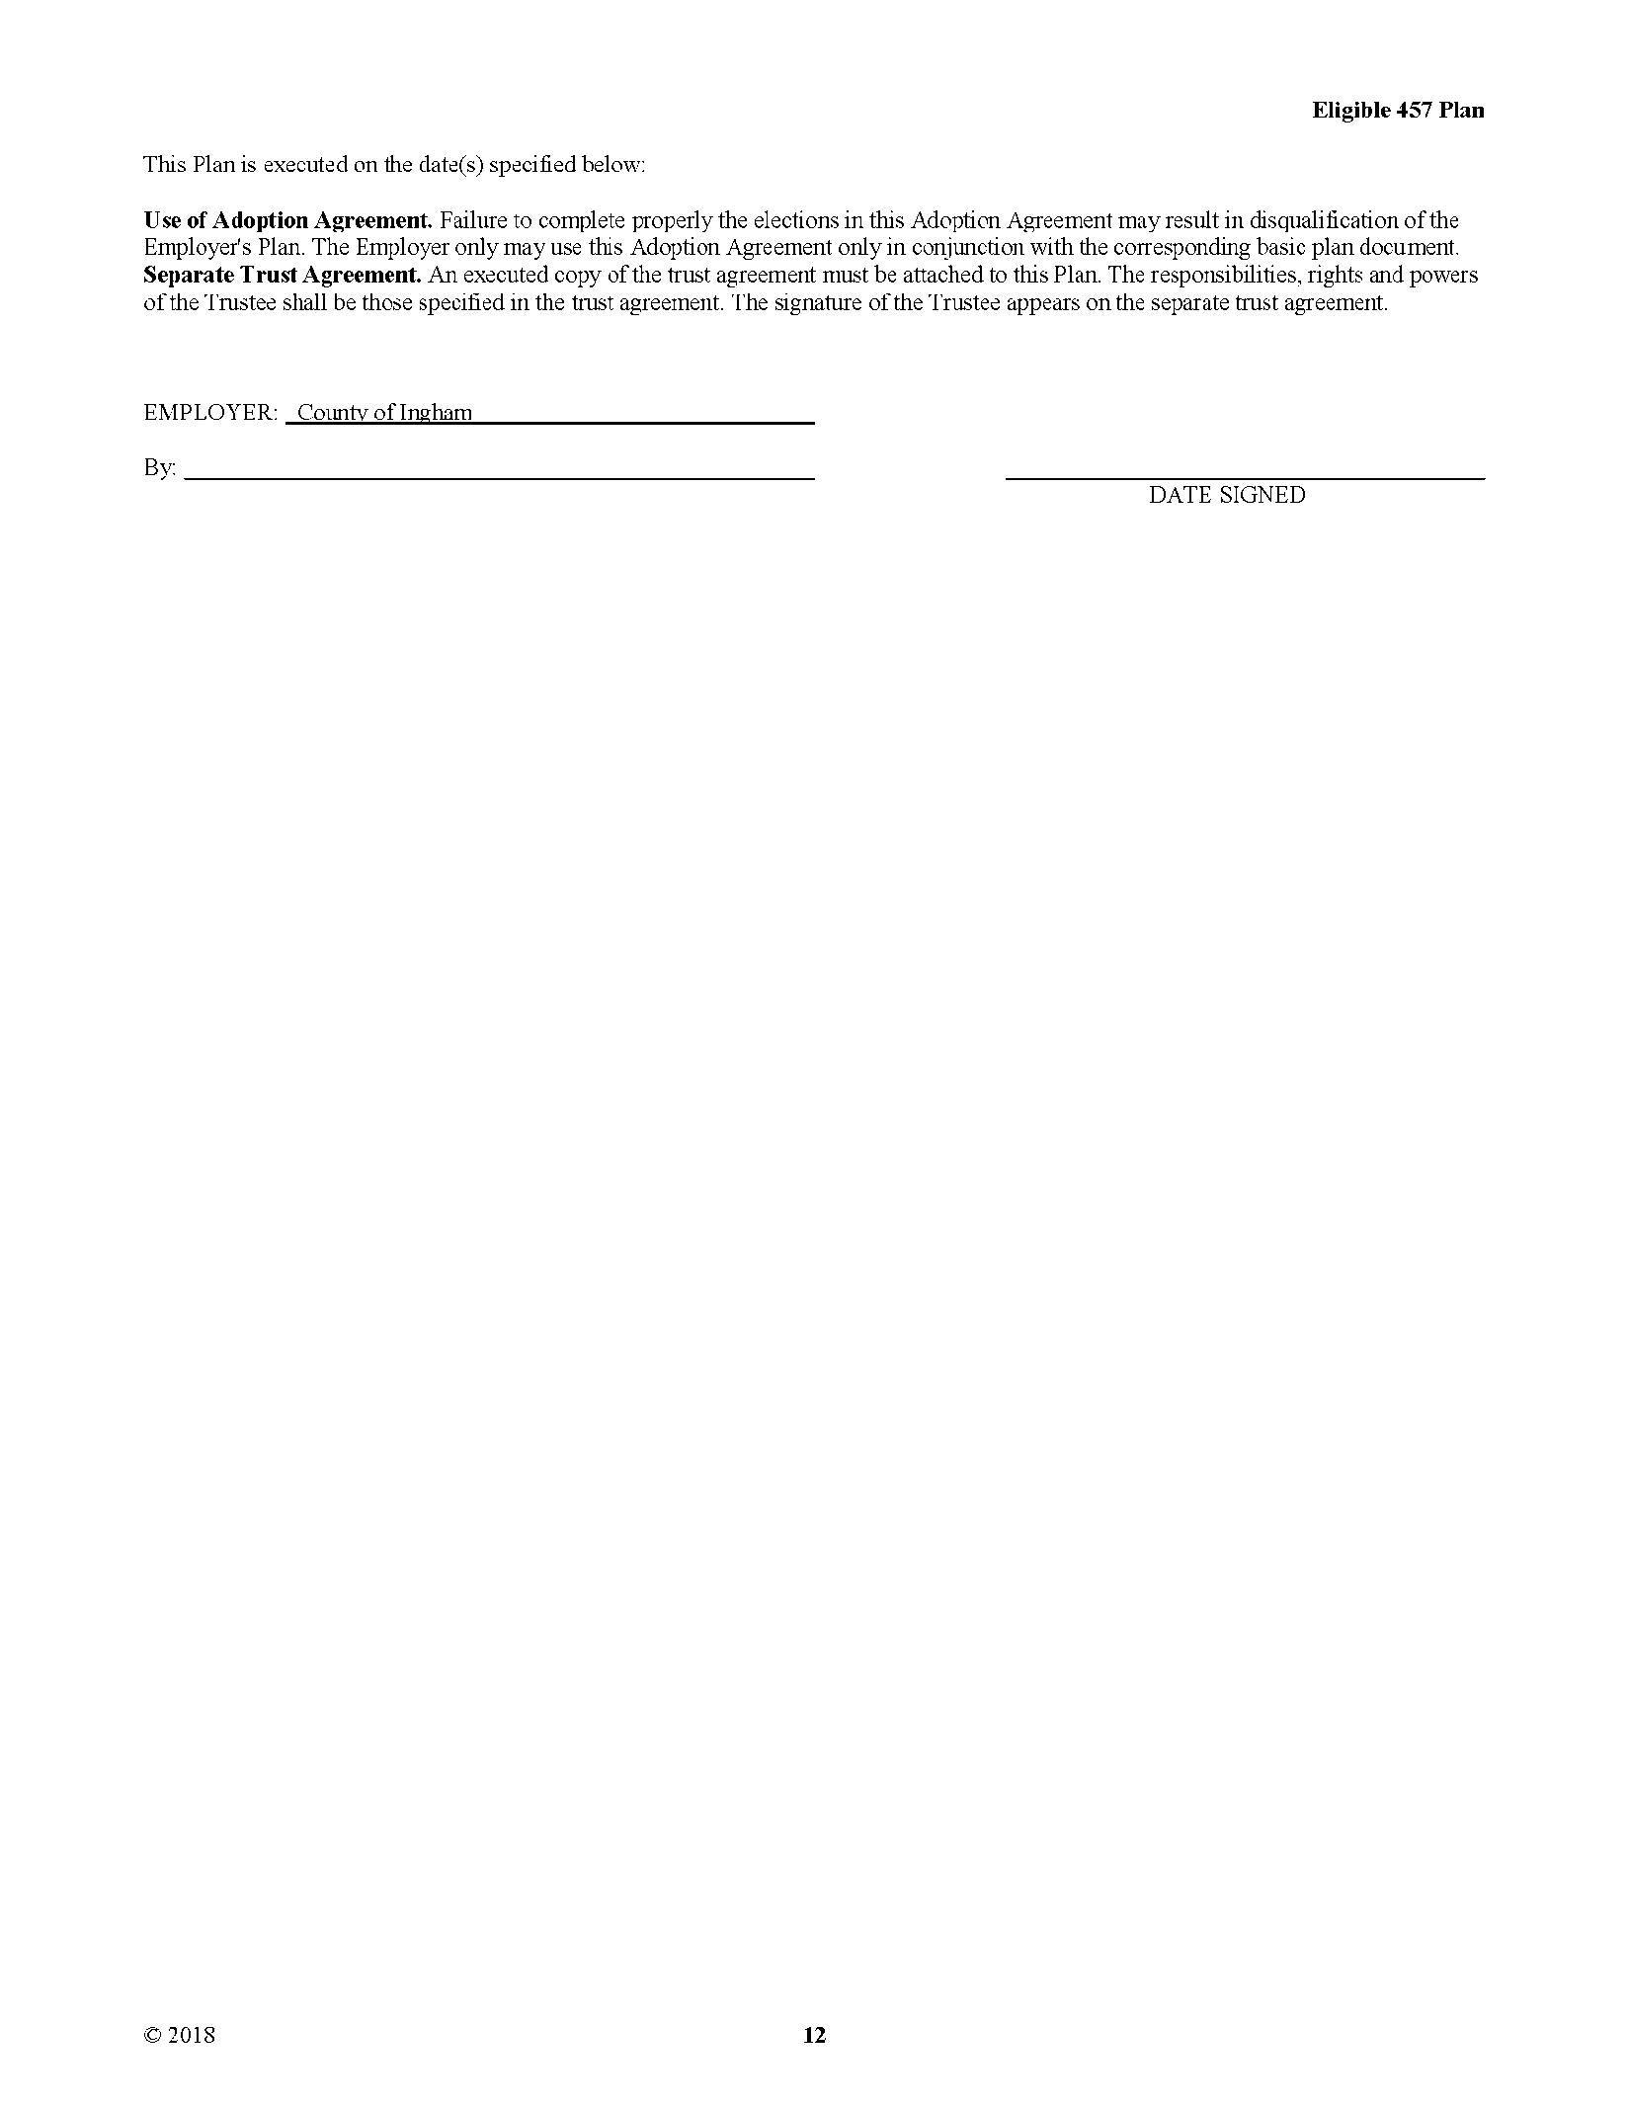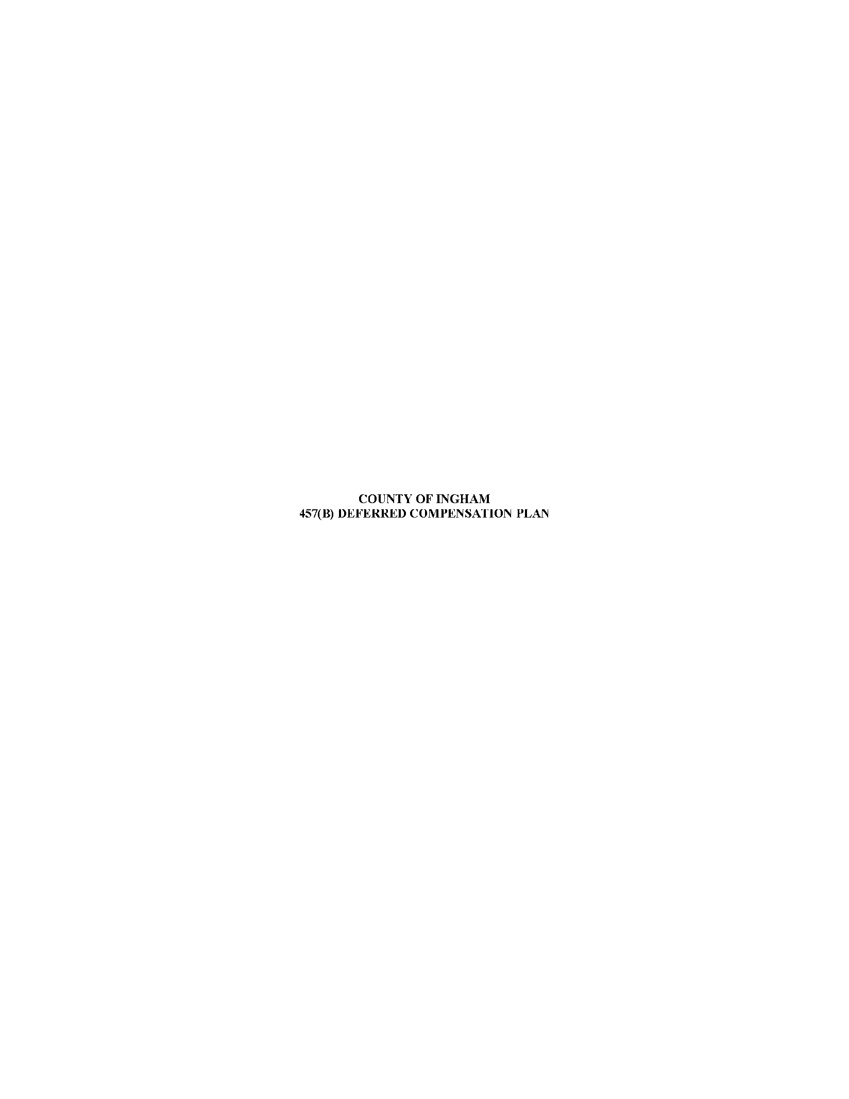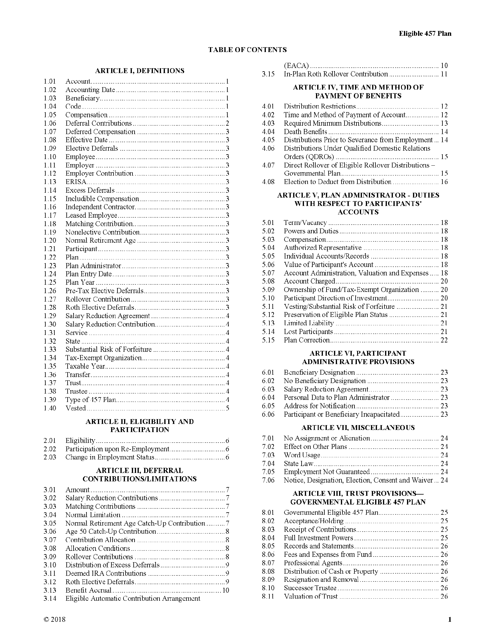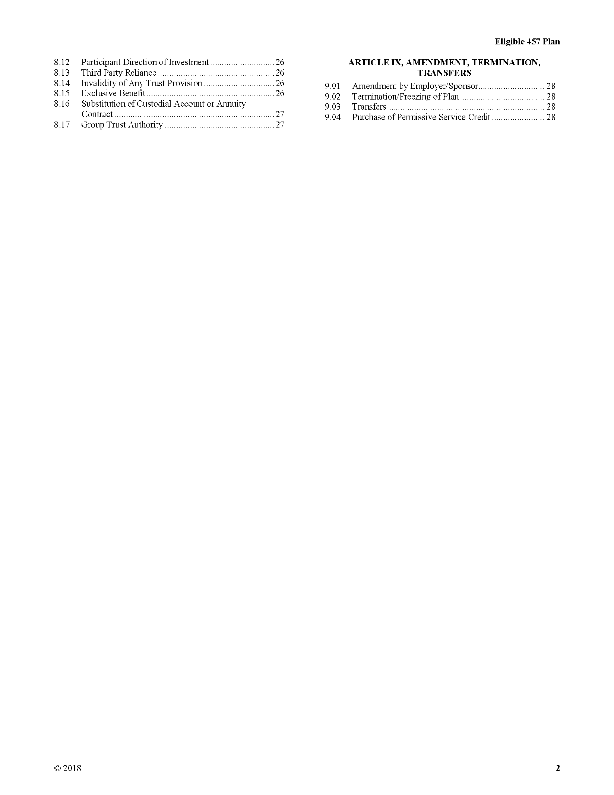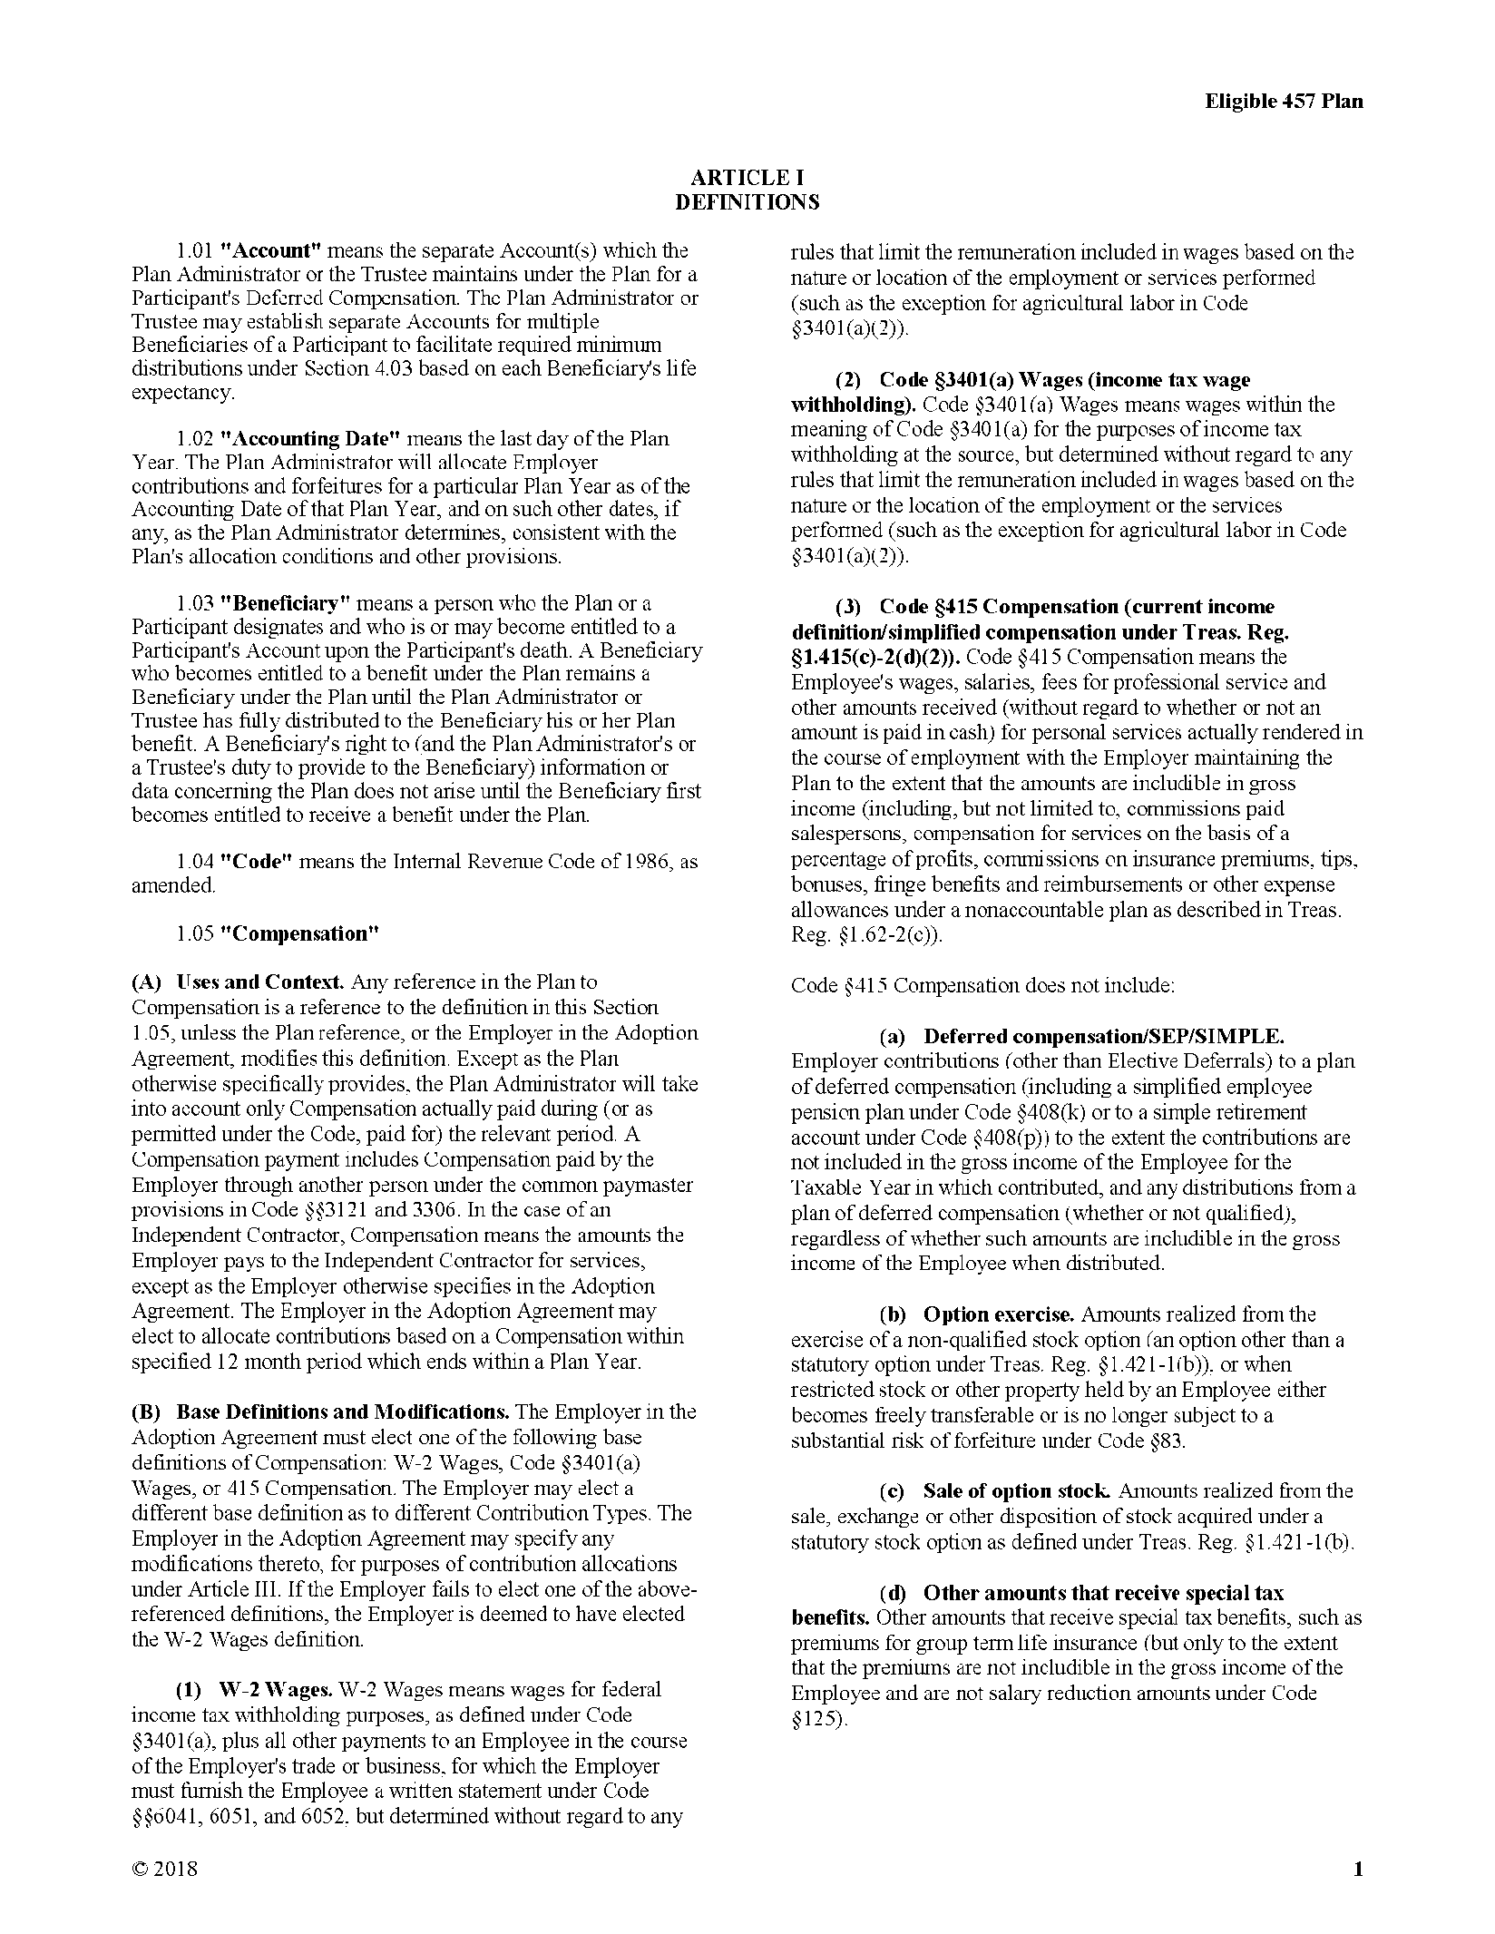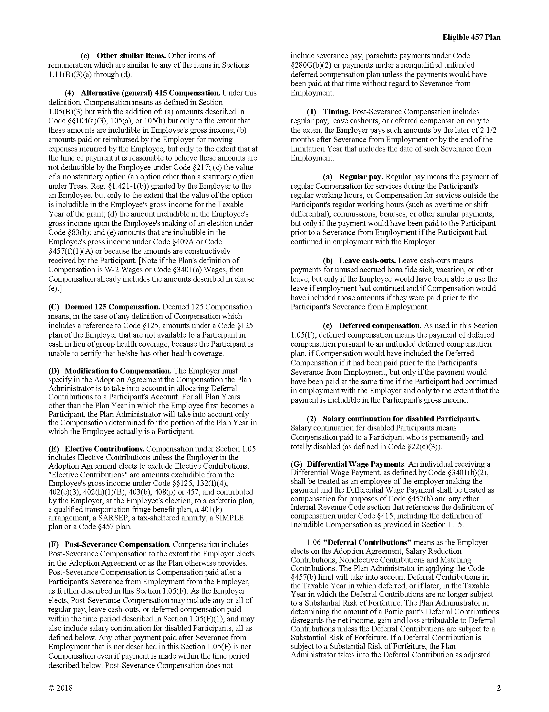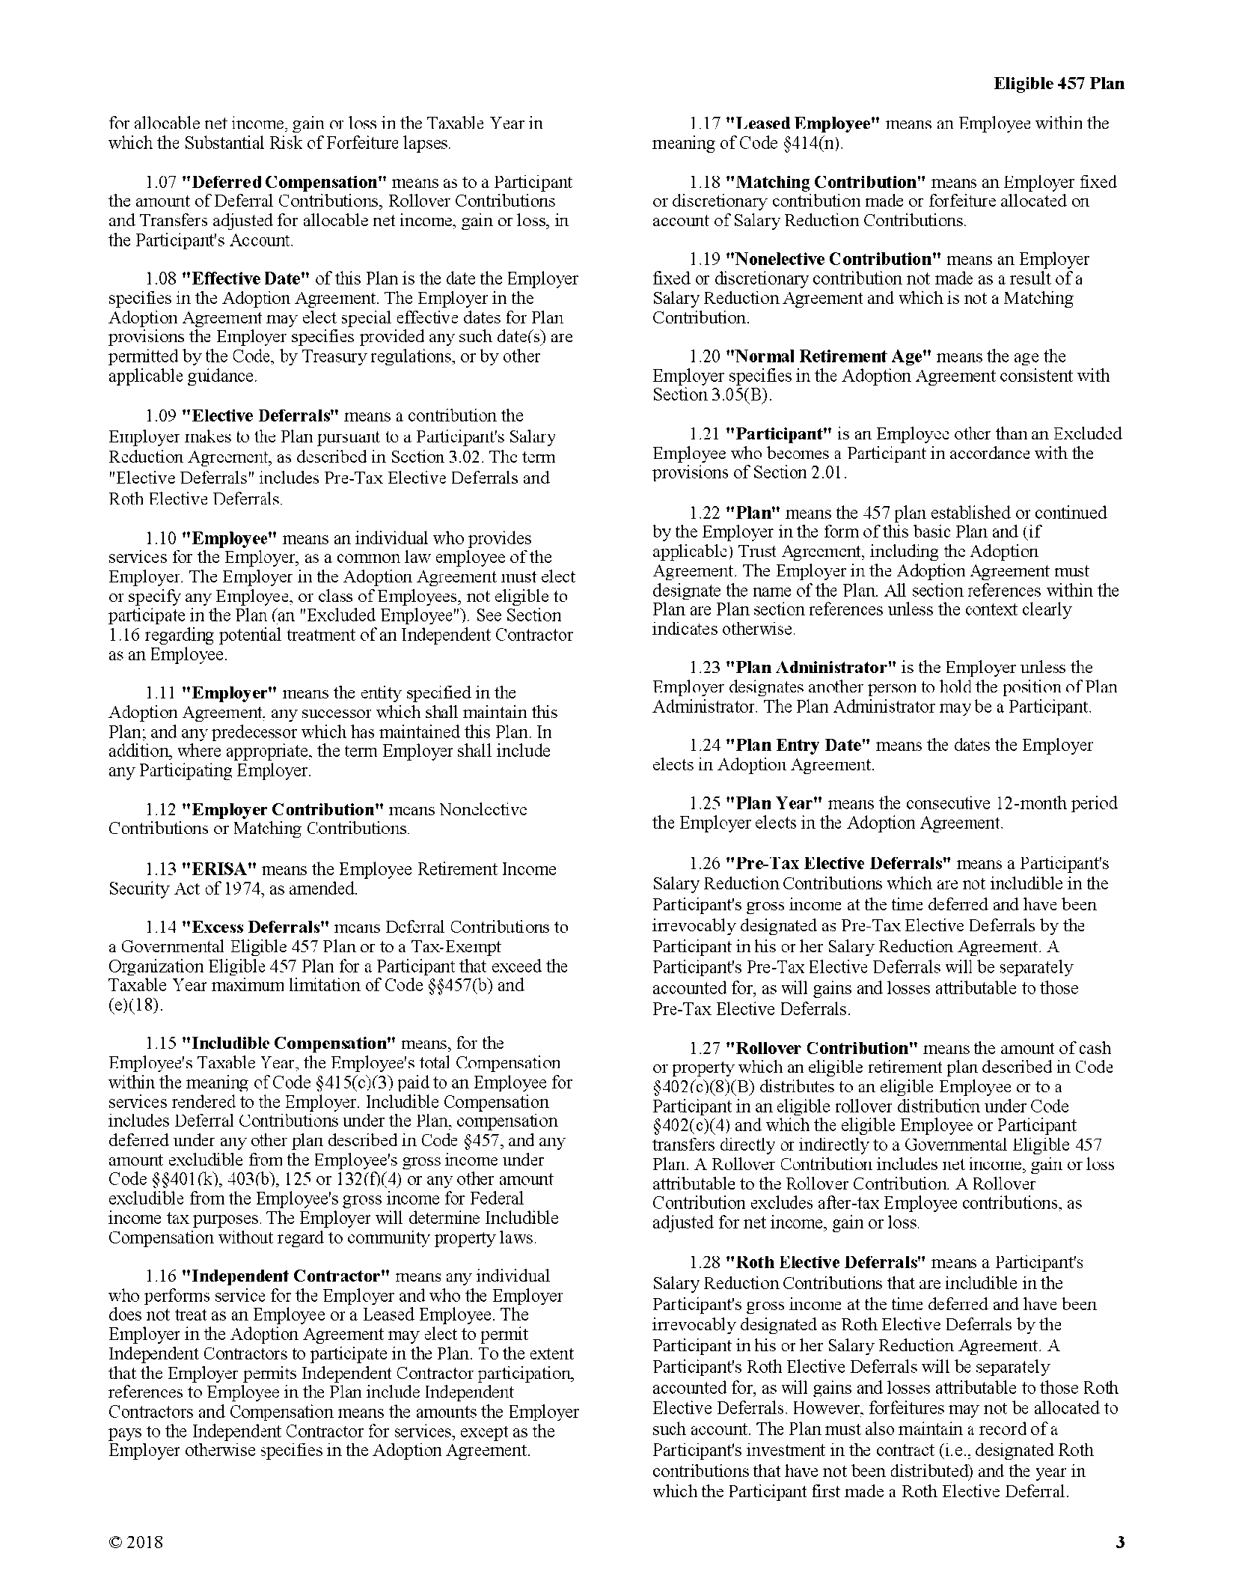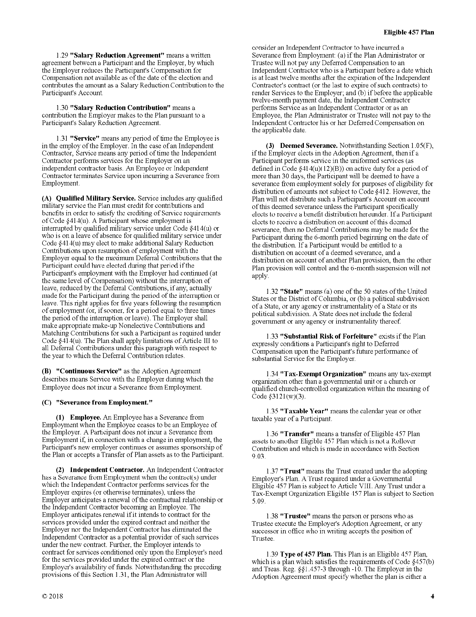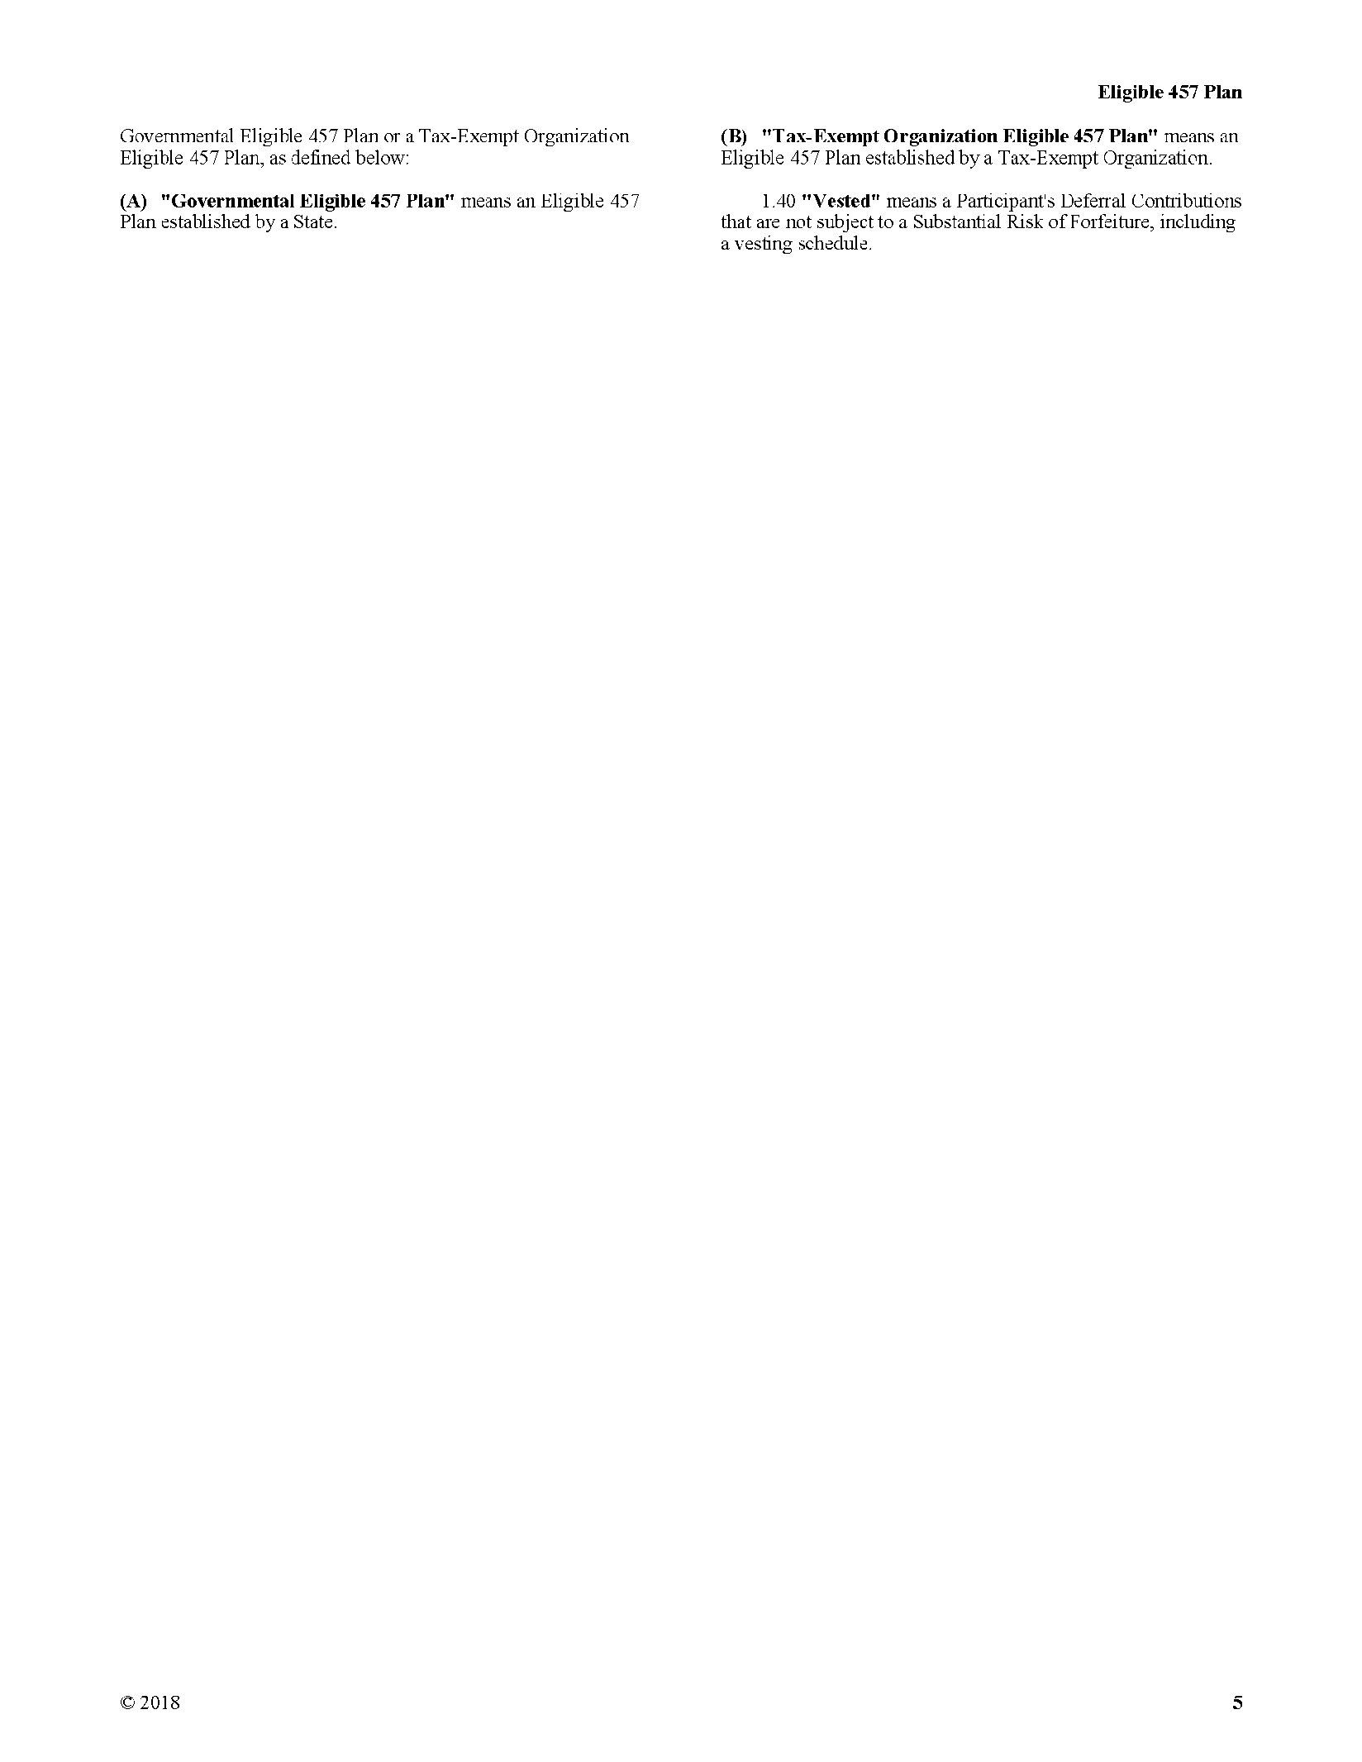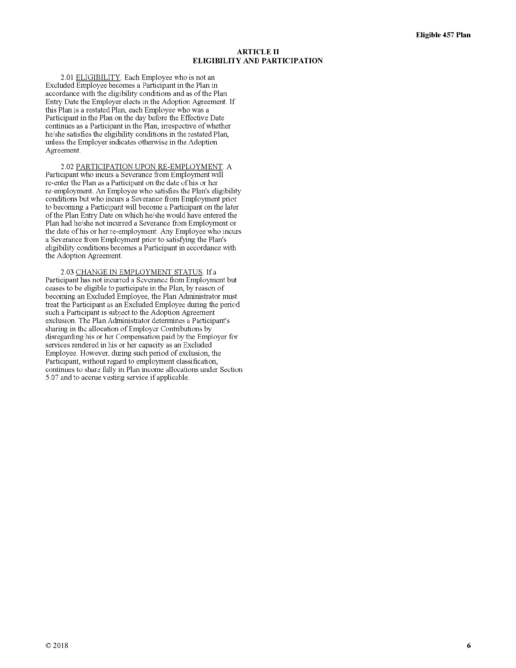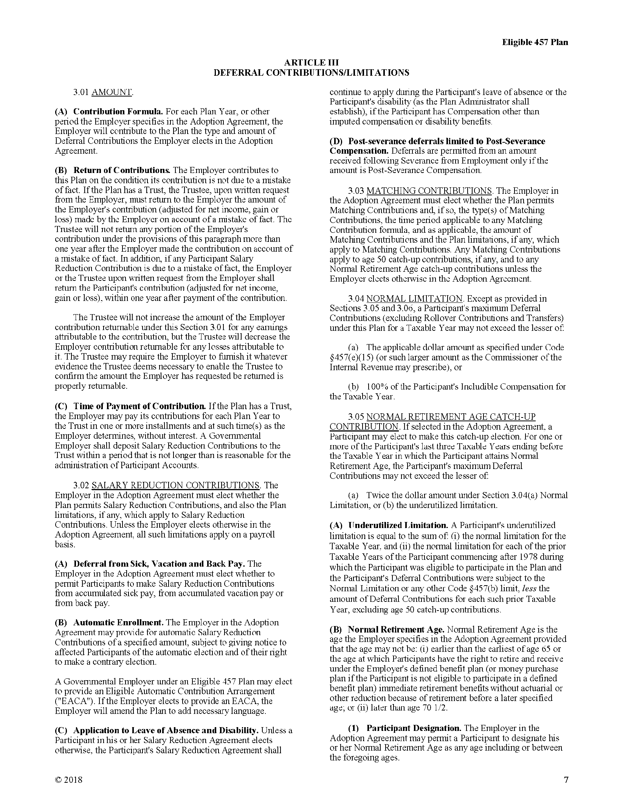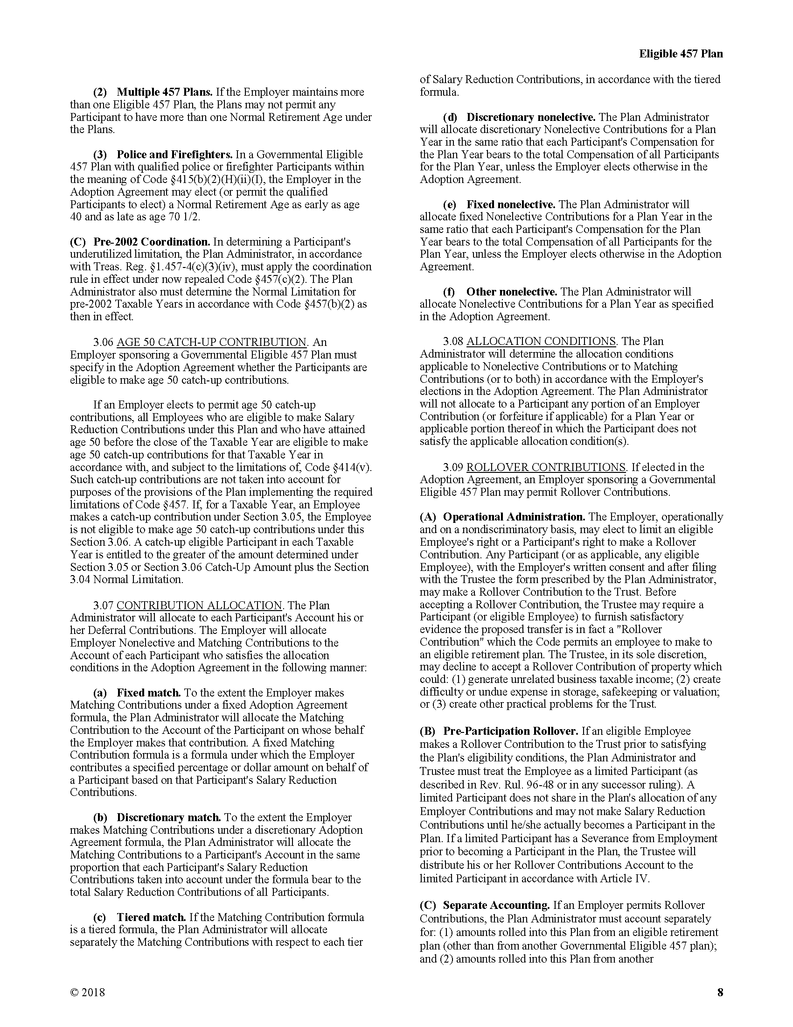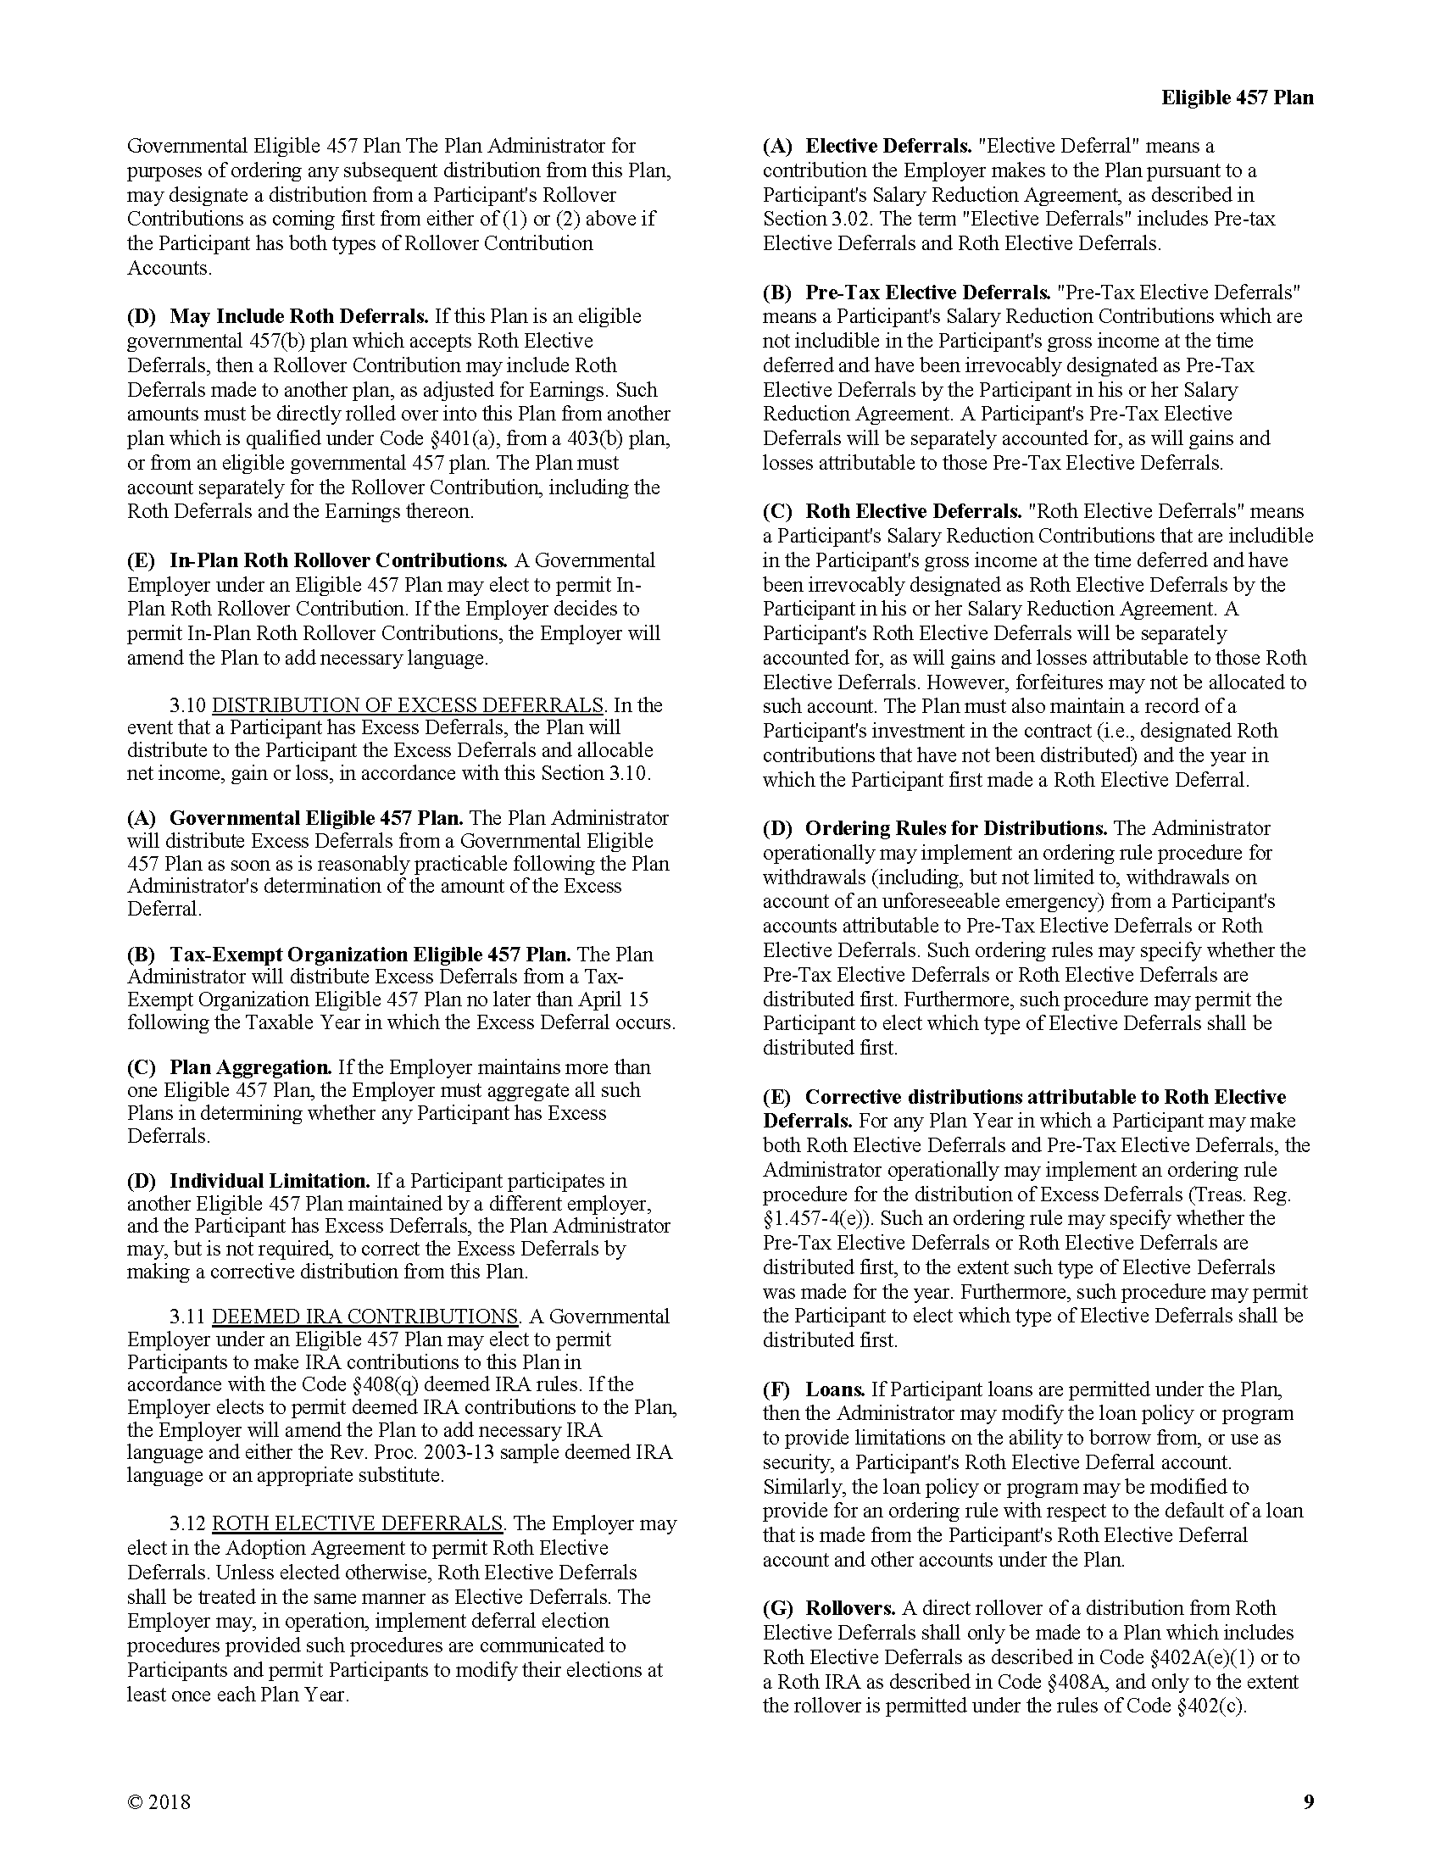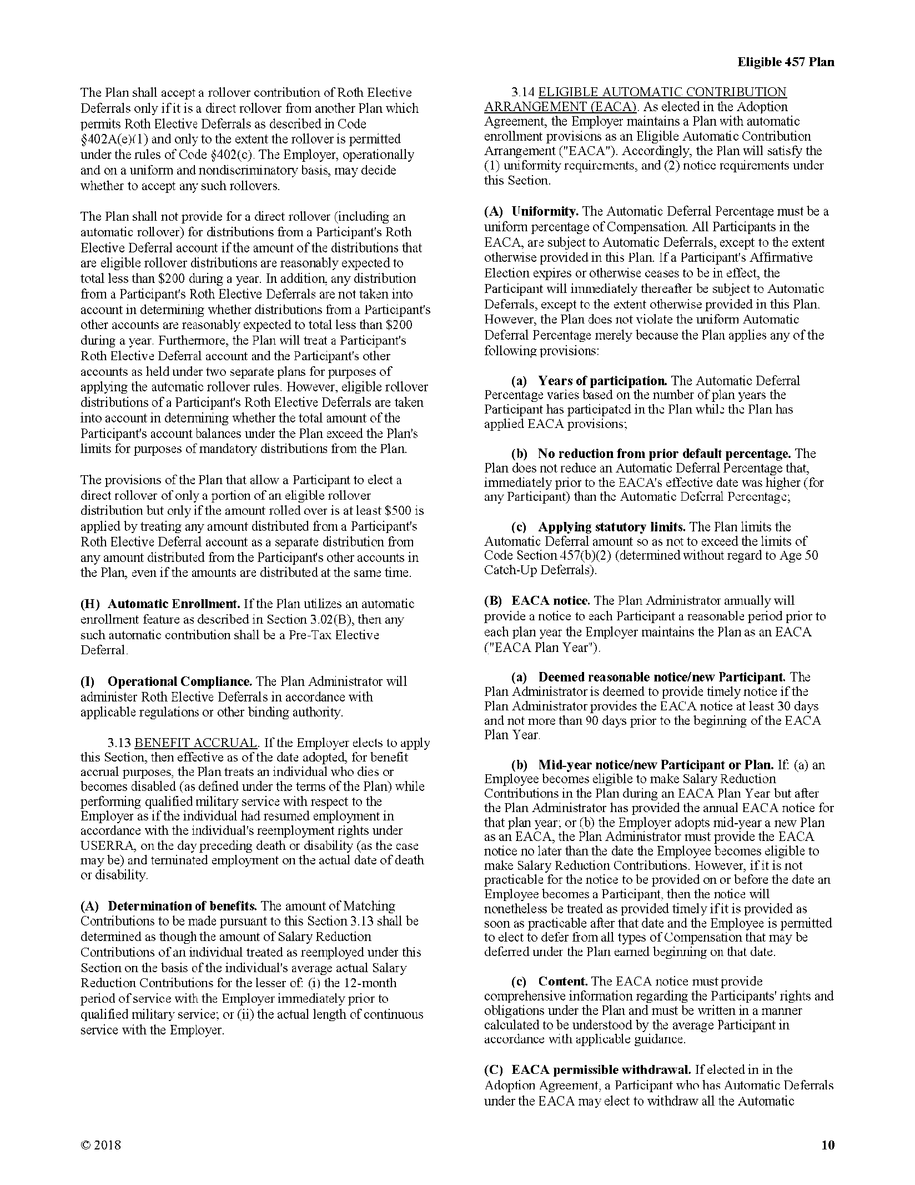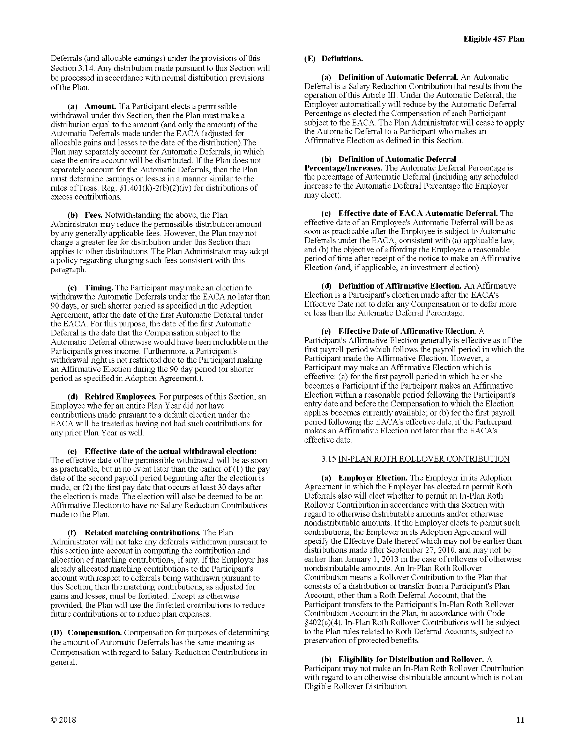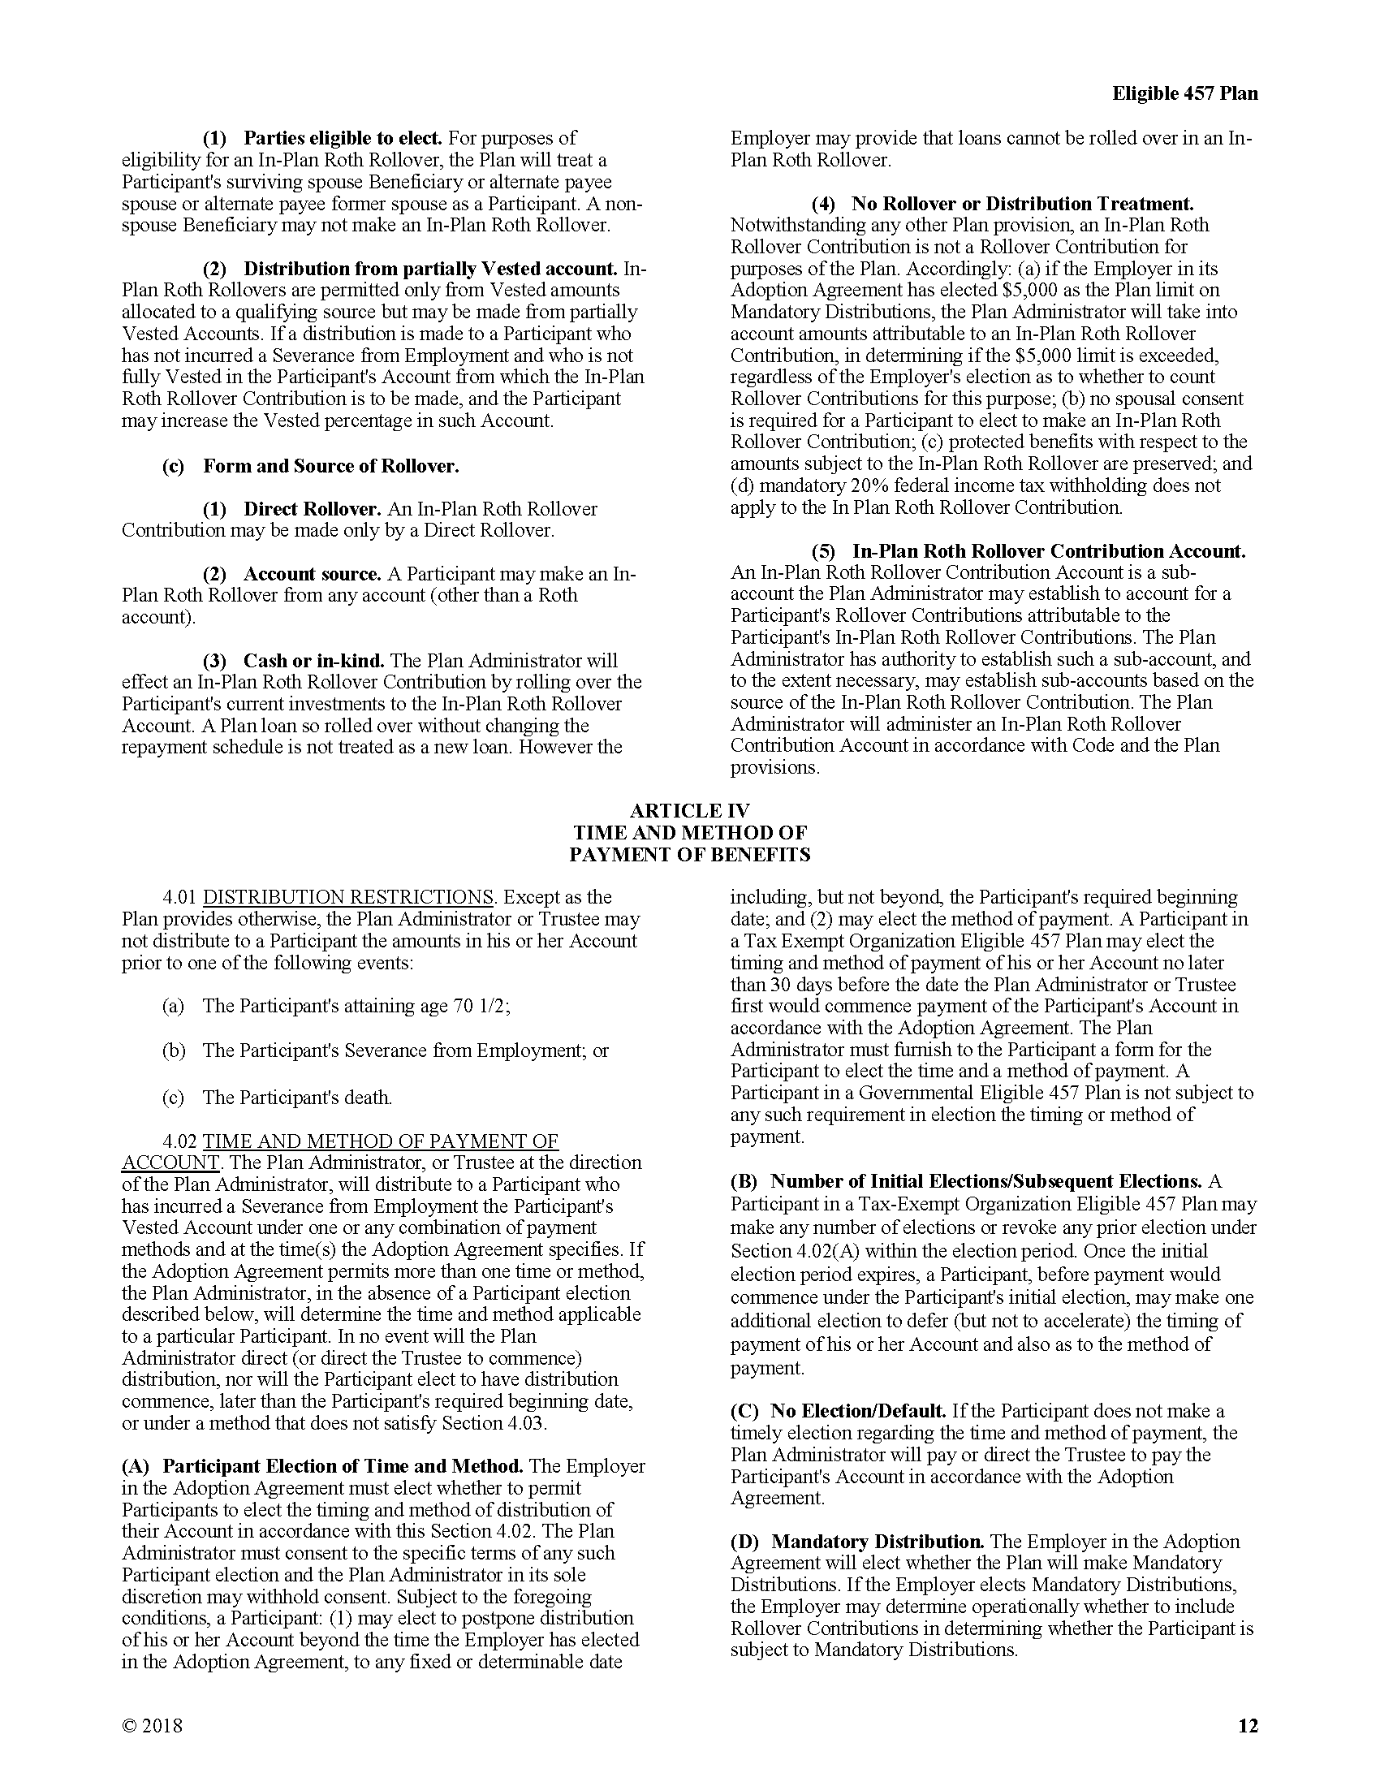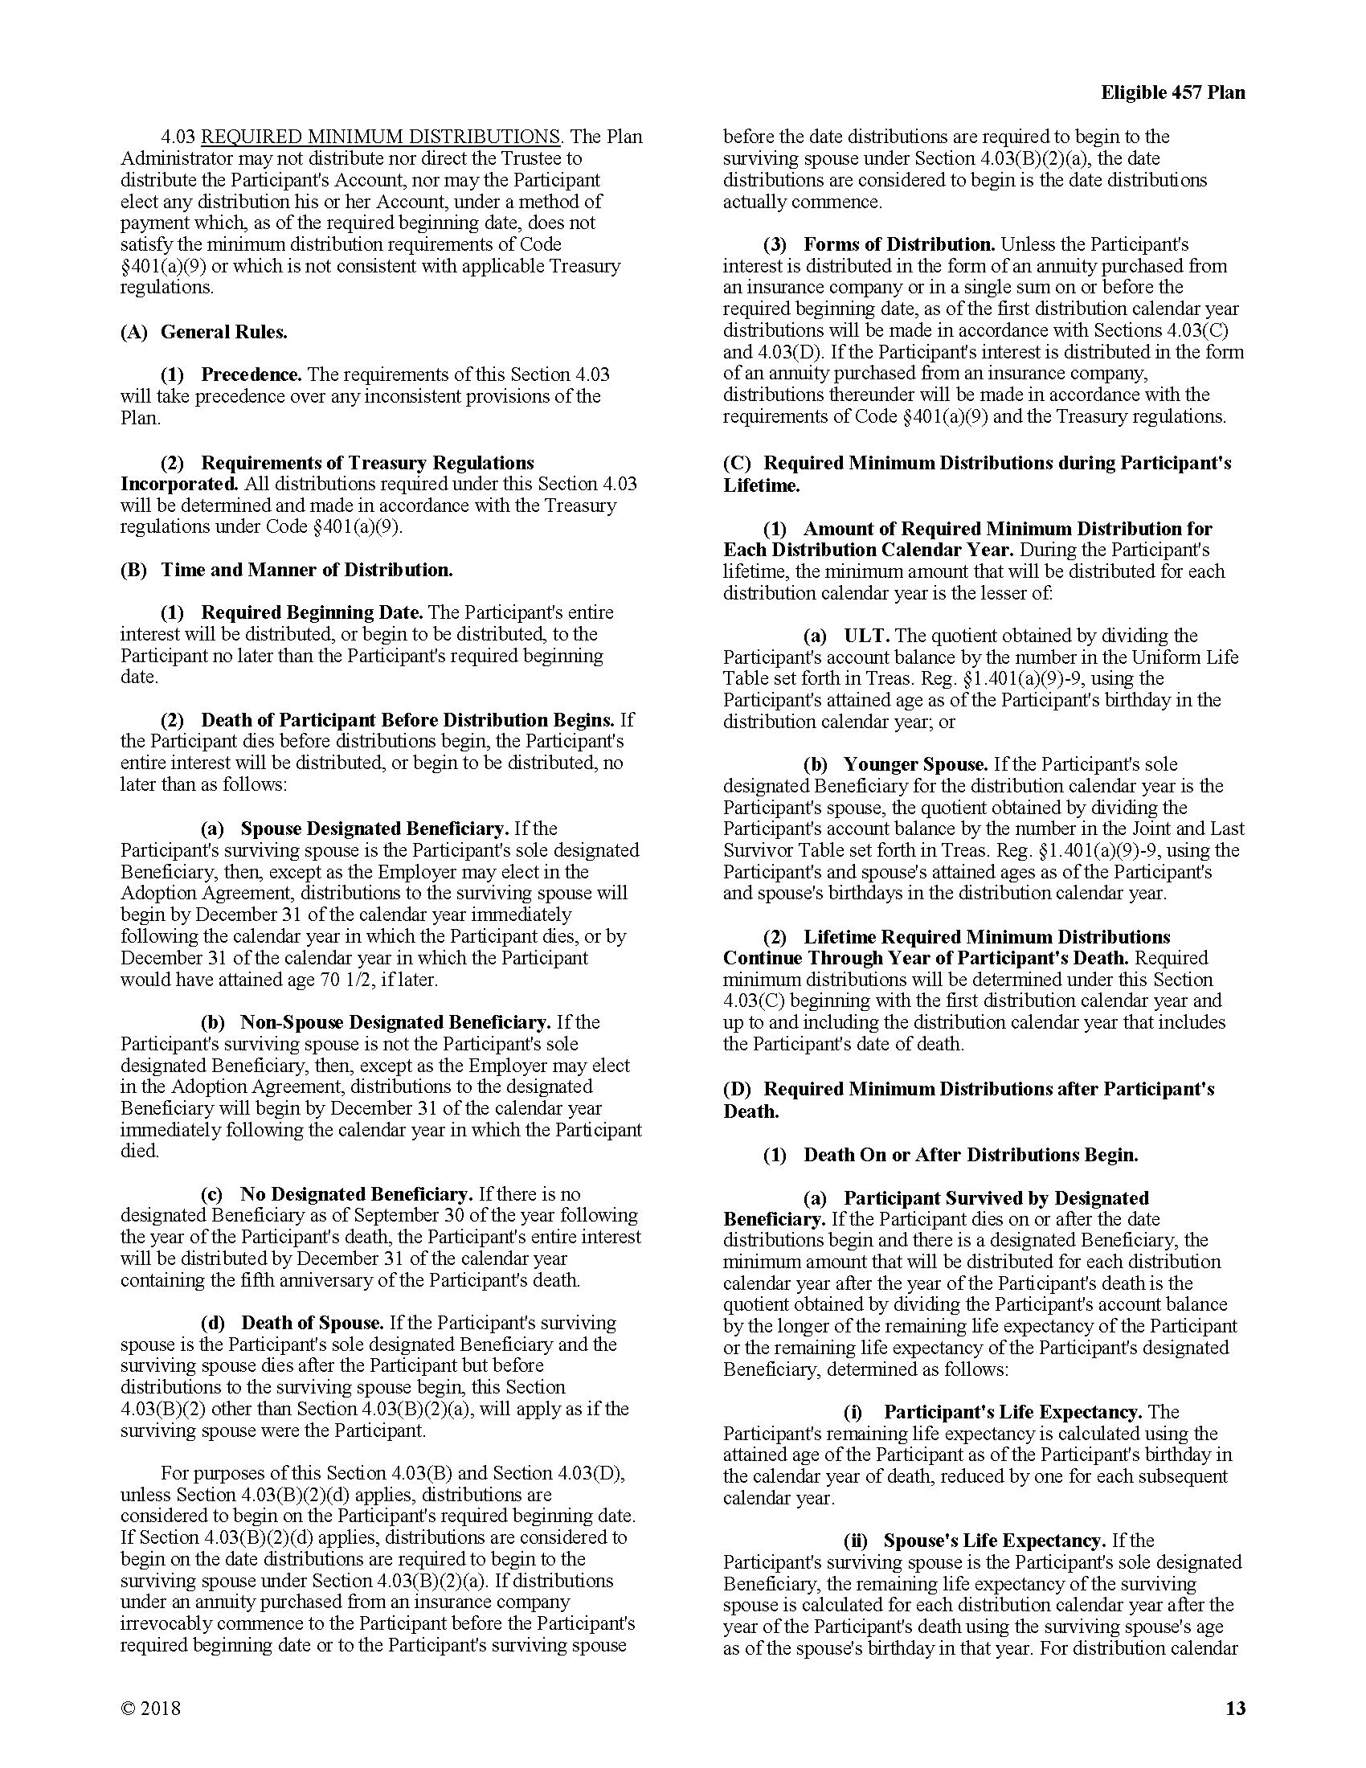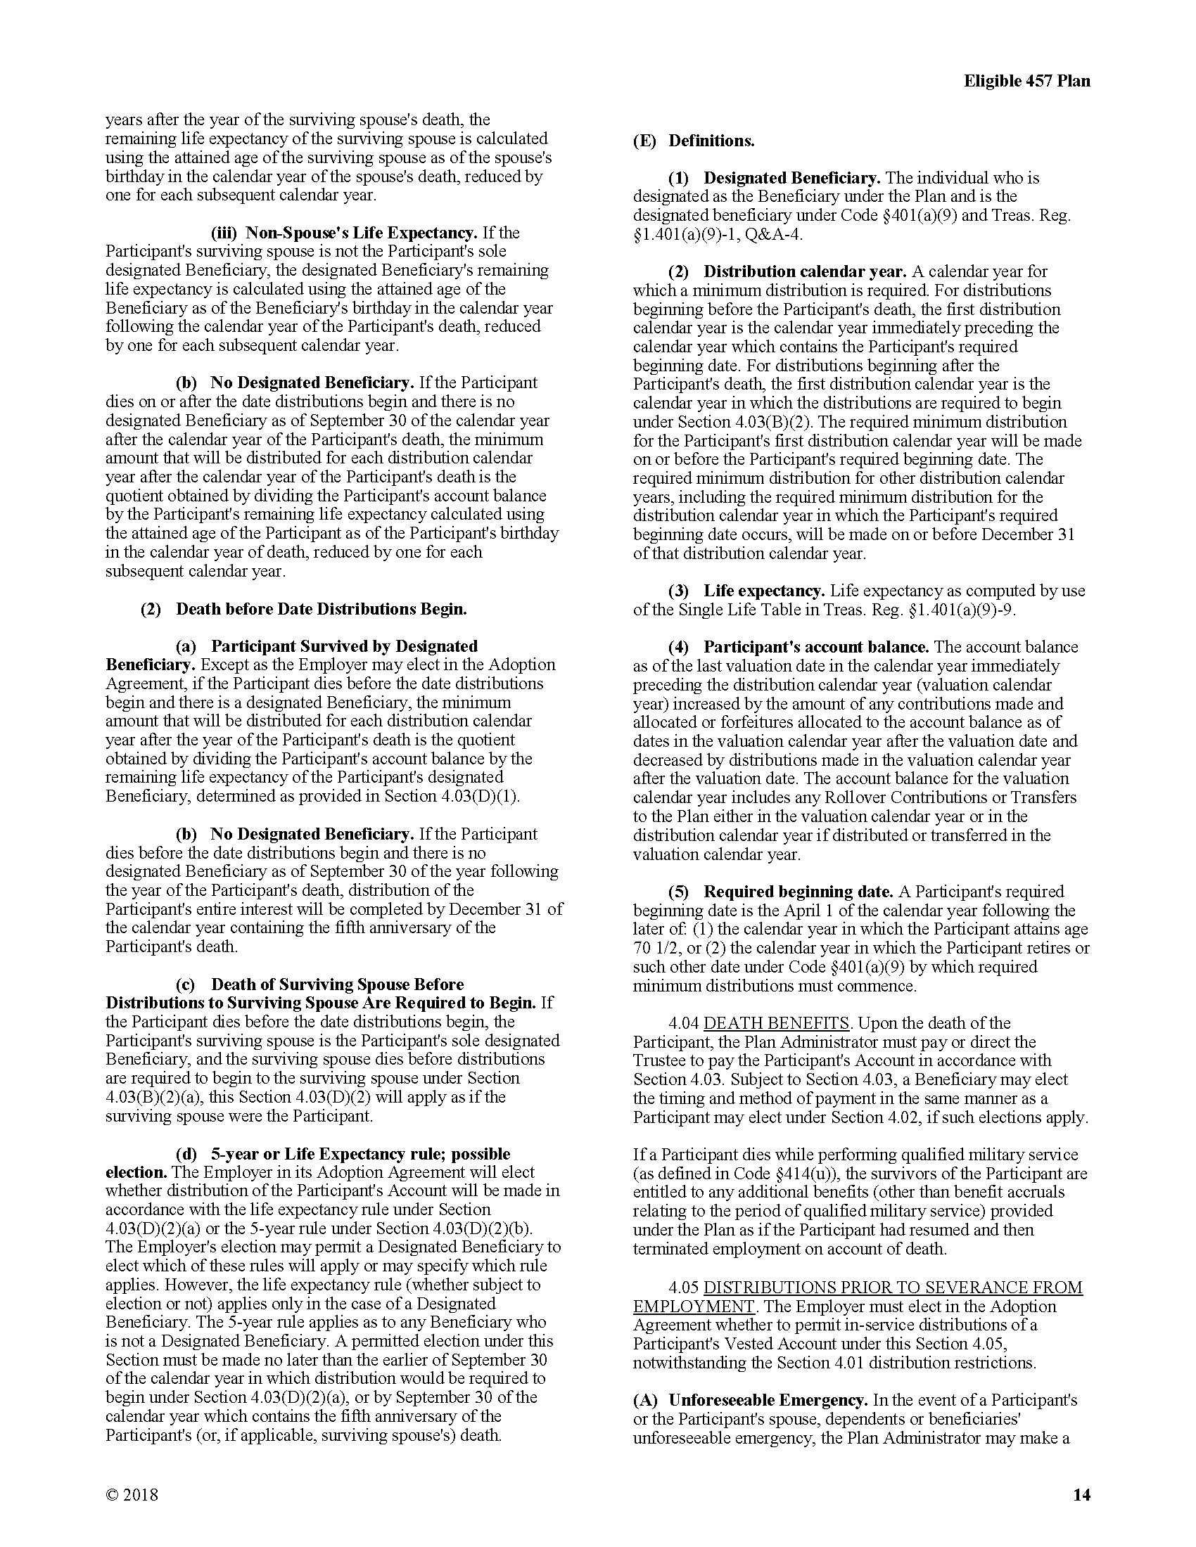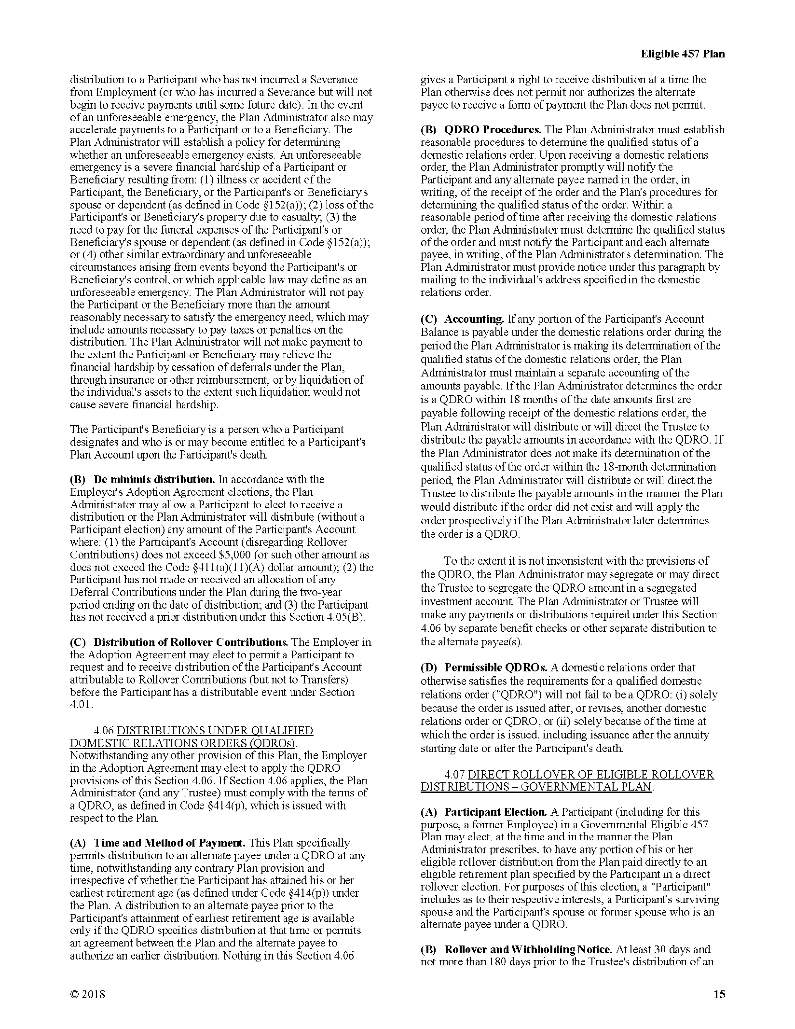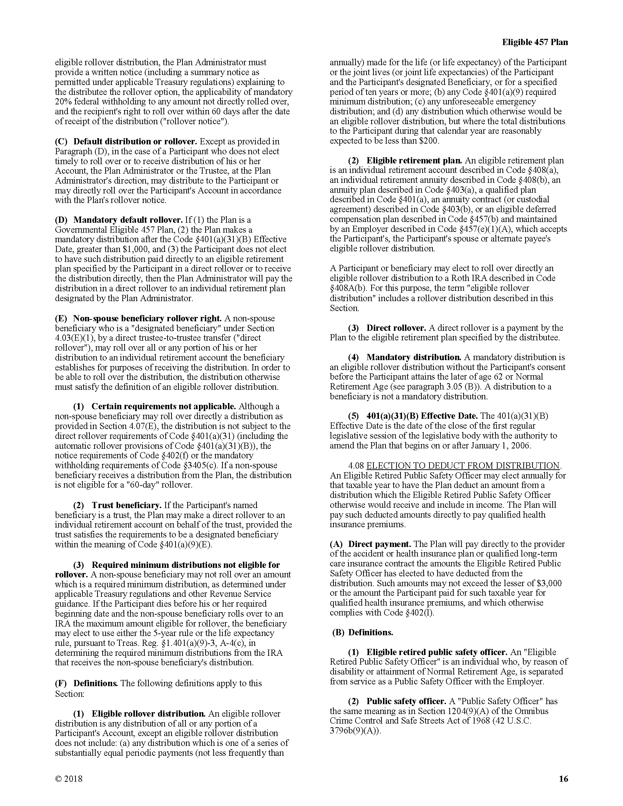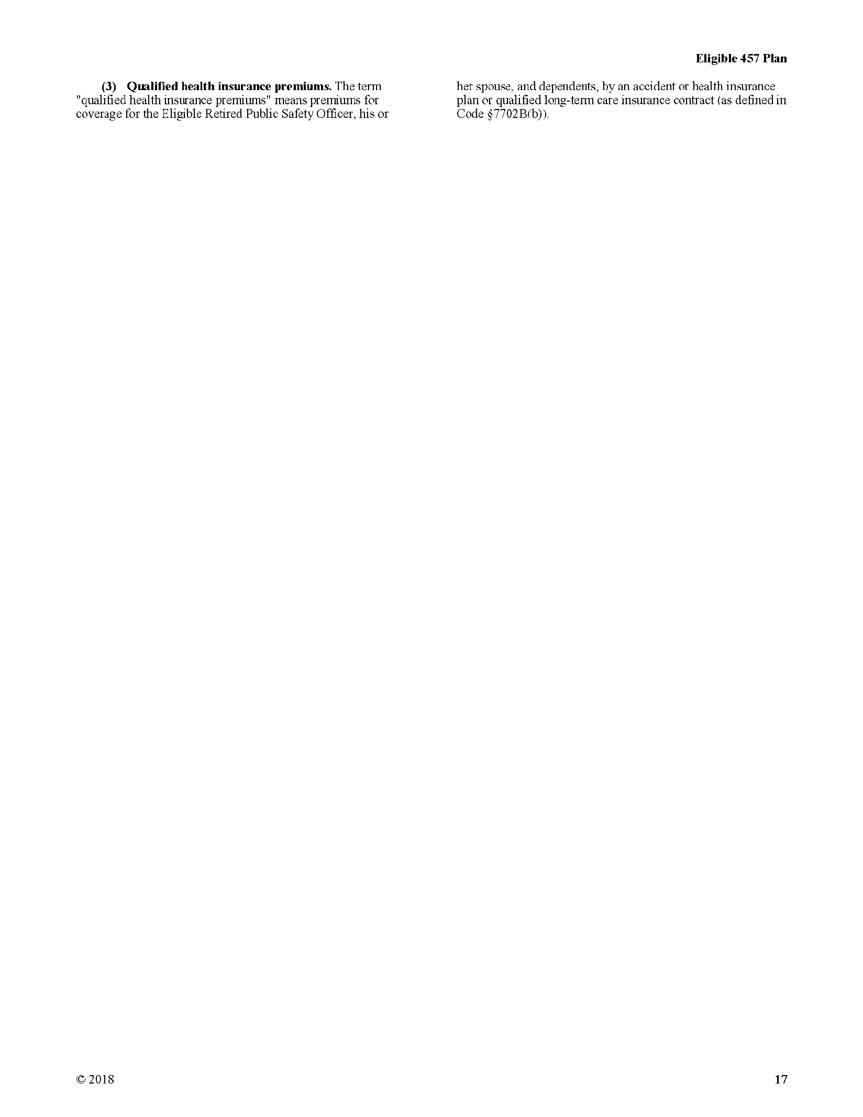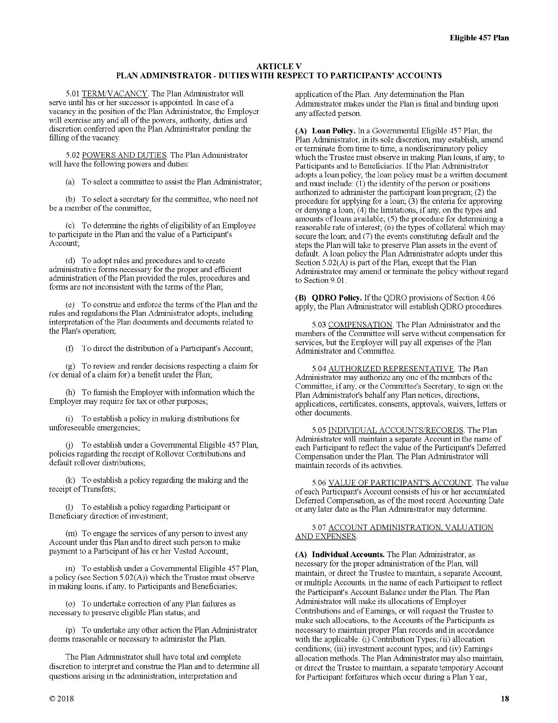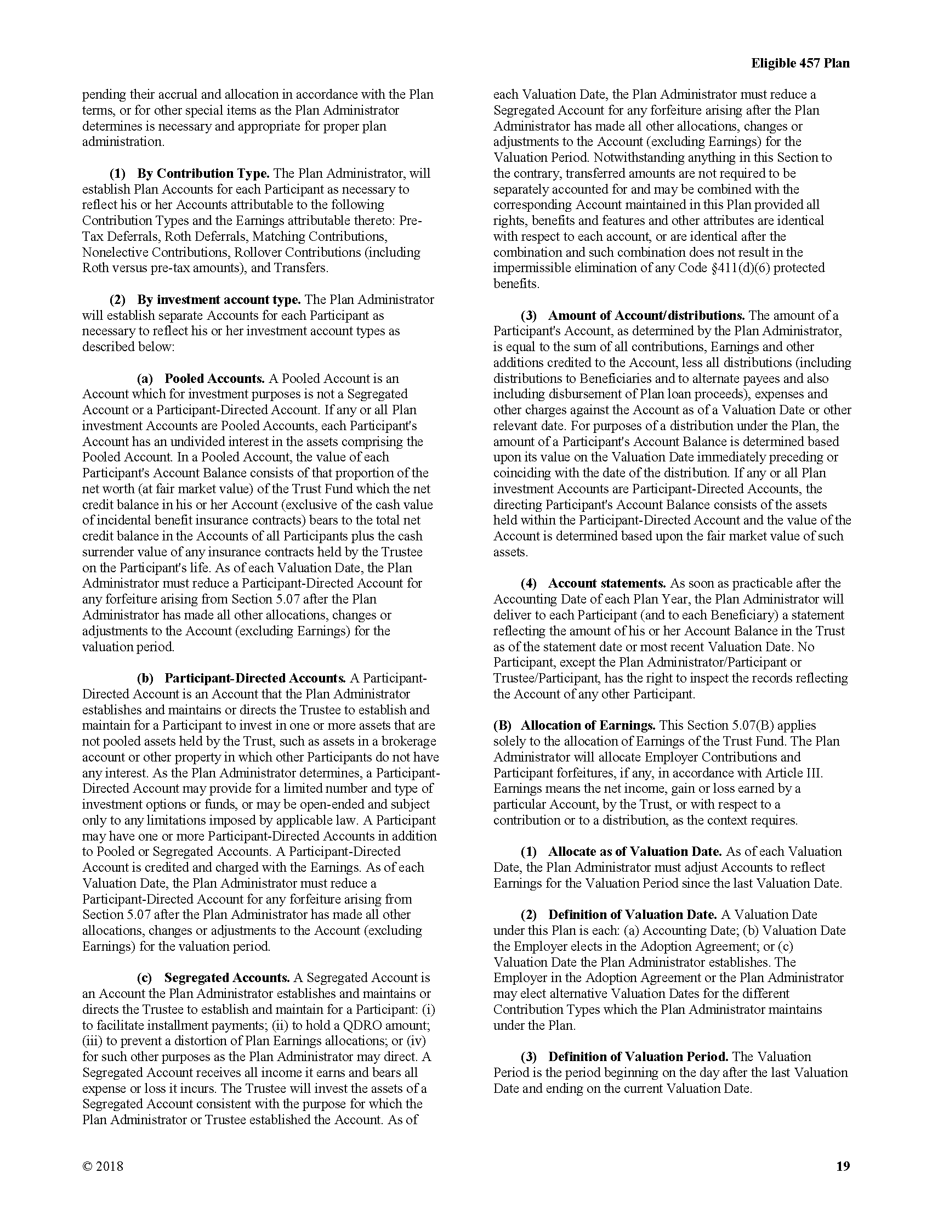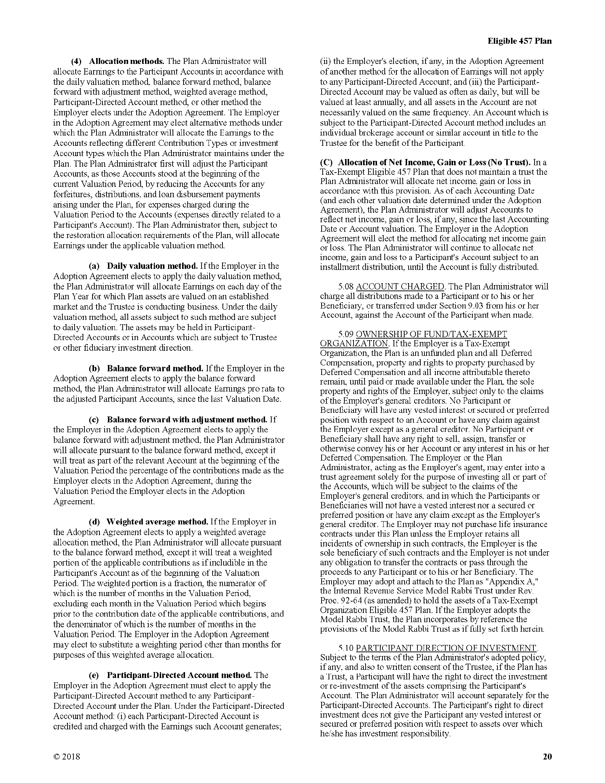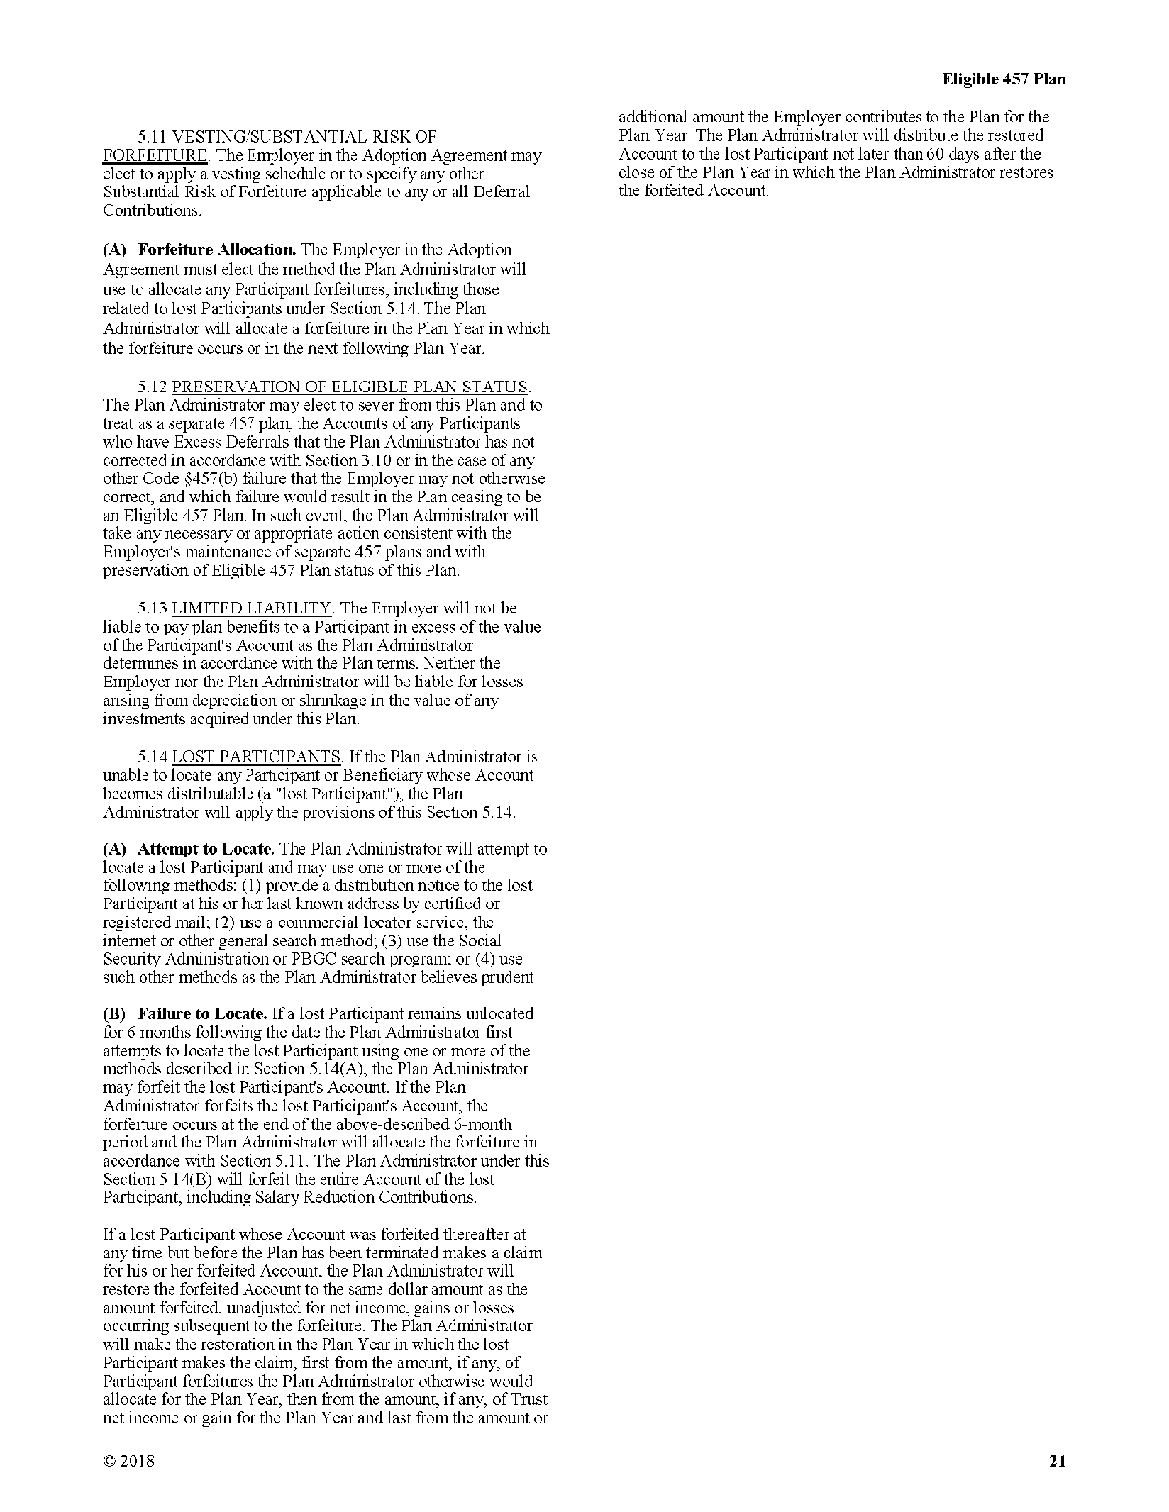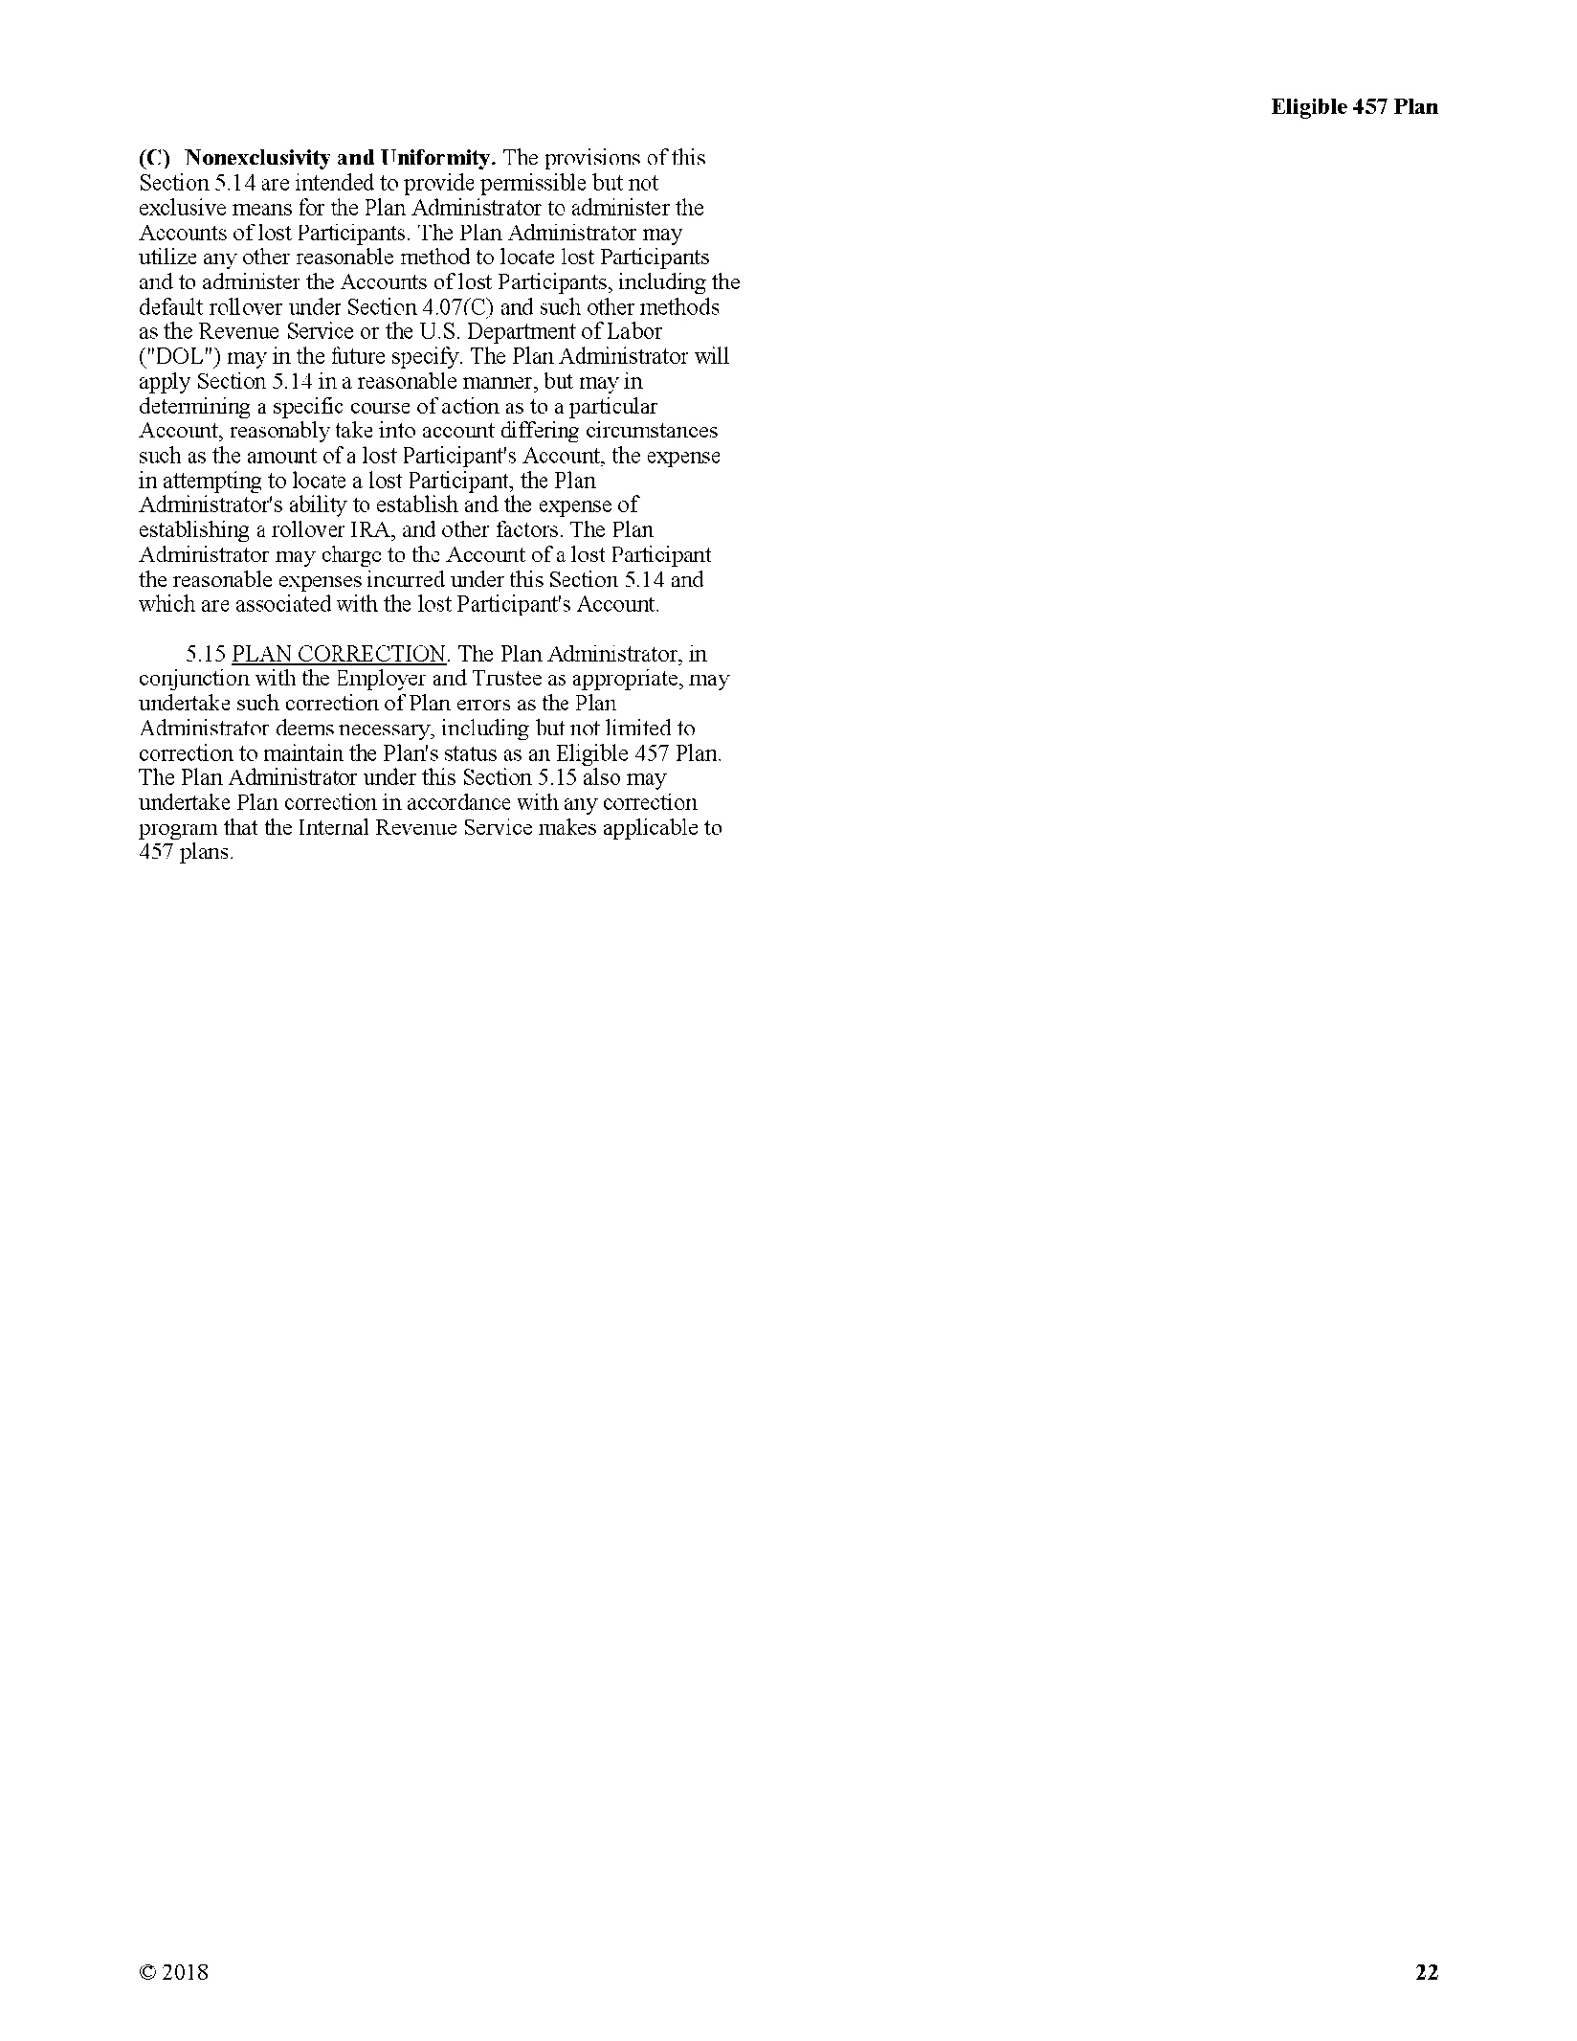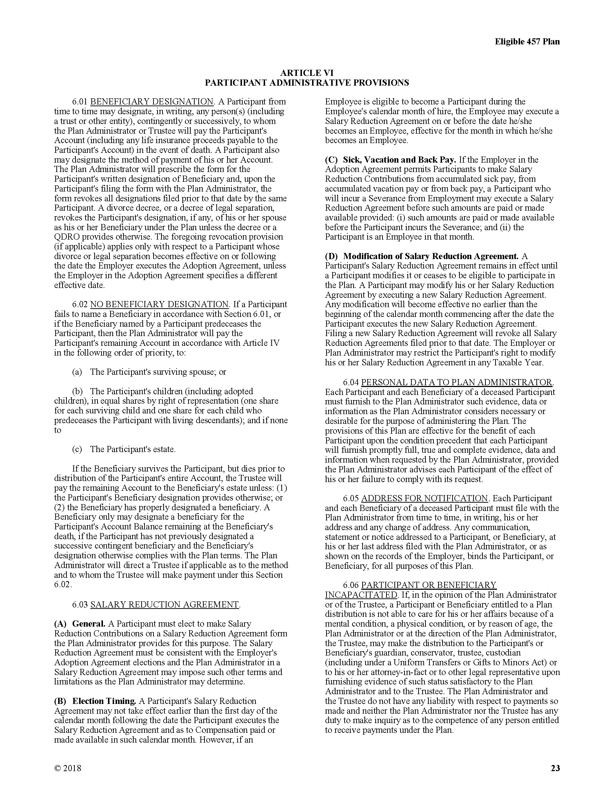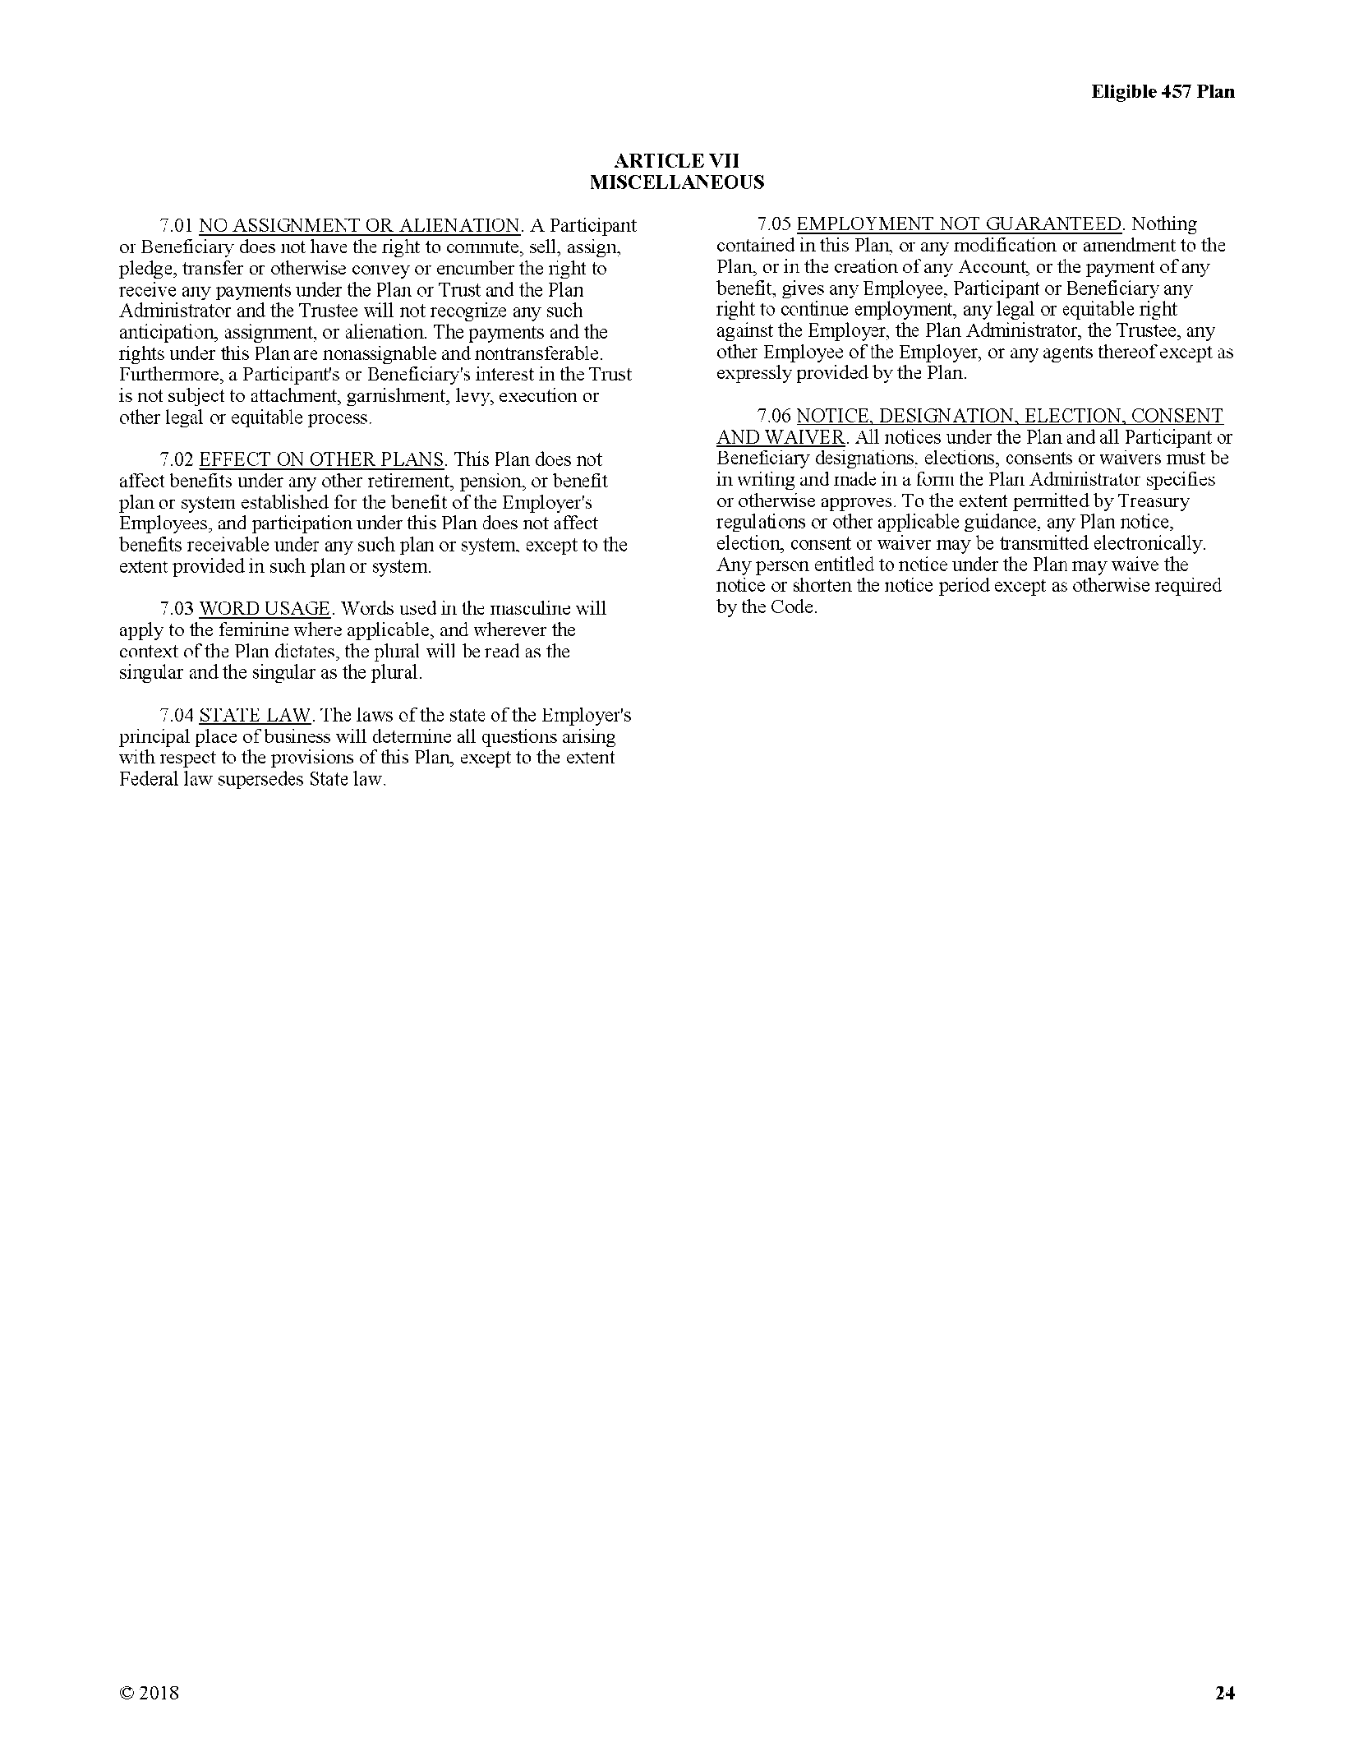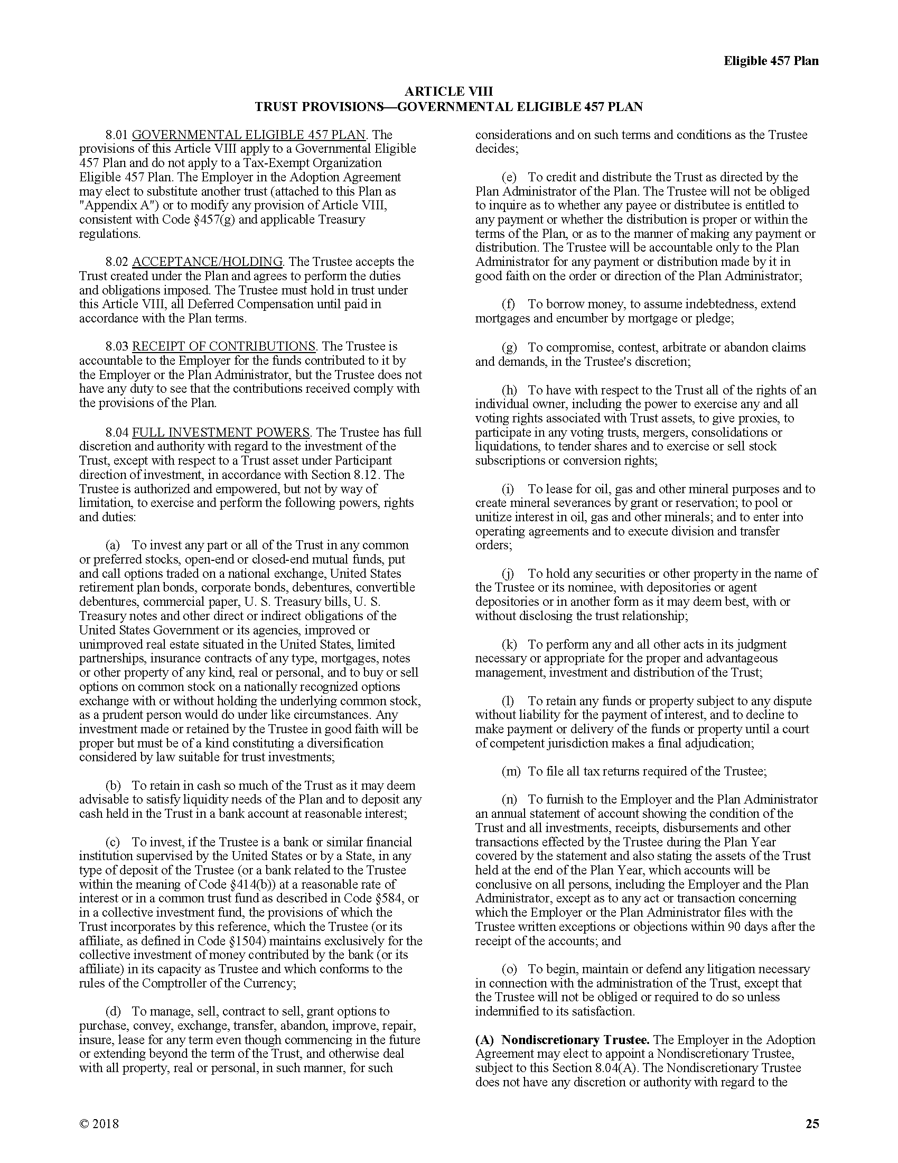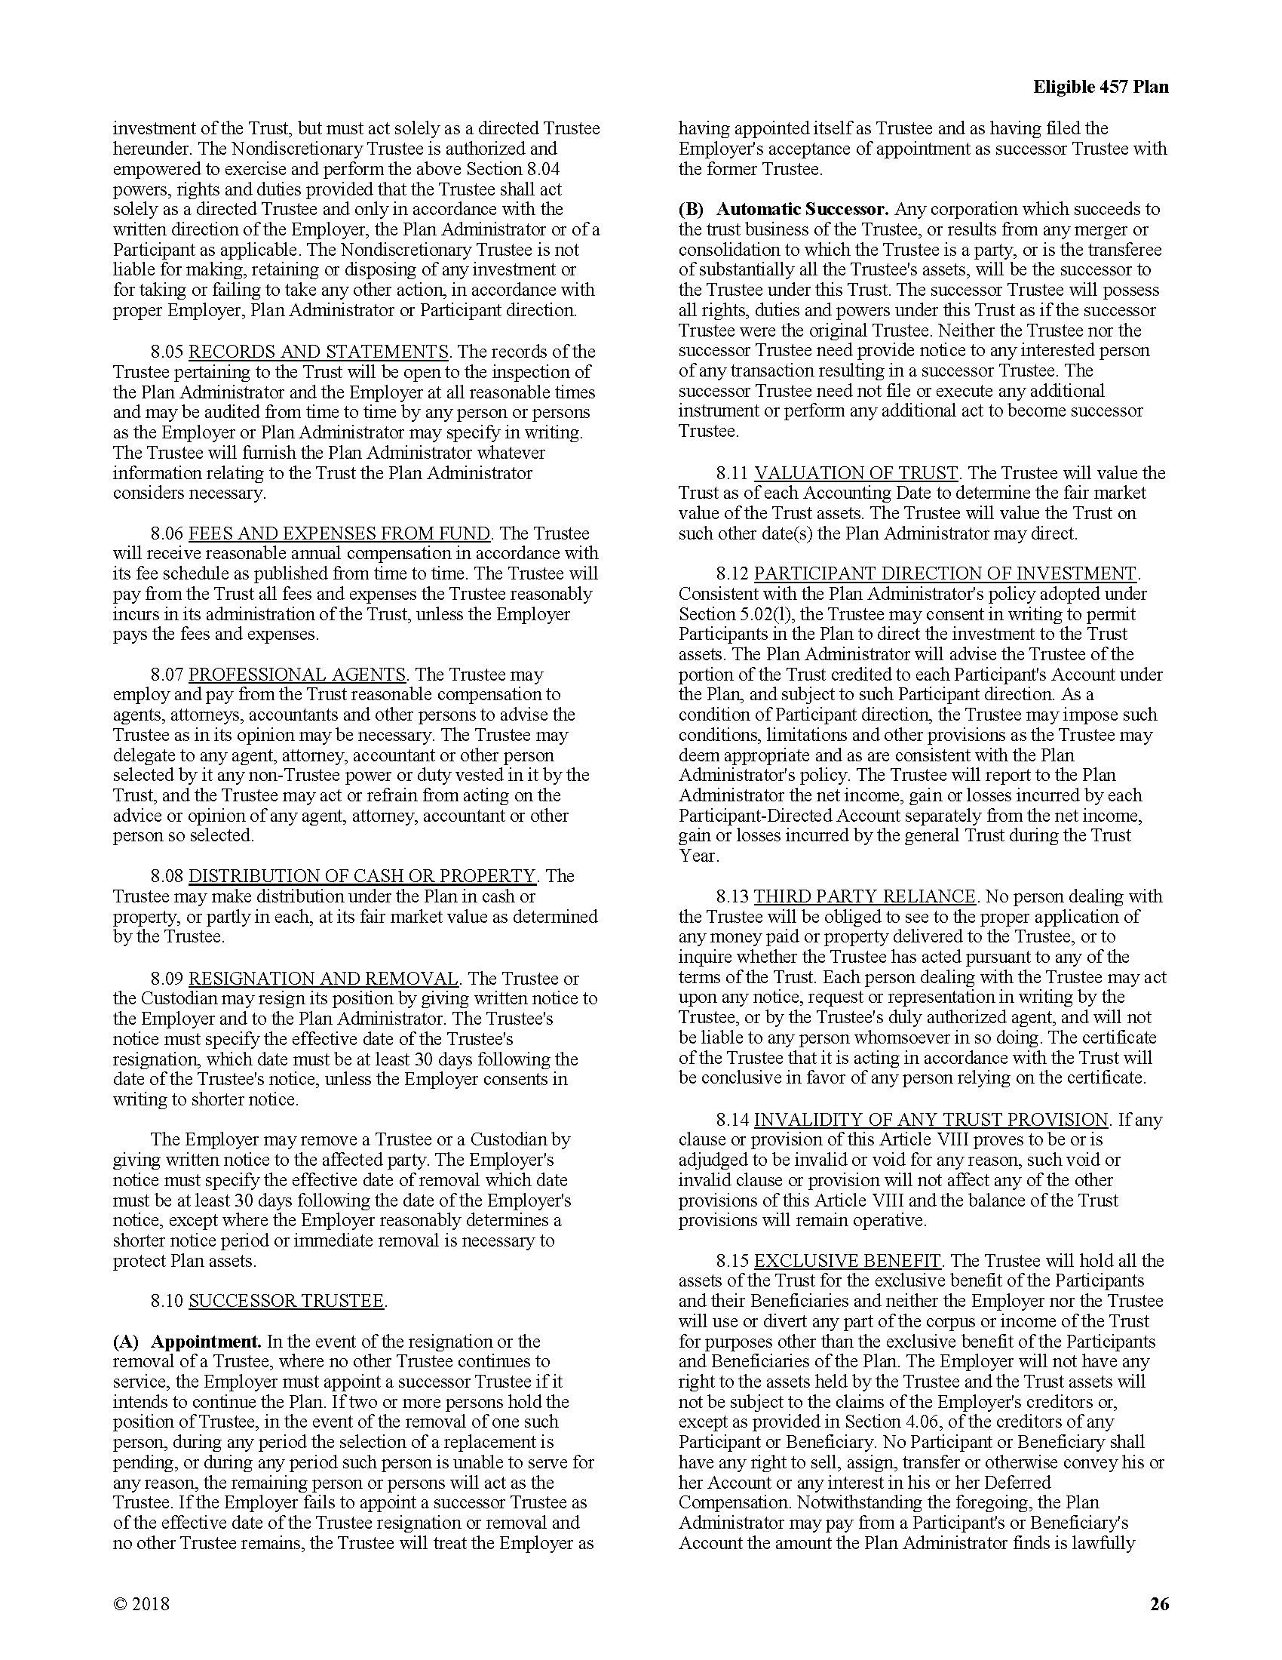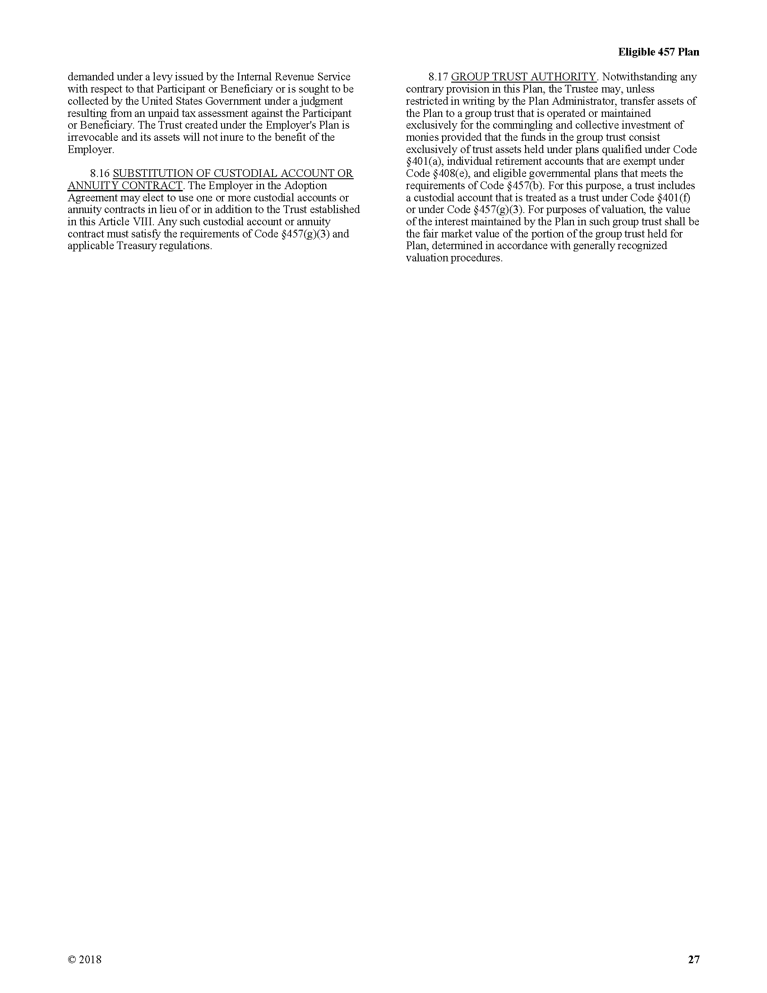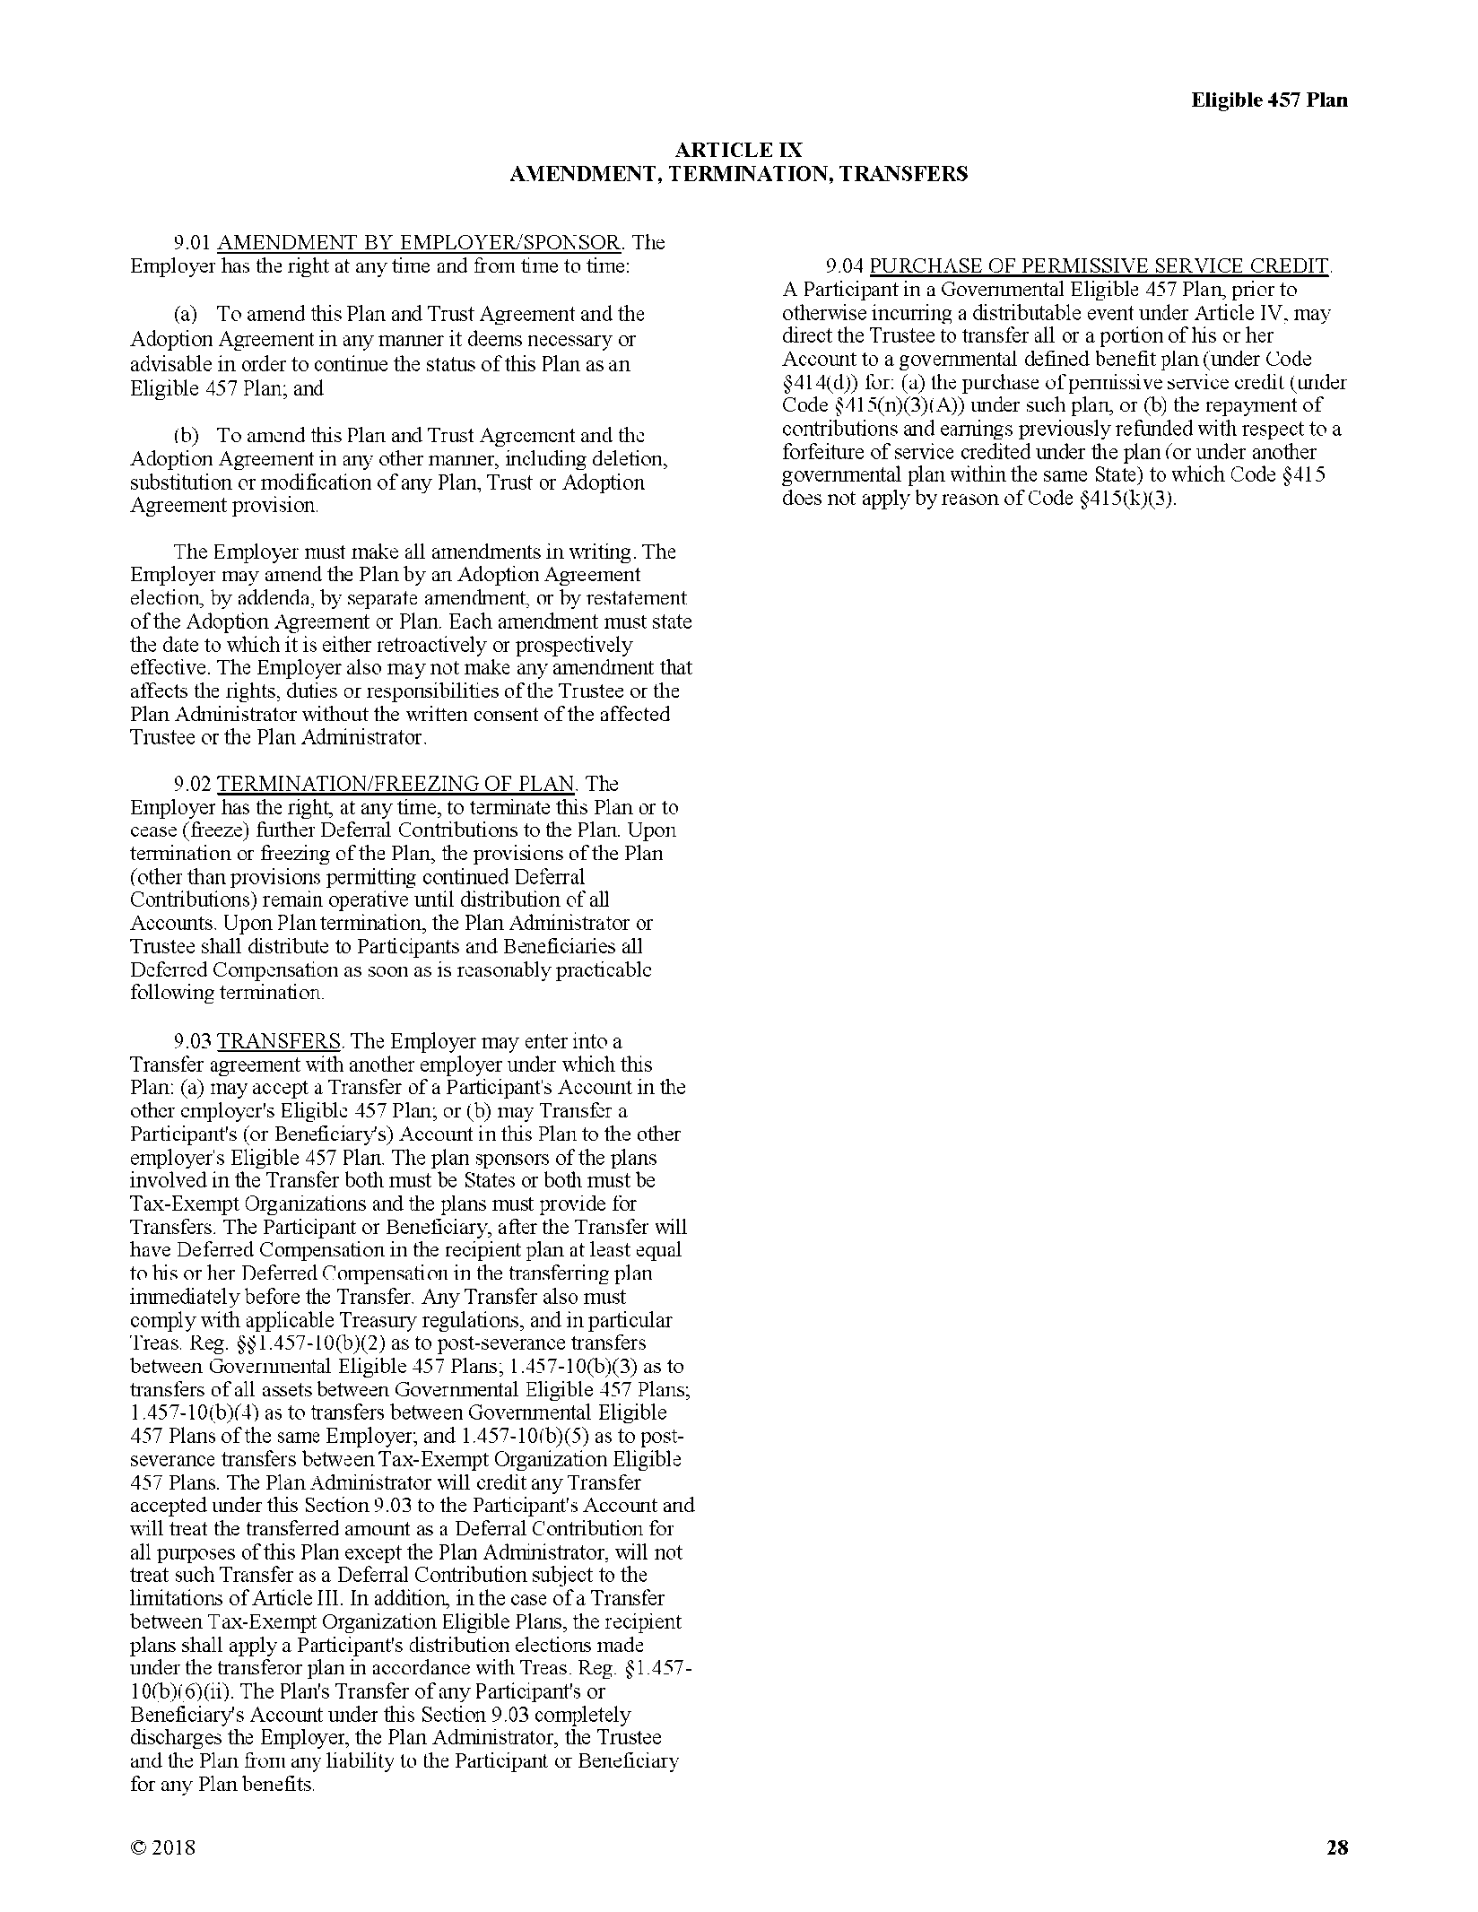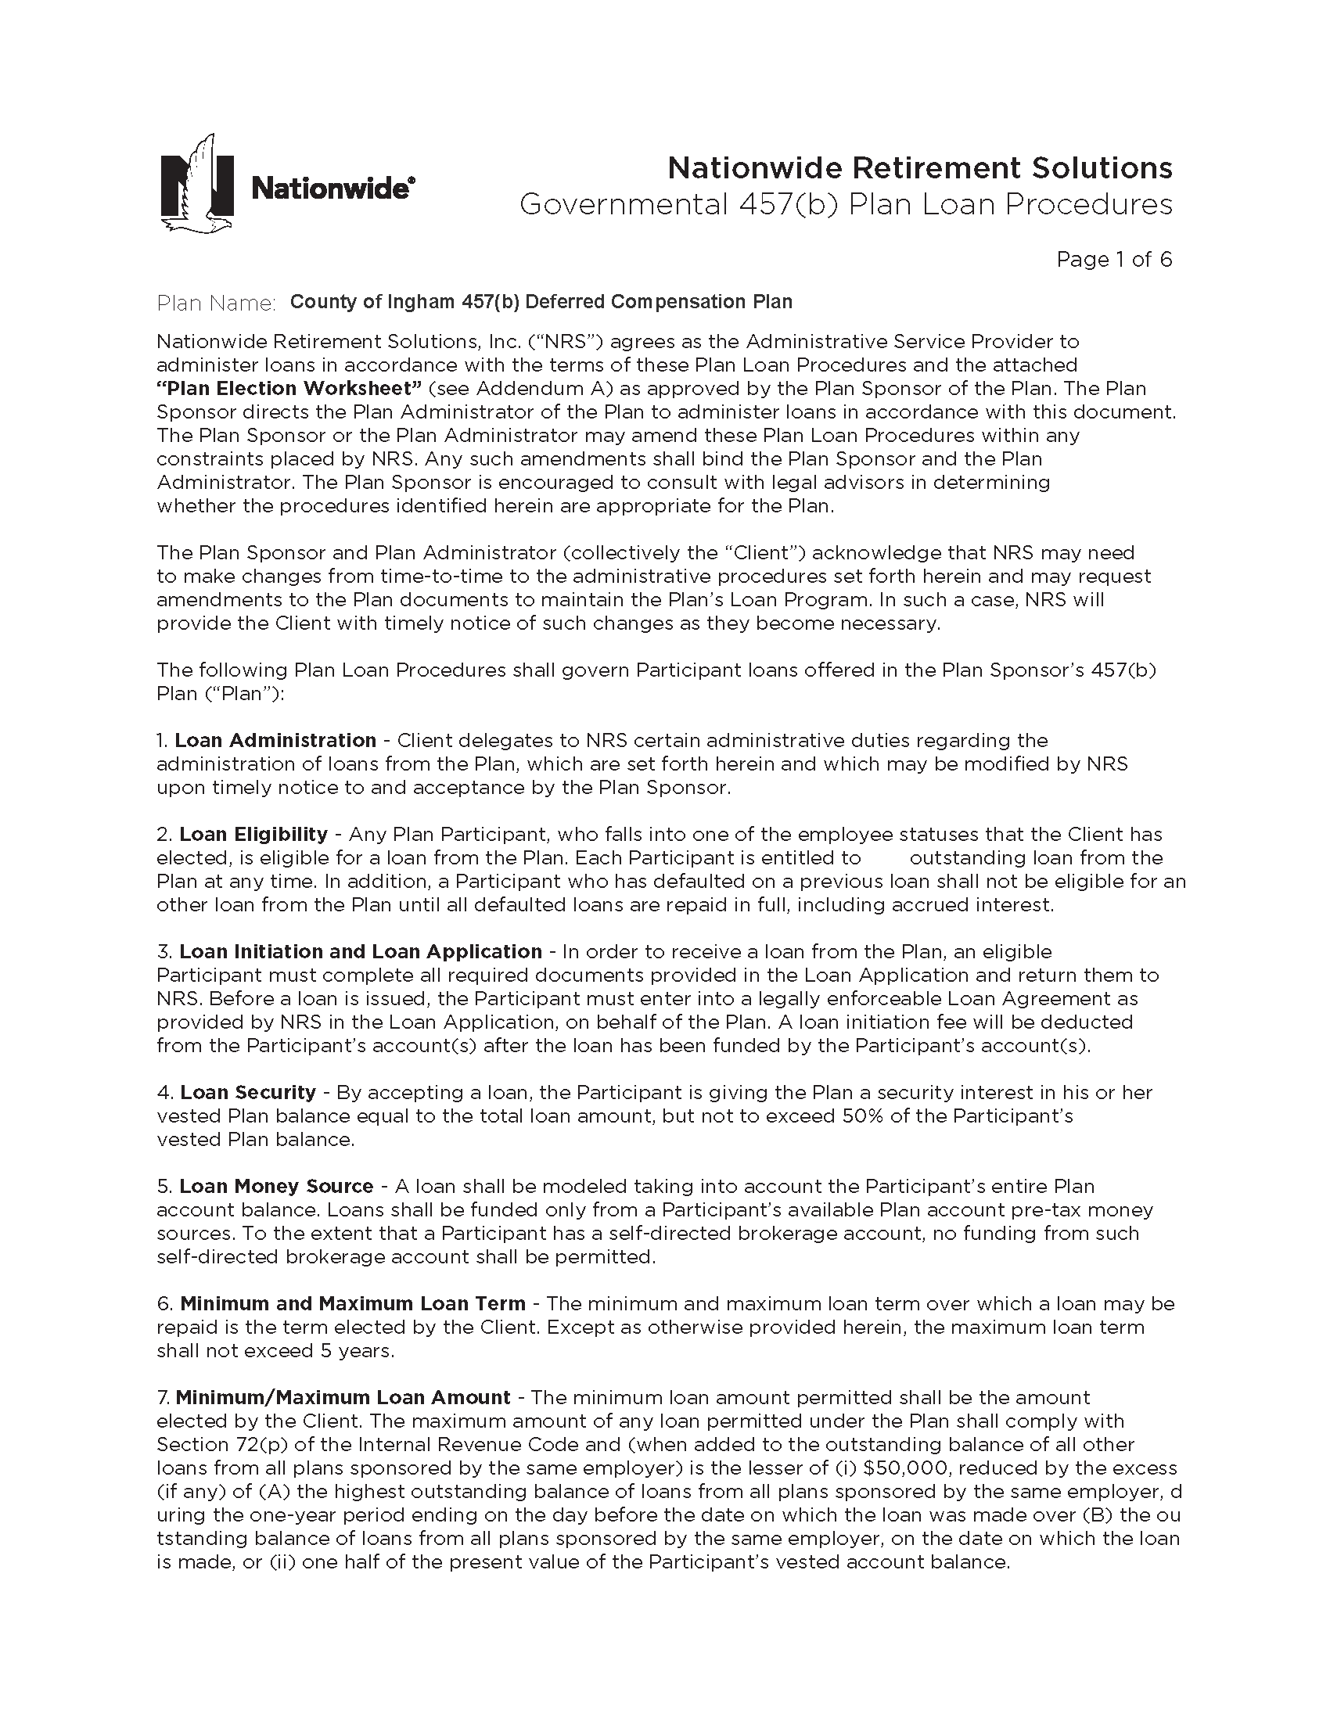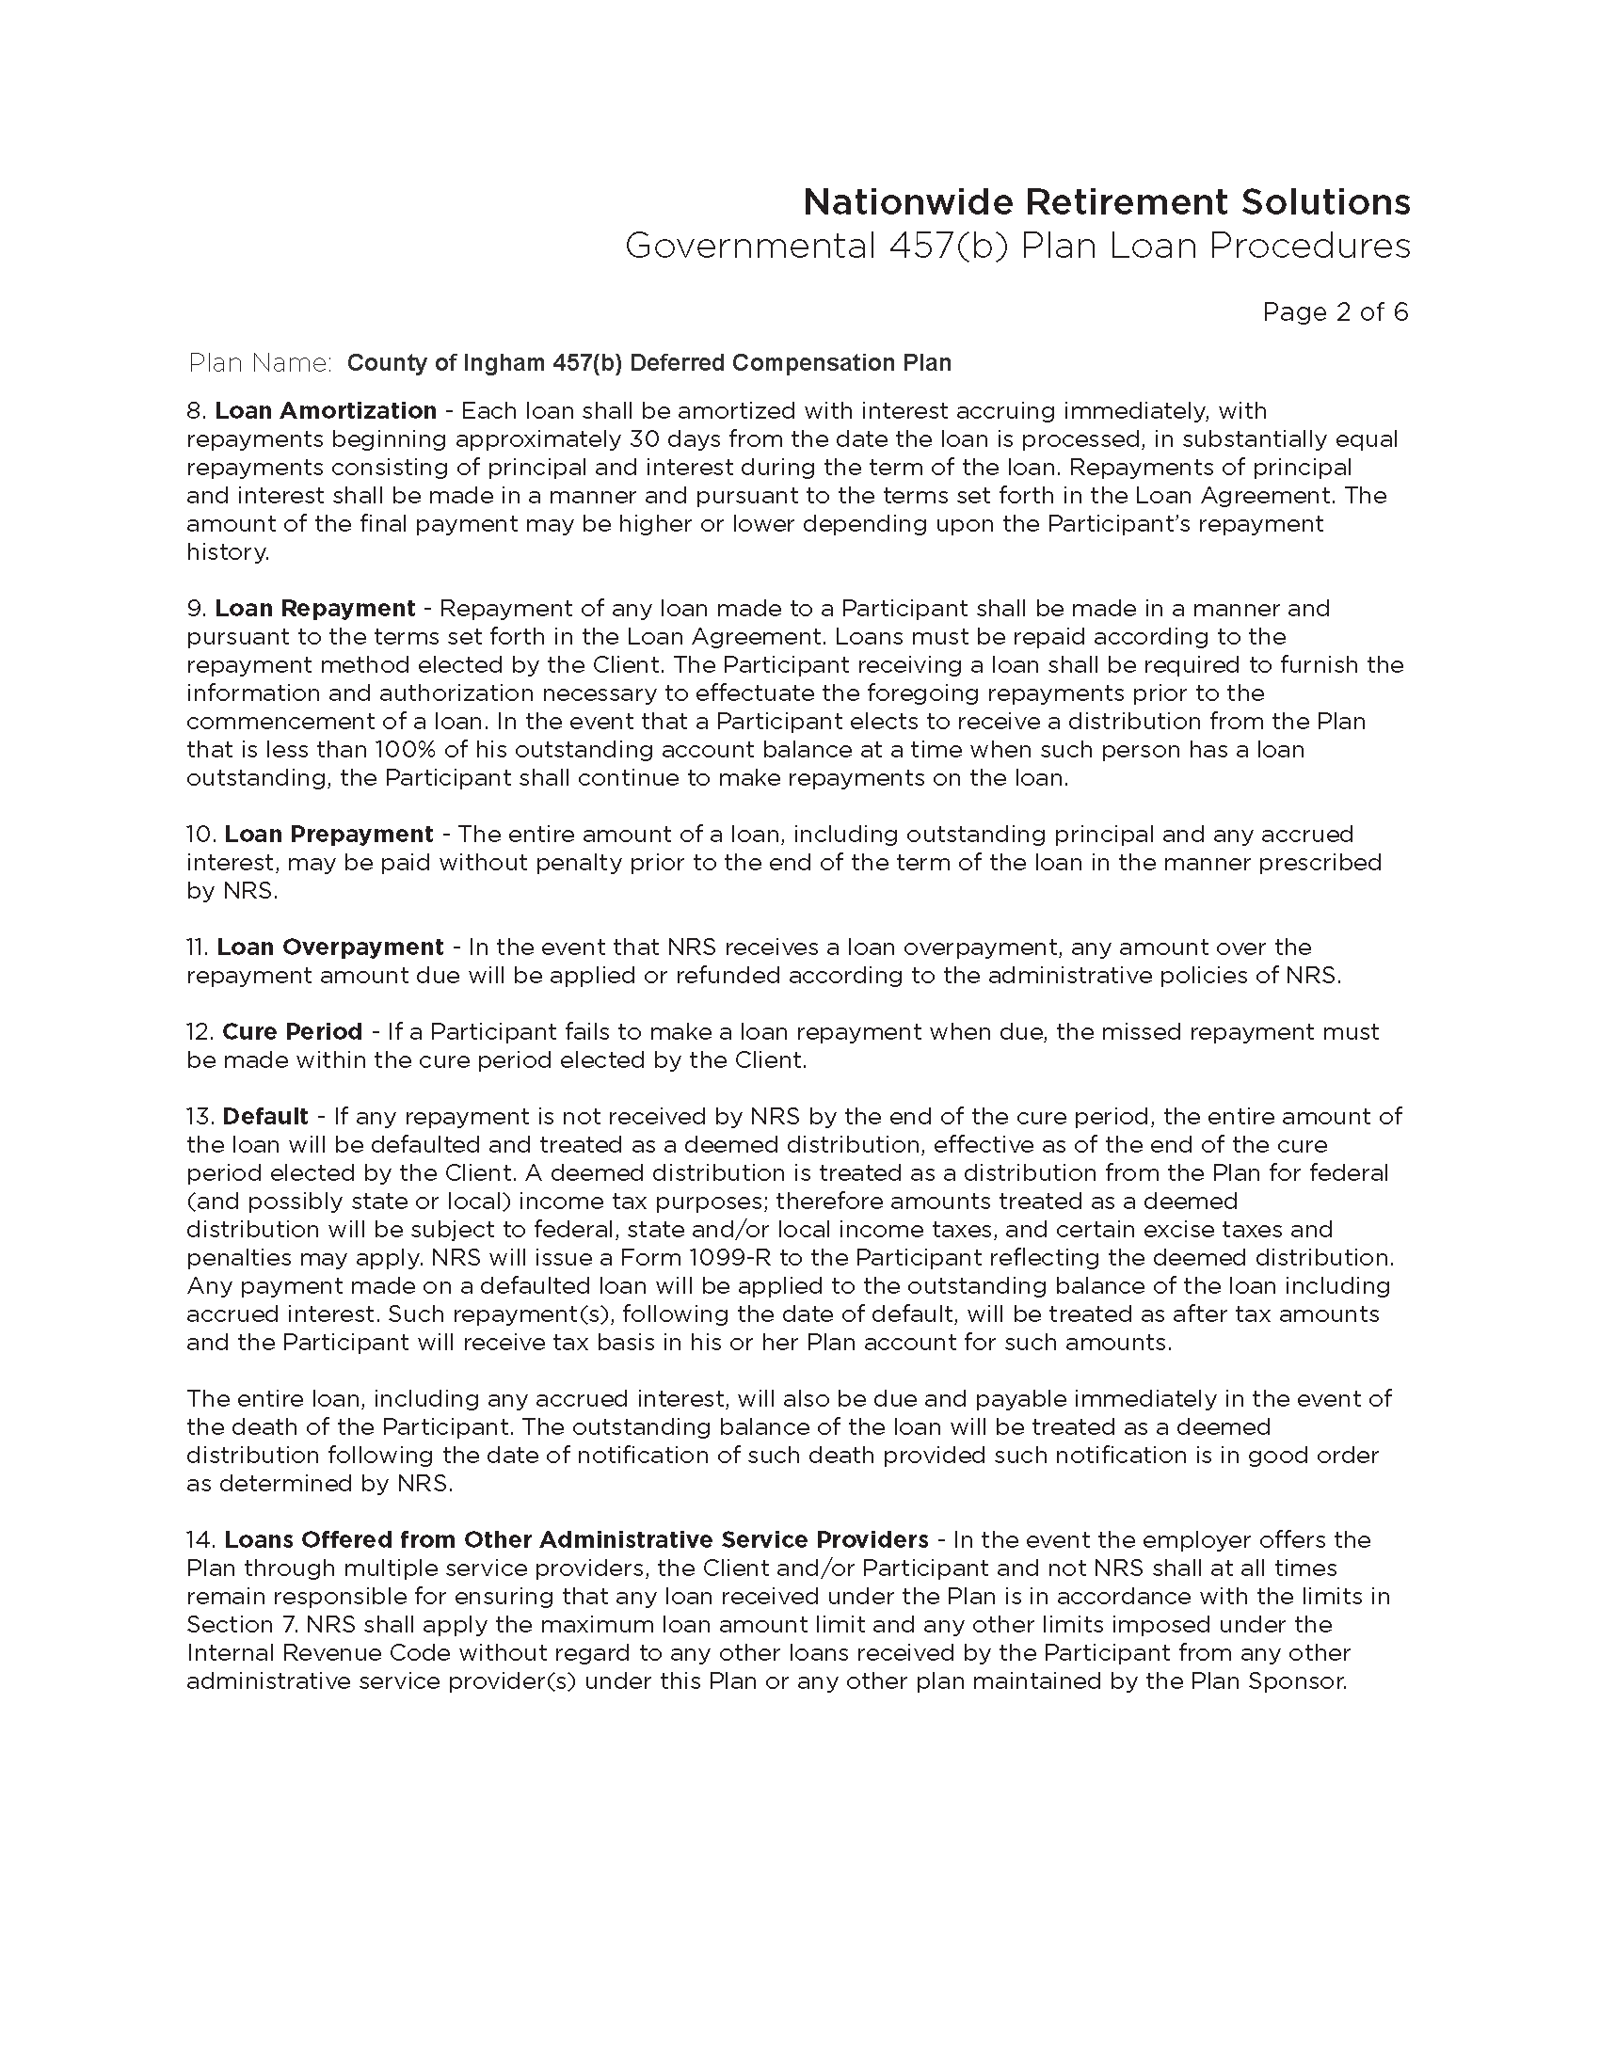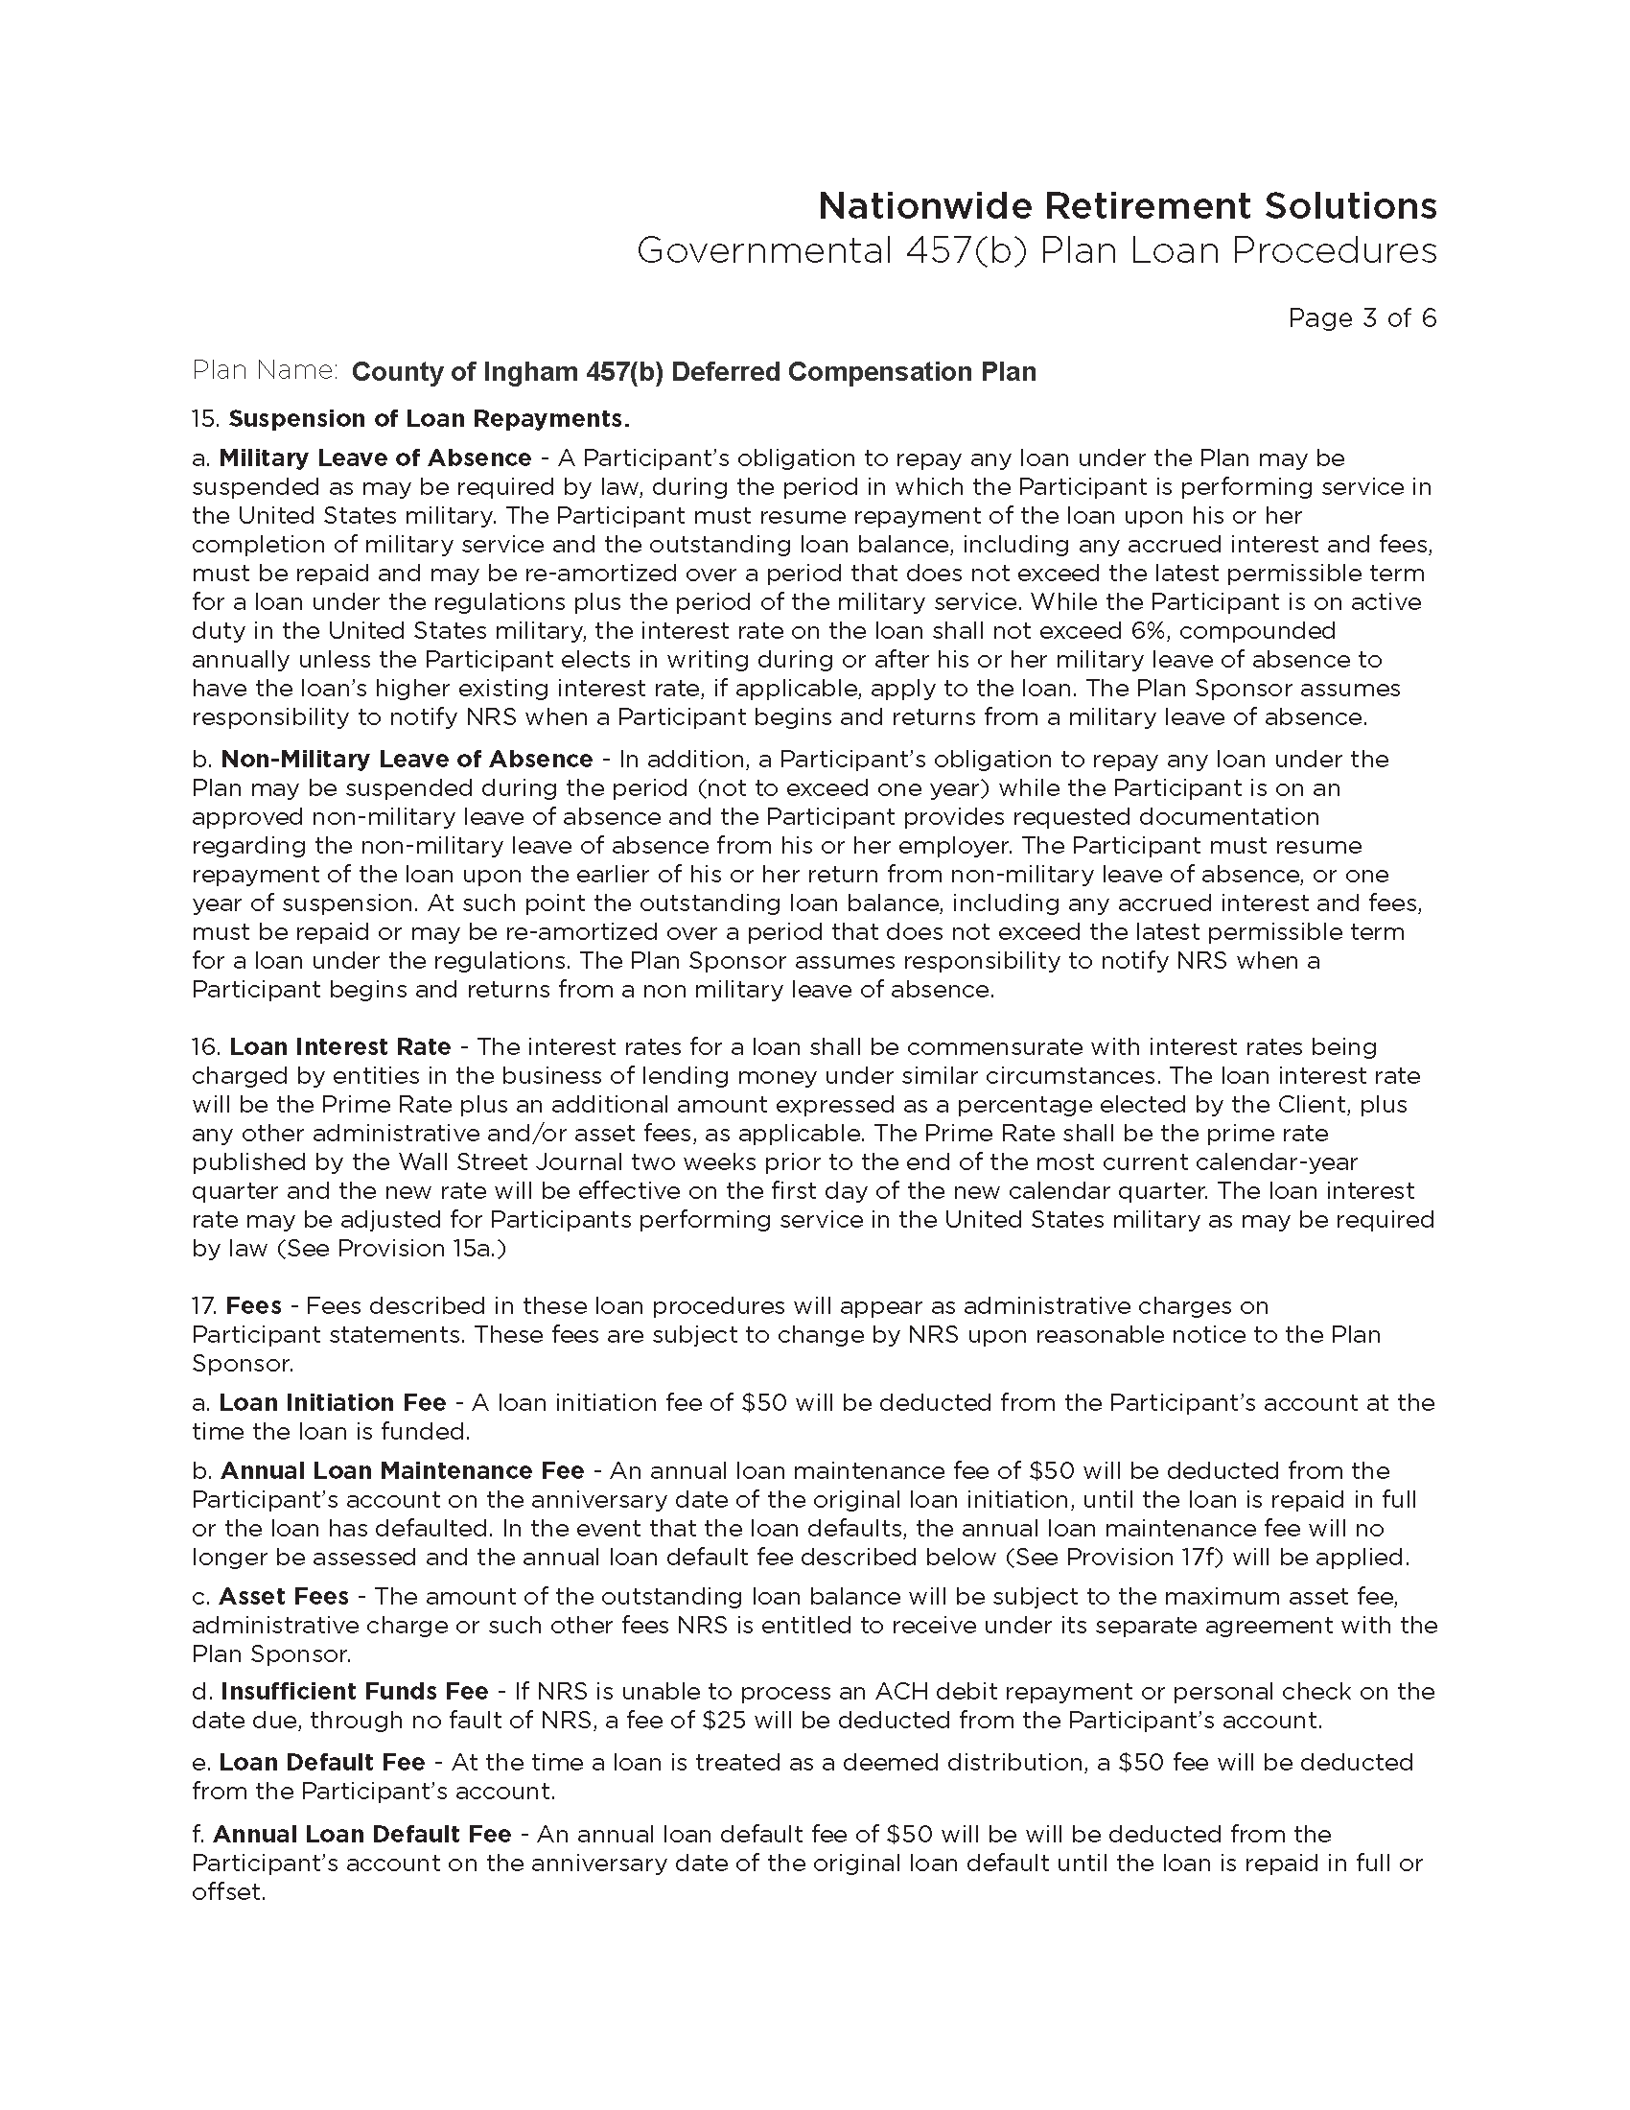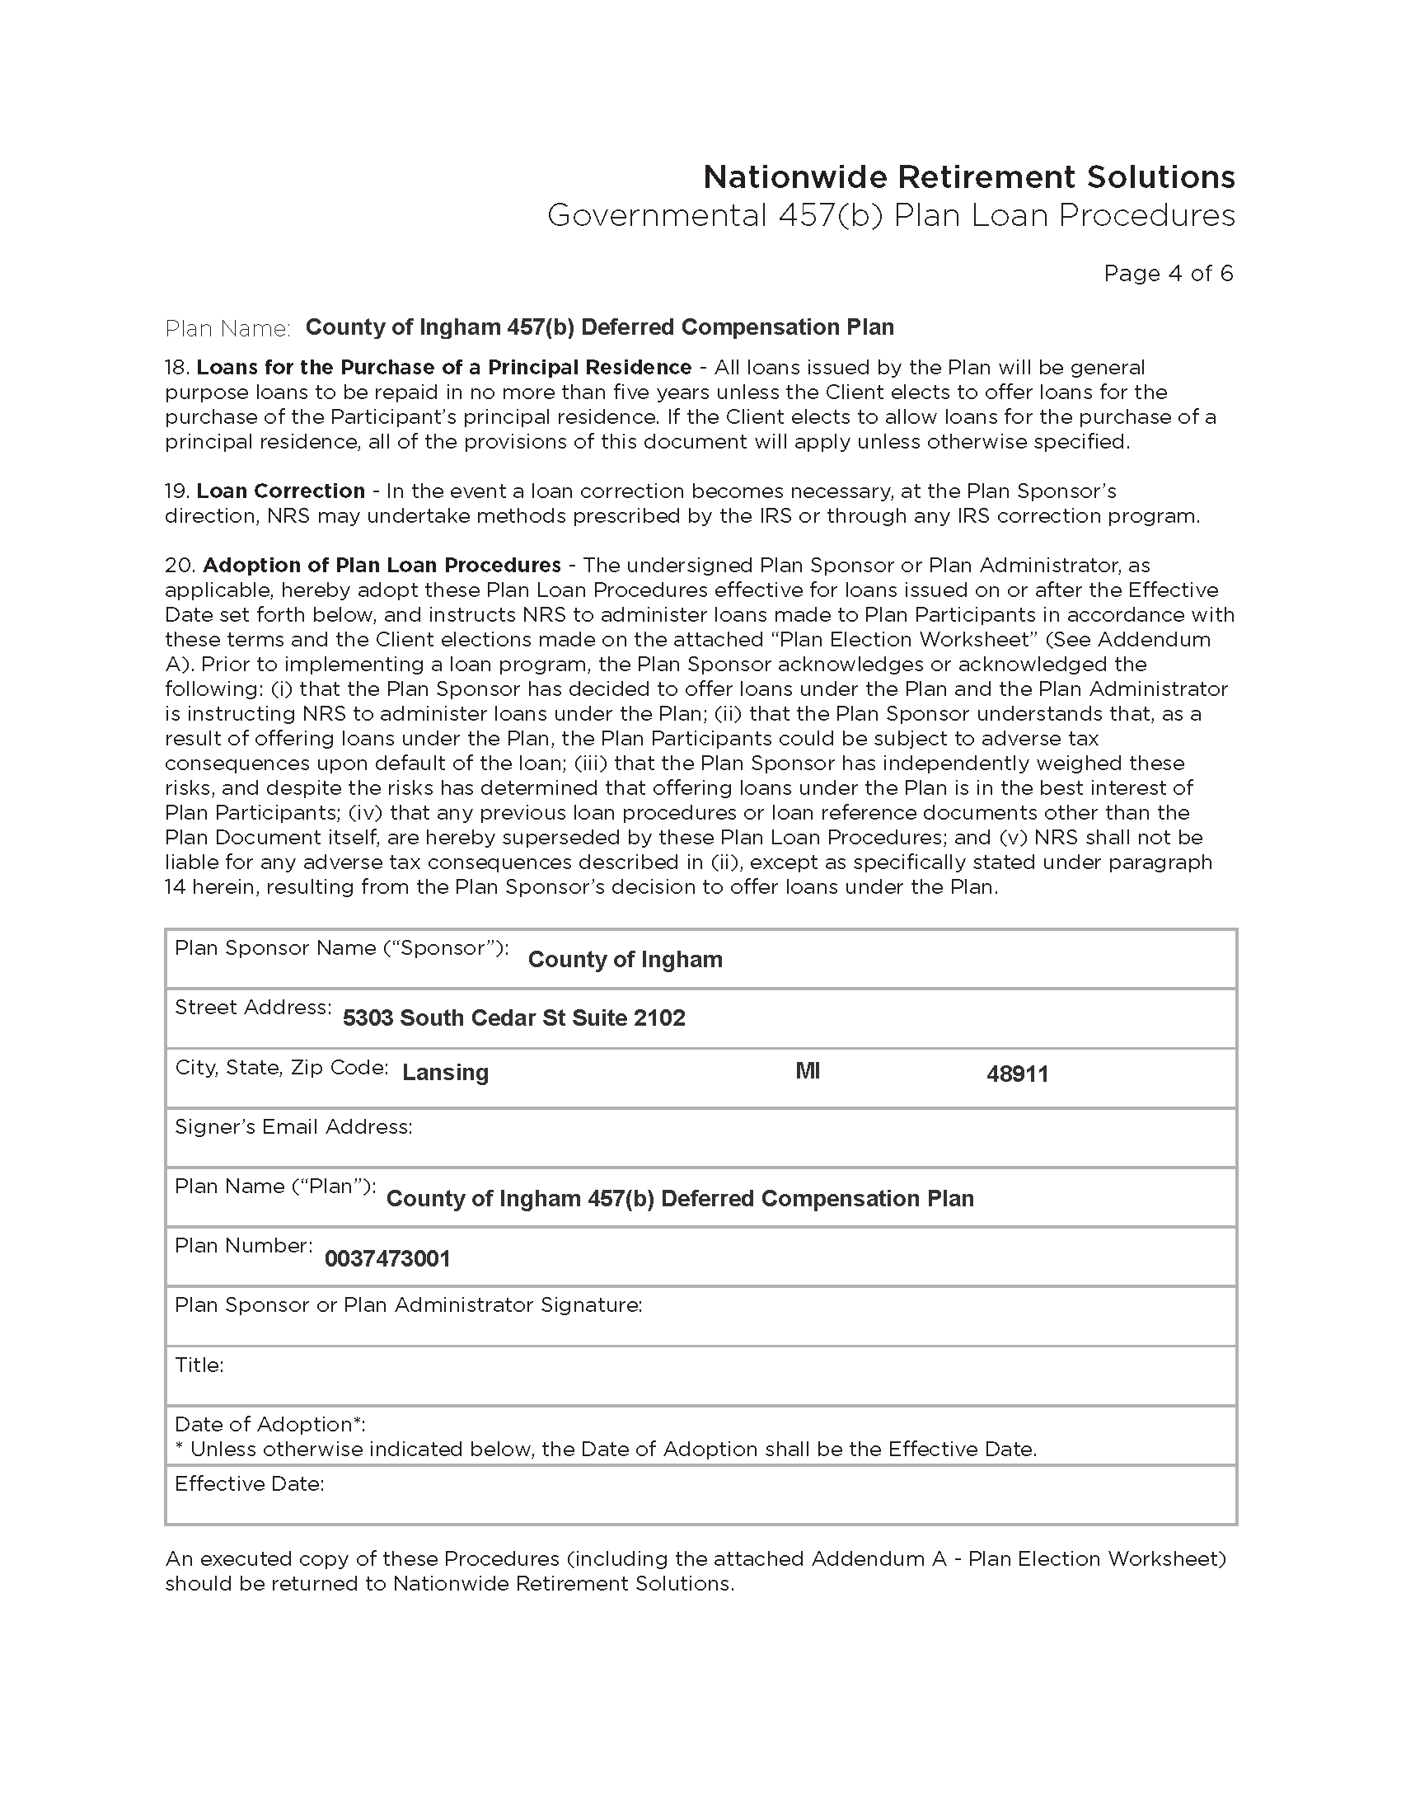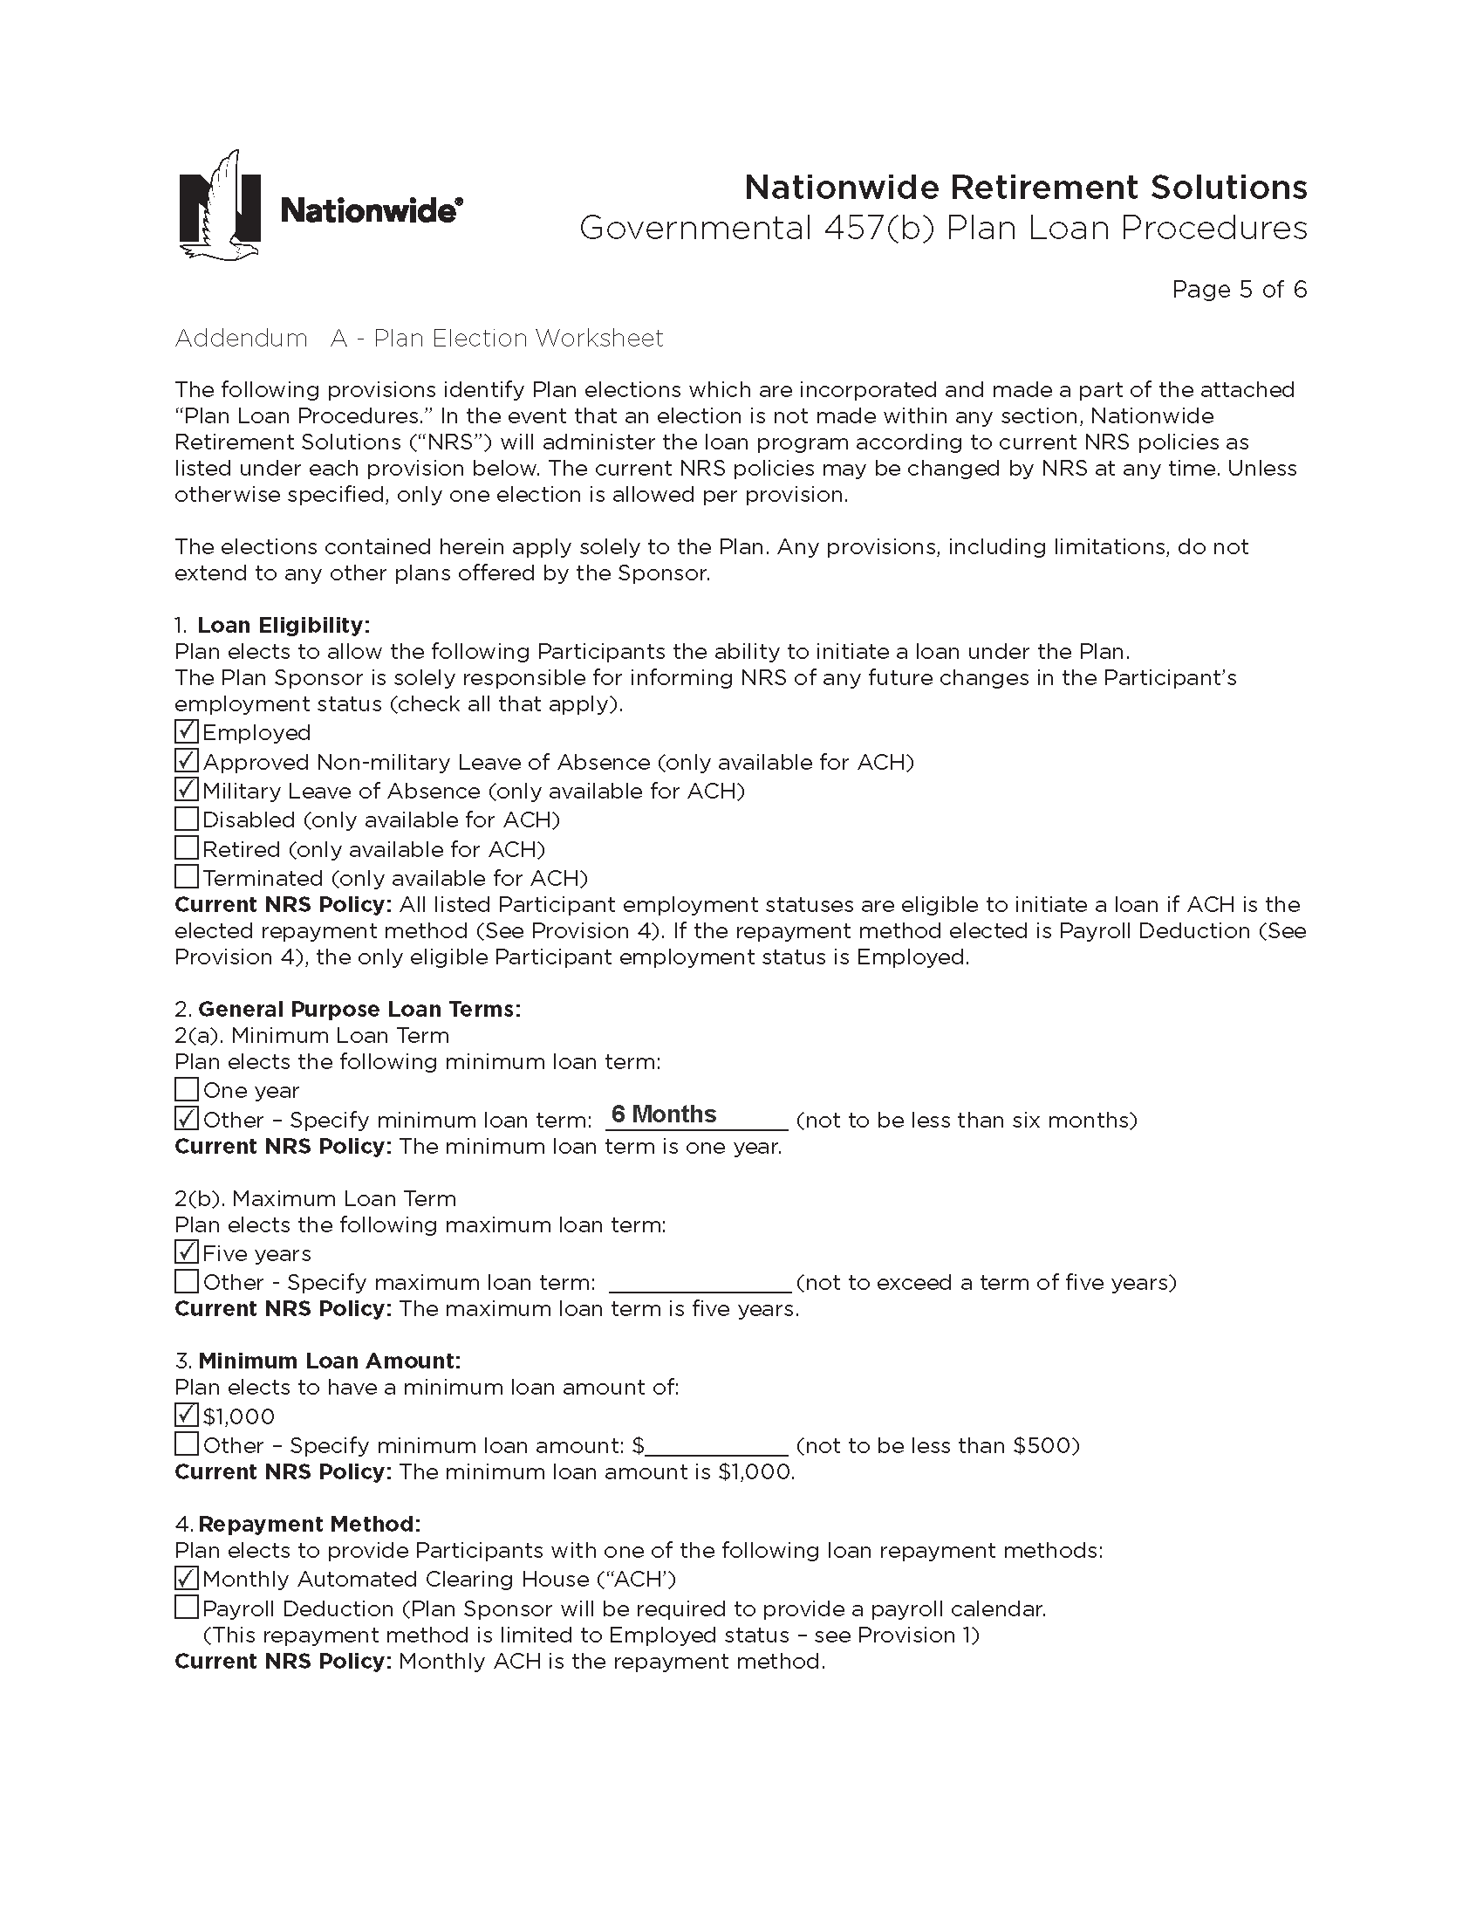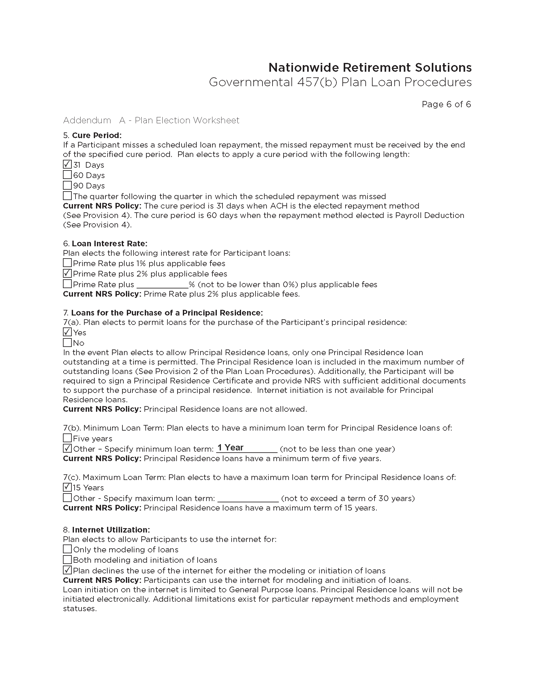
ADOPTED – AUGUST 27, 2019
AGENDA ITEM NO. 30

Introduced by the County Services and Finance Committees of the:

INGHAM COUNTY BOARD OF COMMISSIONERS

RESOLUTION TO APPROVE THE RENEWAL OF THE INFORMACAST
SUPPORT SUBSCRIPTION

RESOLUTION # 19 – 340

WHEREAS, Informacast is an internal emergency notification platform used to notify staff of situations in their locations; and

WHEREAS, support for this system needs to be renewed in order to allow updates and efficient use of the product; and

WHEREAS, the renewal is quoted under the State of Michigan MiDEAL contract; and

WHEREAS, the contract amount is available in the 2019 budget.

THEREFORE BE IT RESOLVED, that the Board of Commissioners do hereby authorize the renewal of the Informacast support subscription from CDWG in the amount not to exceed $38,430.00 for 5 years.

BE IT FURTHER RESOLVED, that the total cost will be paid from the Innovation and Technology’s Contract Maintenance Fund (636-25810-932030).

BE IT FURTHER RESOLVED, that the Controller/Administrator is authorized to make any necessary budget adjustments.

BE IT FURTHER RESOLVED, that the Chairperson of the Ingham County Board of Commissioners is authorized to sign any contract documents consistent with this resolution and approved as to form by the County Attorney.

COUNTY SERVICES: Yeas: Celentino, Stivers, Grebner, Sebolt, Maiville, Naeyaert
Nays: None Absent: Koenig Approved 08/20/2019

FINANCE: Yeas: Grebner, Morgan, Tennis, Crenshaw, Polsdofer, Schafer, Maiville
Nays: None Absent: None Approved 08/21/2019

